
Photo by Jason Charters at Unsplash

Unlocking investments into immersive content for all viewers
AMBEO 2-Channel Spatial Audio live renderer plugin will be available towards the end of 2023

Wedemark, 15 September 2023 – The AMBEO 2-Channel Spatial Audio live renderer will be available as a plugin for Merging Technologies’ Anubis audio interface in Q4 2023. Top broadcasters across the world have expressed their interest in this unique tool, which reliably translates live immersive mixes into an enhanced 2-channel experience. The AMBEO 2-Channel Spatial Audio mix will work on any stereo device, making a separate stereo mix obsolete.

Ground-breaking immersive processing for live broadcasts
“Once again, sports broadcasting fulfils its role as a technology driver,” says Renato Pellegrini, Head of Pro Labs, Sennheiser. “Currently, broadcasters are duplicating their efforts by creating separate immersive and stereo mixes of their large, televised sporting events, as distribution pipelines and viewer access to immersive speaker systems are still limited. With the upcoming Anubis plugin, broadcasters can focus on their immersive mix and know that it will reliably translate into a far better stereo experience than could previously be achieved. AMBEO Spatial Audio increases return on investments in immersive audio by unlocking improvements for the majority of viewers.”

The AMBEO 2-Channel Spatial Audio live renderer plugin transforms, in real-time, standard multichannel surround and immersive formats into two channels of audio that can be delivered anywhere stereo is delivered today. Patented controls, adapted for use in a broadcast environment, allow for fine-tuning of spatialisation settings to maintain mix integrity and improve dialogue intelligibility over stereo mixdowns.

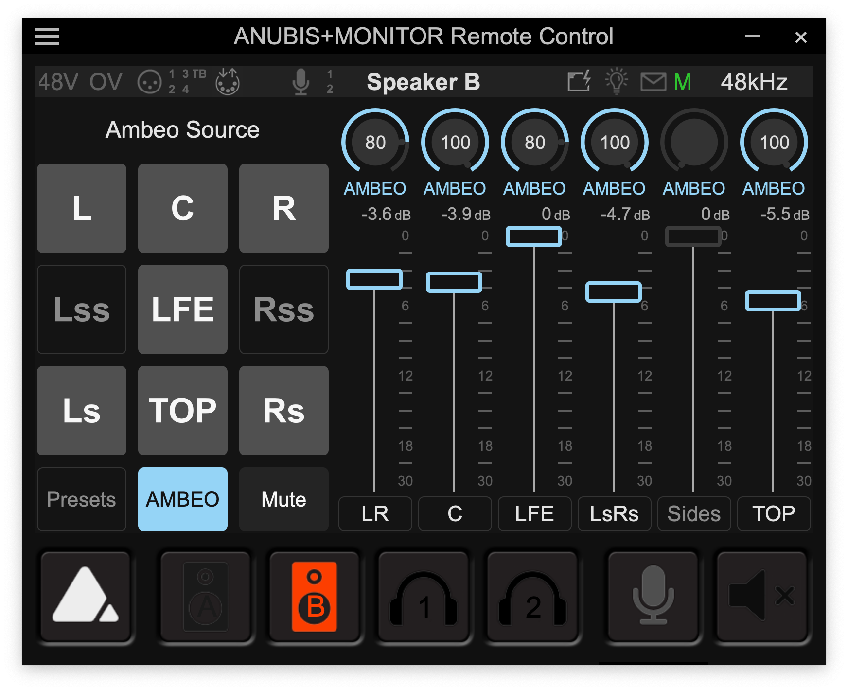 | The AMBEO 2-Channel Spatial Audio live renderer unlocks investments into surround and immersive content for all viewers. Pictured is the prototype of the renderer interface for fine-tuning the spatially enhanced two-channel mix, controlled via the standard Anubis remote control software

From 15 to 18 September, stop by at IBC stand 8D50 for live demonstrations of the renderer, daily at 12:30 and 14:30, and additionally at 17:00 on the Friday and Saturday of the show. Alternatively, contact prolabs@sennheiser.com to schedule a field test.

(Ends)

About the Sennheiser brand
We live and breathe audio. We are driven by the passion to create audio solutions that make a difference. Building the future of audio and bringing remarkable sound experiences to our customers – this is what the Sennheiser brand has represented for more than 75 years. While professional audio solutions such as microphones, meeting solutions, streaming technologies and monitoring systems are part of the business of Sennheiser electronic GmbH & Co. KG, the business with consumer devices such as headphones, soundbars and speech-enhanced hearables is operated by Sonova Holding AG under the license of Sennheiser.

www.sennheiser.com
www.sennheiser-hearing.com

Global Pro Audio Press Contact
Stephanie Schmidt
stephanie.schmidt@sennheiser.com
+49 (5130) 600 – 1275

