Rewriting the immersive audio rulebook
Sennheiser’s AMBEO Soundbar receives prestigious EISA Award

London August 15, 2019 – Sennheiser’s AMBEO Soundbar has been honored with the prestigious EISA Award 2019-2020 in the “Premium Soundbar” category. Presented annually by the European Imaging and Sound Association (EISA), the EISA Awards celebrate products that combine the most advanced technology and desirable features with class-leading performance. Across categories including mobile devices, Hi-Fi and Home Theatre Audio, the awards recognize the very best new products in consumer electronics, as chosen by 55 of the leading international specialist CE magazines.

The AMBEO Soundbar was recognised by the international EISA jury for its ability to create an immersive 3D sound experience from a single all-in-one device. The award will be officially presented at an award ceremony held during IFA 2019 in Berlin.

“With the AMBEO Soundbar, we have sought to enter a new product category and establish new standards for a 3D sound experience at home. Receiving the EISA Award demonstrates that we have succeeded to push new bounderies in the home entertainment speaker market delivering one of the world’s best soundbars,” said Stephane Hareau, Global Head of Products Consumer at Sennheiser. With 13 drivers and the latest virtualization technology jointly developed with Fraunhofer IIS, the soundbar places the listener inside the sound experience with incredible realism, blurring the lines between playback and reality.

Sennheiser’s AMBEO Soundbar received the EISA Award in the Premium Soundbar category.

The EISA Award citation praised the AMBEO Soundbar for its perfect combination of speaker and microphone technology: “With its debut soundbar, Sennheiser has effectively rewritten the immersive audio rulebook. Handling Dolby Atmos and DT S:X, and introducing proprietary AMBEO 3D upmixing for stereo and 5.1 content, this large-scale one-box system ensures an enveloping, cinematic performance from any source. Its 13 drivers, including six 4in woofers and twin upfiring units, work to create an astonishingly realistic soundstage with crisp highs and room-shaking bass, while Sennheiser’s microphone-assisted room calibration results in a precise presentation. Three HDMI inputs, an eARC-enabled output, plus Bluetooth, Chromecast and networking talents allow the AMBEO Soundbar to become your system hub, and the companion smartphone app makes it easy to use. Most importantly, once heard it’s never forgotten...”
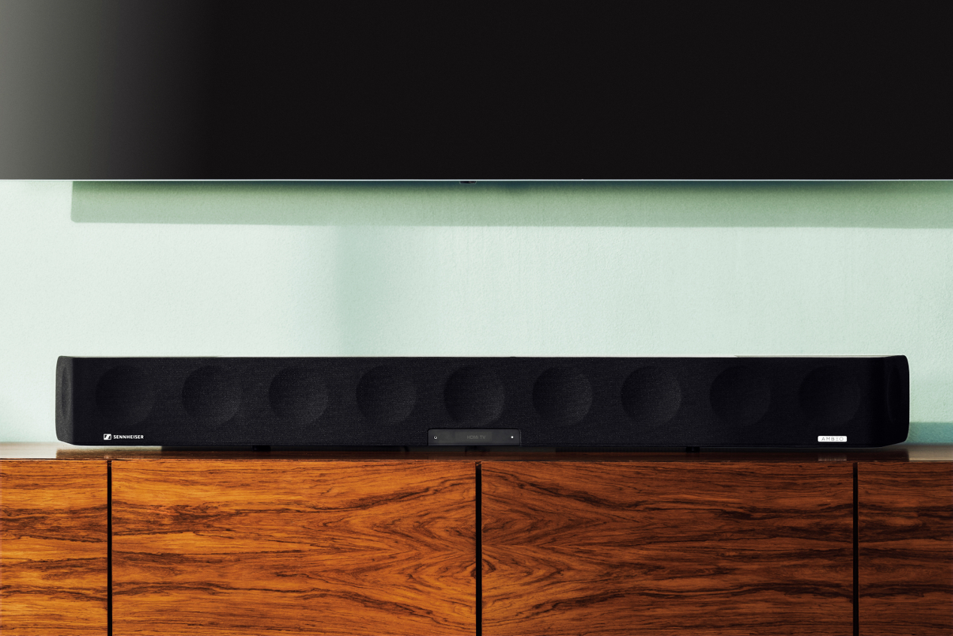

The AMBEO Soundbar delivers an immersive 3D sound experience from a single all-in-one device.

Without the need for additional speakers or an external subwoofer, the AMBEO Soundbar brings perfectly tailored 5.1.4 sound and powerful bass for every kind of home entertainment. It is compatible with Dolby Atmos, MPEG-H and DTS:X. Thanks to its Upmix Technology, it can also recreate stereo and 5.1 content in stunning 3D. The soundbar features five different presets (movie, music, sports, news and neutral) tailored to a range of scenarios and content types that precisely adjust not only the frequencies but also the 3D sound characteristics. Sennheiser’s Smart Control App allows users to adjust acoustic settings via smart devices, including setting presets, personalizing the sound with the equaliser and selecting from three different AMBEO modes.

About Sennheiser
Shaping the future of audio and creating unique sound experiences for customers – this aim unites Sennheiser employees and partners worldwide. Founded in 1945, Sennheiser is one of the world’s leading manufacturers of headphones, loudspeakers, microphones and wireless transmission systems. Since 2013, Sennheiser has been managed by Daniel Sennheiser and Dr. Andreas Sennheiser, the third generation of the family to run the company. In 2018, the Sennheiser Group generated turnover totaling €710.7 million. www.sennheiser.com

Sennheiser UK Ltd
Victoria Chernih
Communications Manager
North and East Europe
Phone +44 (0) 1628 402 234
victoria.chernih@sennheiser.com

Harvard PR
Tricia May
Phone +44 (0) 207 861 3945

Global Press Contact
Sennheiser electronic GmbH & Co. KG
Jacqueline Gusmag
Comunications Manager Consumer
T +49 (0)5130 600-1540
jacqueline.gusmag@sennheiser.com

