#DontStopTheMusic

Listen, dance and enjoy!

Wedemark/Germany, May 28, 2020 – Sennheiser’s #DontStopTheMusic series is now on Facebook! Don’t miss a beat and connect to the next concerts in the series, which will be performed by Javier Reyes (Animals as Leaders), DJ A PLUS, Murthovic and Sadie Dupuis of Speedy Ortiz.

Live concert streams from Friday, May 29 to Friday, June 5
From this point forward, Sennheiser’s #DontStopTheMusic concerts will be streamed on our Facebook channels, but we will continue to keep you updated on our Instagram page @sennheiser and don’t forget to switch on notifications to receive alerts, as dates and artists may be subject to change at short notice.
- Javier Reyes (Animals as Leaders) (@animalsasleaders):
Friday, May 29 at 19:00 UTC (15:00 New York time, 21:00 Berlin time)
- DJ A PLUS (@arroncrascallpage):
Monday, June 1 at 14:00 UTC (10:00 New York time, 16:00 Berlin time)
- Murthovic (@murthovic):
Wednesday, June 3 at 12:30 UTC (08:30 New York time, 14:30 Berlin time, 18:00 Indian time)
- Sadie Dupuis of Speedy Ortiz (@speedyortiz):
Friday, June 5 at 19:00 UTC (15:00 New York time, 21:00 Berlin time)

More music
Please also check out http://www.sennheiser.com/anniversary for the next livestream dates and a great selection of music videos to watch and listen to. Just put on your headphones (or turn up the speakers) and immerse yourself in immersive jazz club recordings, electro sets, or live takes from recording studios.

It’s free but why not donate to fight the coronavirus?
At Sennheiser, we’re delighted to be working with these fantastic artists to help spread positivity by putting on exclusive concerts. They’re totally free, but if you do want to say thank you, do consider supporting the WHO in its fight against the coronavirus:
https://www.who.int/emergencies/diseases/novel-coronavirus-2019/donate

For your social media channels:
Enjoy your favorite artists at home and check out the exclusive concerts in Sennheiser media channels streaming concert series – live on Facebook! #DontStopTheMusic

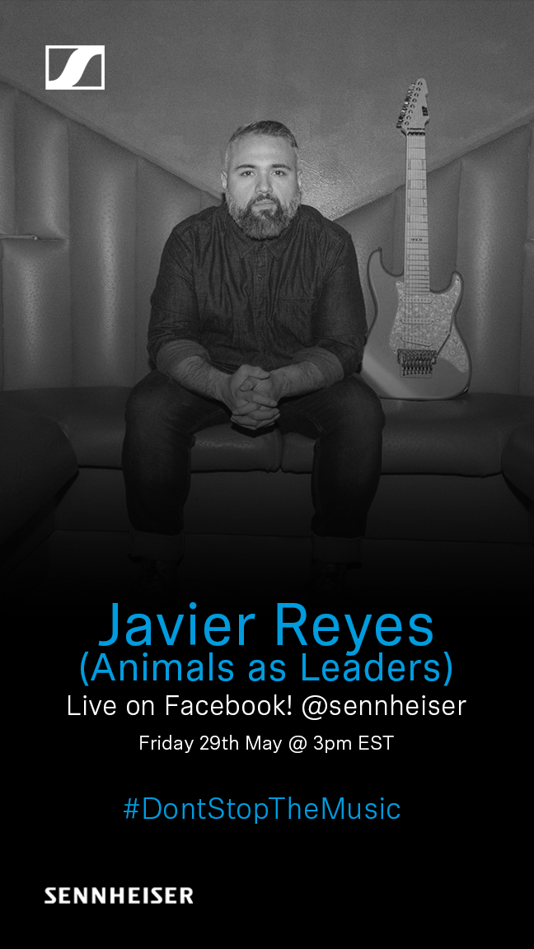 | 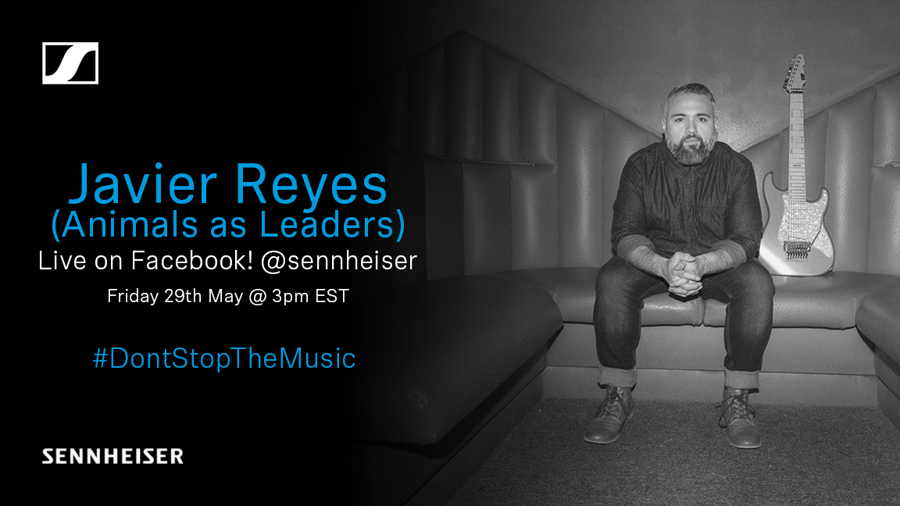
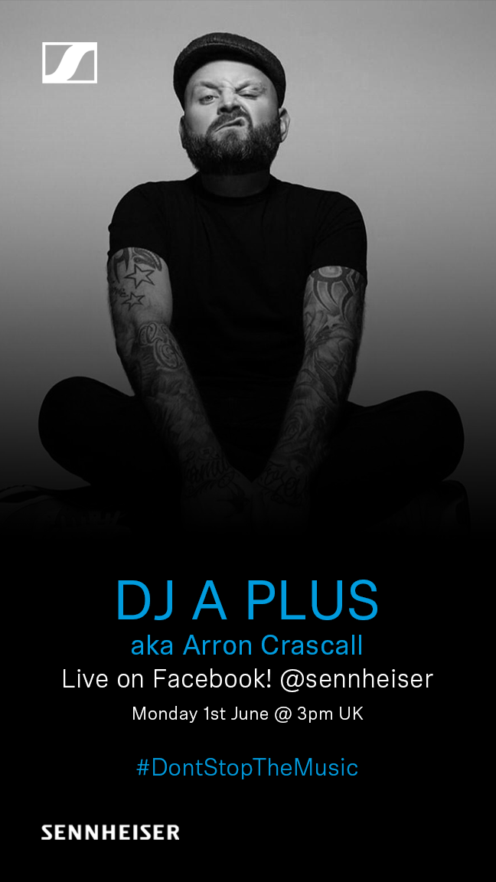 | 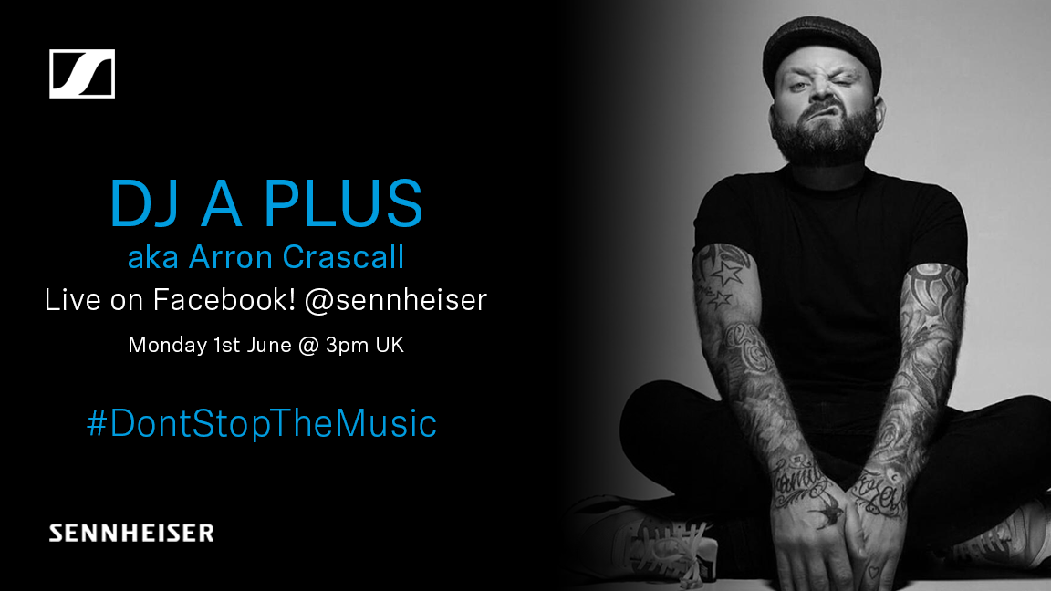
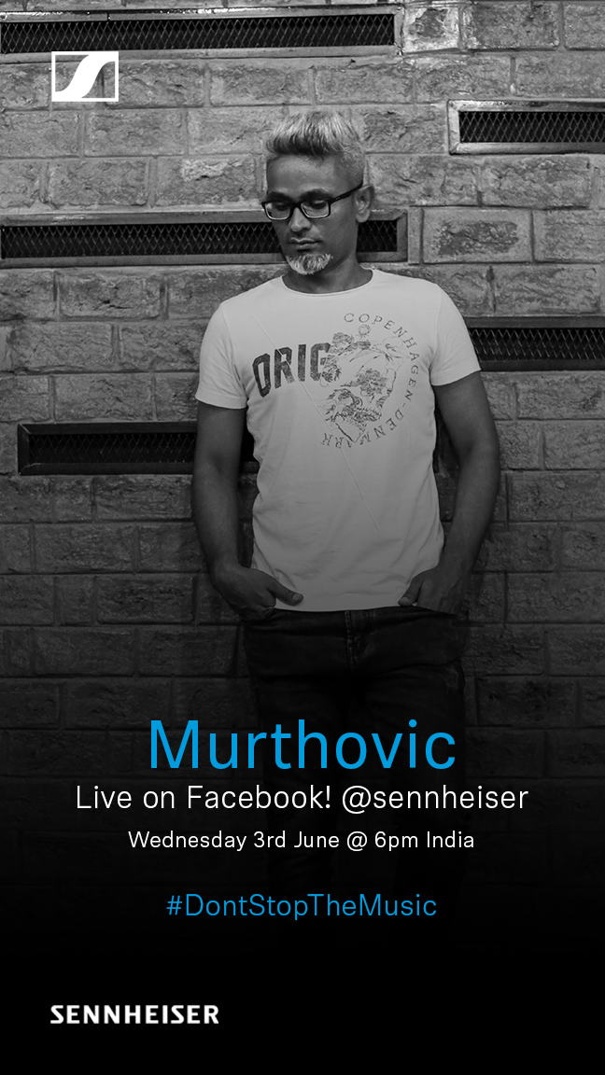 | 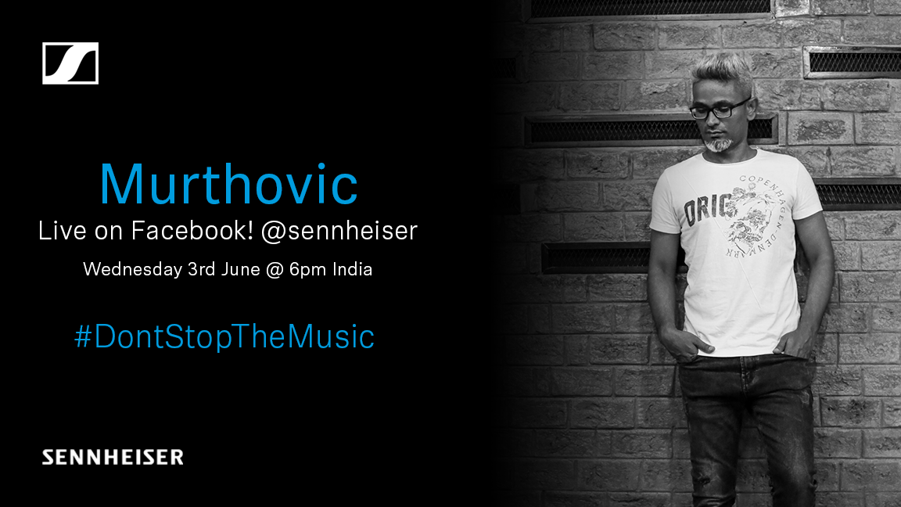

About Sennheiser
Founded in 1945, Sennheiser is celebrating its 75th anniversary this year. Shaping the future of audio and creating unique sound experiences for customers – this aim unites Sennheiser employees and partners worldwide. The independent family company, which is managed in the third generation by Dr. Andreas Sennheiser and Daniel Sennheiser, is today one of the world’s leading manufacturers of headphones, loudspeakers, microphones and wireless transmission systems. In 2018, the Sennheiser Group generated turnover totaling €710.7 million. www.sennheiser.com

Press Contacts

Mareike Oer Stephanie Schmidt
mareike.oer@sennheiser.com stephanie.schmidt@sennheiser.com
T +49 0(5130) 600 – 1719 T +49 0(5130) 600 – 1275

