

Biuro prasowe better. gaming agency
bettergamingagency.prowly.com



Who says work can’t be fun? Welcome to Holiday Motel Simulator!

The latest gameplay trailer reveals the duties awaiting the new owner of an abandoned motel.

Red Phoenix Interactive just dropped a new gameplay video for Holiday Motel Simulator. In this upcoming game, you’ll step into the shoes of the new owner of a rundown motel. Your job? Not only to bring it back to its former glory but also to turn it into a place where guests feel like they’re in paradise. The game is coming to Early Access on Steam this summer, with further development based on community feedback.

Holiday Motel Simulator – watch the new gameplay trailer


https://www.youtube.com/watch?v=oDz9ztdixco

Sea, beach, and palms – in such surroundings, even the worst task suddenly becomes enjoyable! There’s a lot of work ahead, with the building in such bad condition, but it’s definitely worth giving it a second chance. In Holiday Motel Simulator, players will be responsible for every aspect of the renovation process – from power washing the exterior, to replacing floors and painting ceilings, all the way to furnishing each room. And that’s just the beginning!

After the motel is brought back to life, it’s time to take care of other important parts of the business, such as running your own shop and a beach bar. Managing the inventory, arranging the shelves, and helping customers will add another layer of responsibilities for the owners of the world’s best motel! The creators at Red Phoenix Interactive know well that life isn’t all about work, so they’ve also included the option to relax at your own beach bar. Chilling by the bonfire with a cocktail in hand, admiring the sea or watching your guests dance will surely help you recharge batteries before whatever the next day brings.

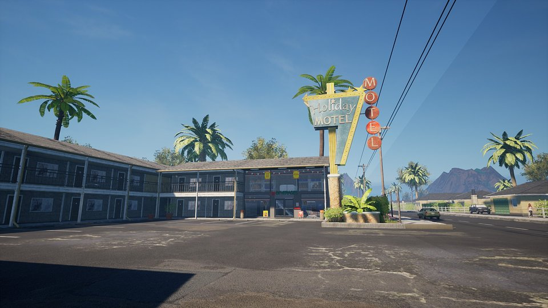

Business is business, as the old saying goes – which is why you’ve got to keep the money coming. In this case, the formula is simple: a satisfied guest means steady income. It’s worth gathering feedback, responding to suggestions, and paying attention to details to ensure unforgettable experiences for your clients. Your decisions will shape the future of the business, and every new guest is like a new chapter in the history of Holiday Motel Simulator.

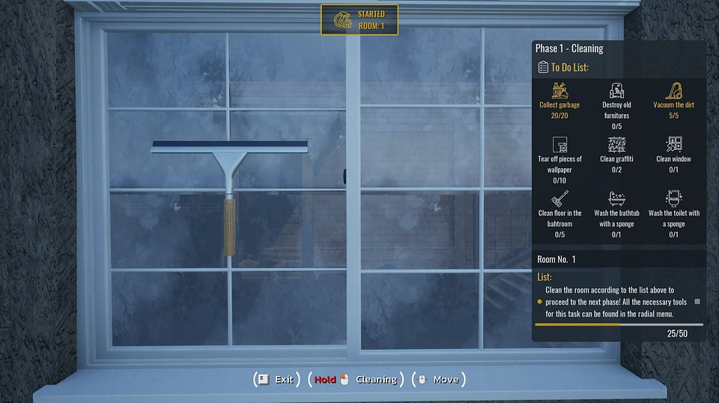

Holiday Motel Simulator – key features:

☀️ Do it yourself – start your adventure from scratch by planning and carrying out a full renovation of the property. It’s up to you whether the motel will regain its former glory and attract new guests.

🌴 Boho style – furnish each room so that guests with different tastes feel at home. Choose from hundreds of available furniture pieces and decorations in various styles.

⛱️ Penny by penny – run the motel’s shop so your guests have everything they need right at their fingertips. Manage the inventory, arrange the shelves, and earn profit from every product sold.

🍹 More than just motel visitors – run your own beach bar where you’ll serve refreshing cocktails and tasty snacks, all while keeping the beach and its facilities clean and inviting. These tasks bring even more chill vibes to Holiday Motel Simulator. Will your guests be happy? Find out for yourself!

🌅 Making your dream come true – step by step, create a special destination that will wow your guests. Manage every aspect of the motel’s business and make sure it becomes a top choice for travelers.

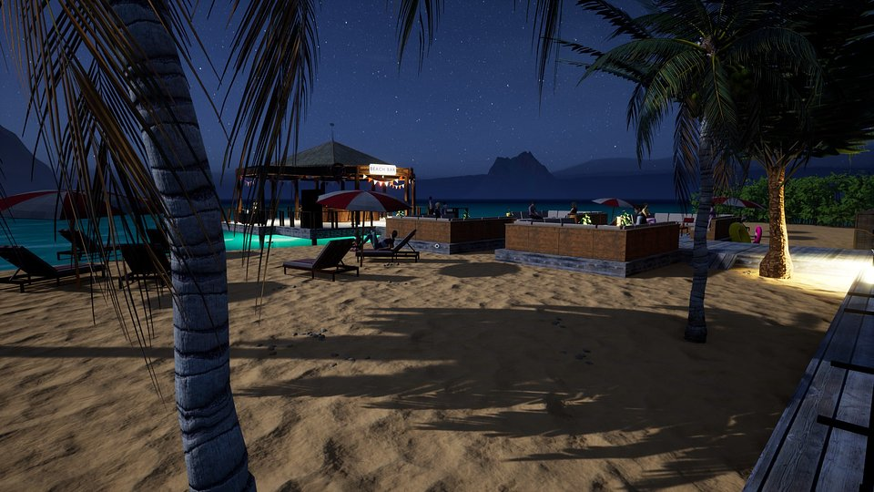

Holiday Motel Simulator is coming to Early Access this summer, and everyone interested in the game can already wishlist it on Steam. The developers at Red Phoenix Interactive are excited to get the community involved in helping improve and grow the game. That’s why they encourage everyone to join the community on Discord and keep up with our progress on X and TikTok.

Press kit is available HERE.

About Red Phoenix Interactive:

Red Phoenix Interactive is an independent studio based in Poland, born from passion and the dream of creating their own games. The team is made up of people who, after gaining experience across various industries over the years, finally decided to follow their true calling. For Red Phoenix Interactive, video games are not just products but emotional stories that connect developers and gamers. Currently, the studio is working on Holiday Motel Simulator, scheduled for release in summer 2025. More information can be found on the official website.

