EMBARGOED UNTIL WEDNESDAY, AUGUST 26, 2026, at 12:00 PM CEST (UTC+2)

Sennheiser and Mercedes-Benz Shift Performance Audio Into High Gear
German brands unveil the Mercedes-AMG edition of an audiophile favorite for immersive gaming experiences—the first product in a multi-year collaboration.

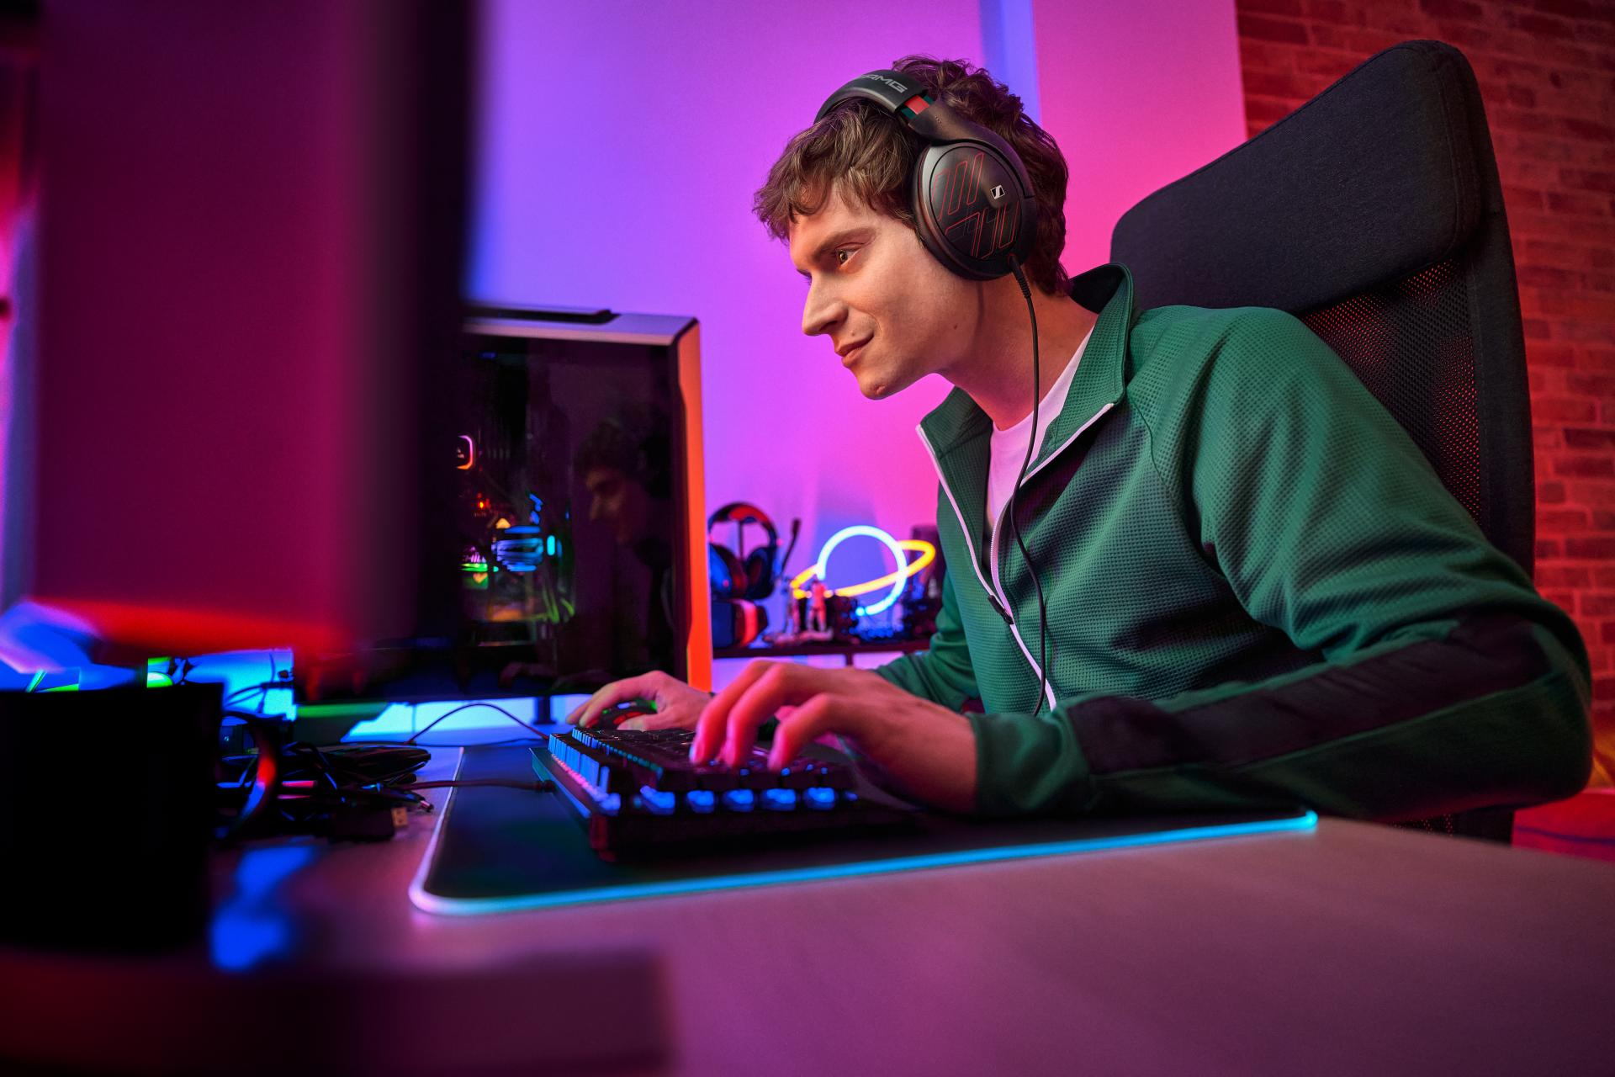
Cologne, Germany – August 26, 2026 - The Sennheiser brand and Mercedes-Benz today announced a new partnership; an alignment of precision engineering for automotive and audio enthusiasts alike. Debuting at gamescom®—the world’s largest gaming fair—the collaboration fuses Sennheiser’s high-fidelity expertise with Mercedes-Benz’s passion for precision, sensory-rich performance. The effort underscores a demand for top-tier acoustics that excite, meeting the moment with a Mercedes-AMG gaming edition of the lauded HD 620S, and a promise of more to come
"For gamers, sound is not a passive experience—it’s essential for shaping an immersive world, and the raw emotion that comes from serious gameplay," said Johann Evanno, Category Director for Sennheiser Consumer Hearing. "From redlined engine notes to distant footsteps, the HD 620 Mercedes-AMG Edition can elevate in-game audio cues into a competitive advantage."

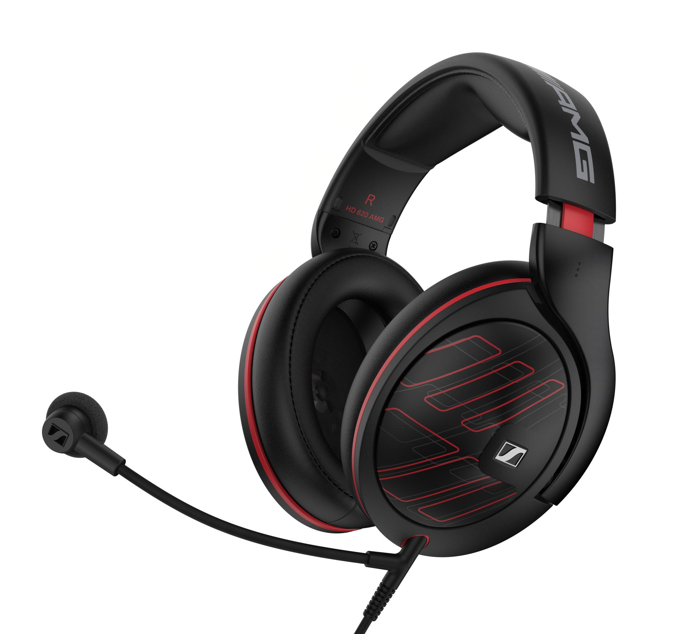
Legendary Sound for Future Legends
In conjunction with the announcement, the Sennheiser and Mercedes-Benz brands are unveiling a bundle designed specifically for competitive gamers and streamers: the HD 620 Mercedes-AMG Edition. Built for gamers that understand the smallest details decide the biggest moments, it offers sound so clear it feels like a cheat code. Targeted for shipping in November 2026, the hardware delivers passive noise isolation and attention to detail that is nothing short of luxurious. The included HD 500 BAM (boom arm mic) ensures crystal-clear speech pickup for hands-free communication when you need it and detaches for focused audiophile listening sessions.
Blurring Virtual and Physical Worlds
The partnership serves as a high-octane showcase of how high-fidelity sound elevates gaming and sim racing, through a heritage of premium quality. Whether navigating a racetrack or a virtual arena, success often comes down to the details others miss. Sennheiser’s True Sound philosophy—trusted for decades by the gaming community for a competitive edge—bridges the gap between digital landscapes and physical sensation, illustrating how total immersion is fundamental for both brands.
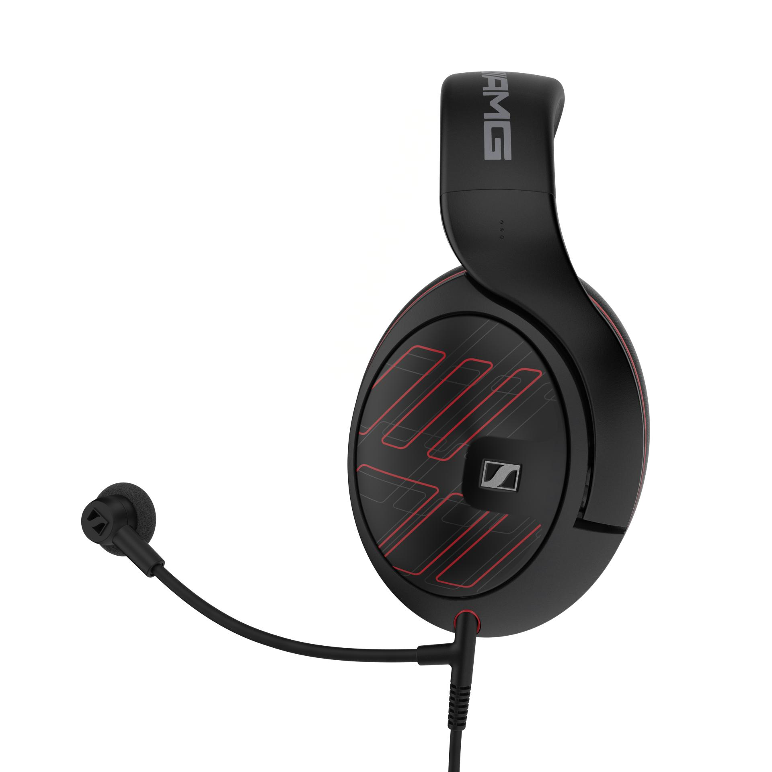
"Sound is vital to our engineering philosophies," added Christian Ern, Product Manager. "This partnership emphasizes the standard of excellence we demand when performance matters most and gamescom is the first step in transcending the thrill and precision of driving a Mercedes-Benz to a PC using sound."
Availability & Interactive Showcases
Attendees can experience the collaboration firsthand by visiting the Mercedes-Benz booth at gamescom, where the Sennheiser brand’s high-performance audio solutions will be featured. The HD 620 Mercedes-AMG Edition will retail for $449.95 USD and begin shipping November, 2026. For more information on the bundle and partnership activations, visit sennheiser-hearing.com.

Mercedes-Benz® and Mercedes-AMG® are registered trademarks of Mercedes-Benz Group AG. All other brands are property of their respective owners.

About the Sennheiser Brand – Over 80 Years Building the Future of Audio
We live and breathe audio. We are driven by the passion to create audio solutions that make a difference. This passion has taken us from the world’s greatest stages to the quietest listening rooms – and made Sennheiser the name behind audio that doesn’t just sound good: It feels true. In 2025, the Sennheiser brand celebrated its 80th anniversary. Since 1945, we have stood for building the future of audio and bringing remarkable sound experiences to our customers. While professional audio solutions such as microphones, meeting solutions, streaming technologies and monitoring systems are part of the business of Sennheiser electronic SE & Co. KG, the business with consumer devices such as headphones, soundbars and speech-enhanced hearables is operated by Sonova Holding AG under the license of Sennheiser.

sennheiser.com
sennheiser-hearing.com

About Sonova Consumer Hearing
Sonova Consumer Hearing offers premium headphones and hearables – primarily in the true wireless segment – as well as audiophile headphones, hearing solutions and soundbars under the Sennheiser brand. The business is part of the Sonova Group, a global leader in innovative hearing care solutions with headquarters in Switzerland and more than 17,000 employees worldwide.

Press contact
Eric Palonen
PR Manager | Americas
Sonova Consumer Hearing USA
T +1 860 908 1210
eric.palonen@sonova.com

