Sennheiser Sport analyzes the international fitness soundtrack
Sennheiser, a leading global audio brand, finds hip hop and R&B are replacing rock music as the preferred genre to listen to when doing sports.

Wedemark, June 30, 2022 – The new Sennheiser SPORT True Wireless provides fitness enthusiasts and athletes with a superior audio experience, no matter how intense the workout. In order to understand what kind of music powers people’s sporting activities, the Sennheiser Brand recently commissioned an independent study with Panelbase.* The results are in, and they have found that, in many countries, hip hop and R&B are preferred over traditional pop and rock music as the optimal soundtrack for doing sport.**
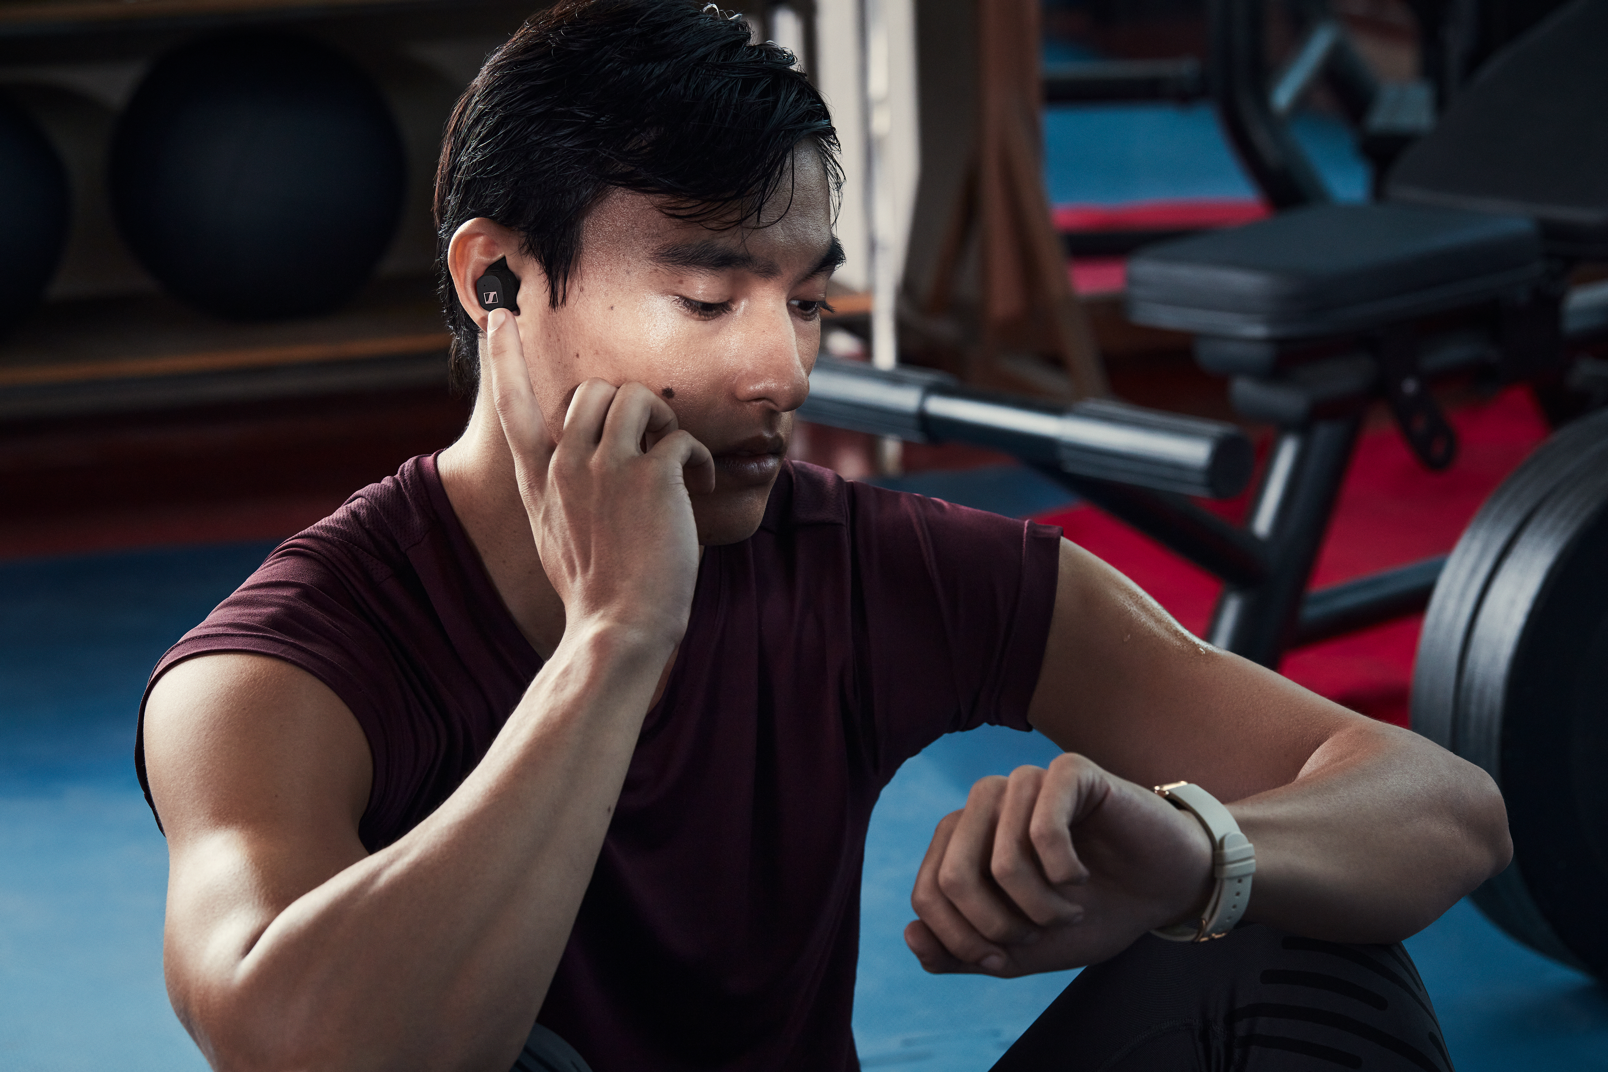
Numerous fitness guides and top tips for exercising emphasize the importance of motivation. Without it, it's not only hard to go for a run early in the morning, but also to spur yourself on to new heights when motivation is low. And hardly anything helps in this regard as much as the right music. But what is the "right" music for sporting activity? Are the beats per minute the deciding factor? Does it need to be quiet and focused, or loud and energizing?

What's your workout soundtrack?
The Sennheiser Brand wanted to find out what kind of music people prefer to listen to when doing sport, and asked users in countries around the world about their favorite workout soundtrack genre.

The results showed that in all the countries surveyed, people tend to prefer hip hop and R&B, moving slightly away from pop and rock – although these two genres remain popular for working out. Dance and electronic, as well as metal, are also popular exercise soundtracks. Apart from minor deviations, people from France to the U.S. and Japan to Australia are relatively unanimous when it comes to a good workout playlist. The major differences are more likely to be found in the breakdown of age groups.

Hip hop instead of rock
Here, too, there is a clear trend in all the countries surveyed: Hip hop and R&B are replacing rock and metal. Among 46- to 60-year-olds in the USA, rock is still favored by 32% and hip hop by 21%. However, among 16- to 29-year-olds, the latter genre is the choice of 50% of listeners, with rock music represented by just 9%.

A look at the UK, Germany, France, Australia and even Japan shows that this is not an American phenomenon. In every country surveyed, hip hop and R&B come out on top against rock and metal in the younger group of respondents compared to the older groups. And not only rock - but traditional pop music has also ceded percentages to the hip hop and R&B genres among the younger generation. This is particularly evident in Japan, as well as in Germany.

Diverse functions for diverse tastes
So, every generation, or rather every age group, has its favorite music genres for sports. But even within these groups, tastes are diverse beyond tangential preferences:

The findings show there are lovers of classical music amongst the younger athletes, but also a preference for house and electronic music amongst the older ones. In the end, it all comes down to everyone’s own music experiences during their training sessions and workouts.

For all of these music genres and preferences in sports, the SPORT True Wireless delivers the right sound. Just as it offers a choice of open or more closed sound for the different demands of a multitude of sports through the Adaptable Acoustic feature, it also offers the right sound for different genres of music. The TrueResponse transducer, developed in Germany, delivers powerful bass and clear highs without distortion. Using the Sennheiser Smart Control app, users can make individual pre-settings via the Sound Check function. The intuitive touch controls of the SPORT True Wireless can be personalized according to personal preferences and provide direct access to features such as audio navigation or voice assistants.

* About Panelbase
Panelbase is a global fieldwork specialist with over 350,000 registered adult members, dedicated youth panels comprising over 50,000 engaged kids and teens, 800+ profiling fields and access to 8 million+ panelists worldwide. Panelbase delivers robust quality data together with a fast, flexible and competitively priced sample-only and full-service offering. Panelbase is a member of the British Polling Council (BPC) and is accredited to deliver up-to-the-minute political polling data that is featured throughout the world’s media.

** About the survey
Panelbase sampled 3,000+ people from independent consumer panels in six countries (USA, Australia, UK, Germany, France, & Japan) to find out which genre of music people prefer to listen to when doing sport. Sampling to broad nationally representative quotas, respondents were screened to ensure that they participated in sport regularly and that they listened to music when participating in sport. This was conducted independently and the Sennheiser brand was not informed at any stage of the sponsor of this study.

About the Sennheiser brand
We live and breathe audio. We are driven by the passion to create audio solutions that make a difference. Building the future of audio and bringing remarkable sound experiences to our customers – this is what the Sennheiser brand has represented for more than 75 years. While professional audio solutions such as microphones, meeting solutions, streaming technologies and monitoring systems are part of the business of Sennheiser electronic GmbH & Co. KG, the business with consumer devices such as headphones, soundbars and speech-enhanced hearables is operated by Sonova Holding AG under the license of Sennheiser.

www.sennheiser.com
www.sennheiser-hearing.com

Press contact
Paul Hughes
Head of PR and Influencers
Sennheiser Headphones & Soundbars
Sonova Consumer Hearing GmbH
T +49 (0) 162 2921 861
paul.hughes@sennheiser-ce.com

