For more information, please contact Marta de Paco
On +34 670 780 664 or email press@comunicahair.com

Important:
These images are only available for editorial content.
Credits must be included.
Notification of their publication is expected.

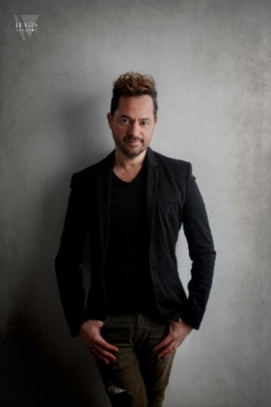
JUANMY MEDIALDEA
KINTSUGI Collection

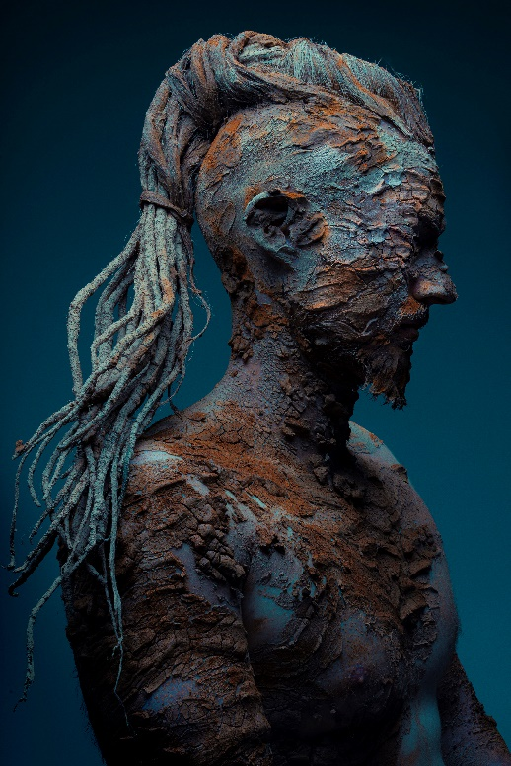
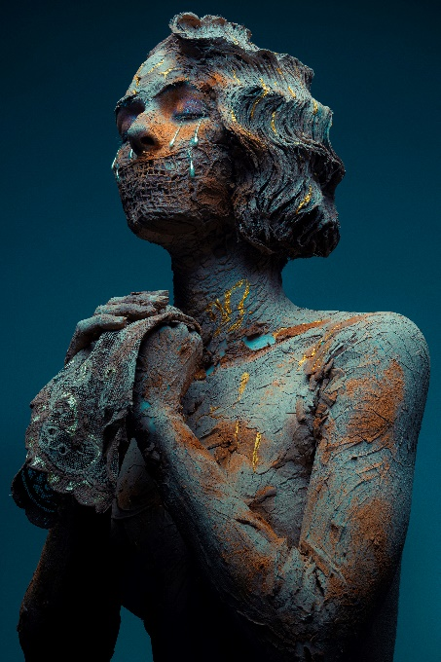
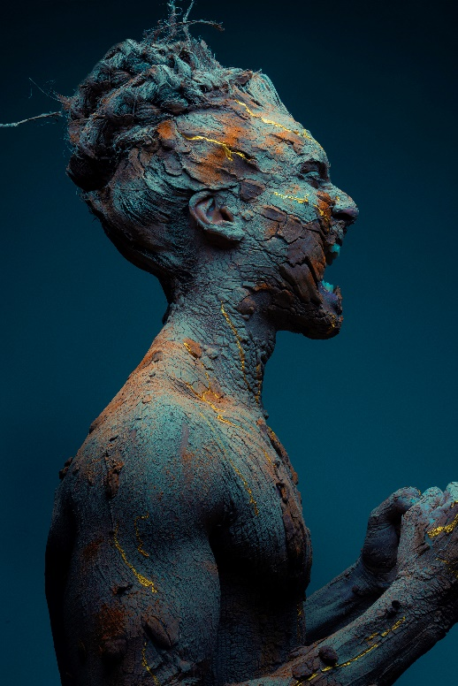

Hair: Juanmy Medialdea @ Juan Miguel Medialdea Peluqueros
Hair Instagram: @juanmy_medialdea
Hair Assistants: Jessica del Árbol and Sergio Peña Castillo
Instagram: @sergiocastillo_makeup
Photography: David Arnal Instagram: @davidarnalteam
MUA: D y D Escuela Superior de Imagen Integral, Sergio Peña Castillo, Álvaro Quirós and Inés Sánchez Calderón Instagram: @dydescuelasuperior @alvaroquiroslabella @iscimagenintegral @sergiocastillo_makeup
Products: Schwarzkopf Professional Instagram: @schwarzkopfpro.spain
Models: Agencia de Modelos Raquel Nofuentes @nofuentesmodels
Instagram Models: @r.m.tomas, @firaspantera, @rosaamg, @anaa_2442

JUANMY MEDIALDEA
KINTSUGI Collection

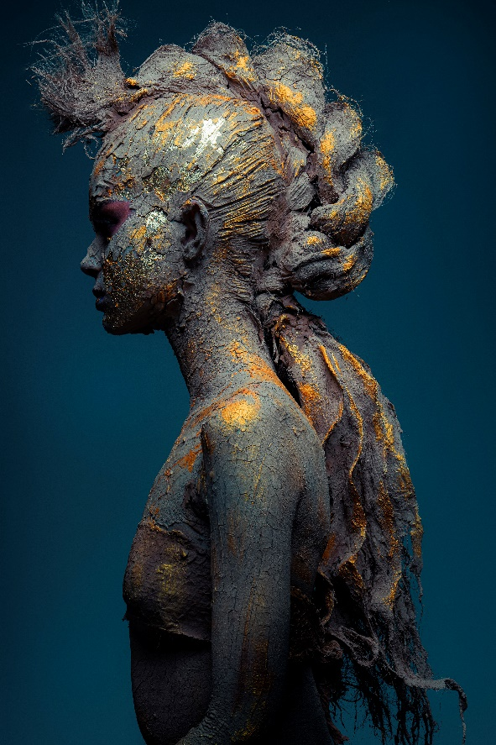
In a time when being strong is our only option, KINTSUGI is born, naming a solidarity collection that wants to pay tribute to the hard times we are going through, showing its most human side and reflecting the MOURNING that we are all living during this terrible PANDEMIC.

KINTSUGI is a Japanese repair technique applied to ceramic when it breaks. This philosophy states that breakages and repairs are part of the history of an object, and that they should be shown instead of hidden to remind us how strong we can be.

In the same way as ceramics, we can also rebuild ourselves, but for that it is essential to go through 4 phases: denial, pain, anger and acceptance, which will make us transcend spiritually, reaching something that is outside the limits that the body imposes on us. Because every break entail learning.

That is why it fits perfectly with the collection we have created since, in one way or another, today, we are all BROKEN.

PHASES OF MOURNING

NEGATION:
The first phase of mourning, when we feel so much pain that it prevents us from believing what is happening, or we refuse to see what happened.

PAIN:
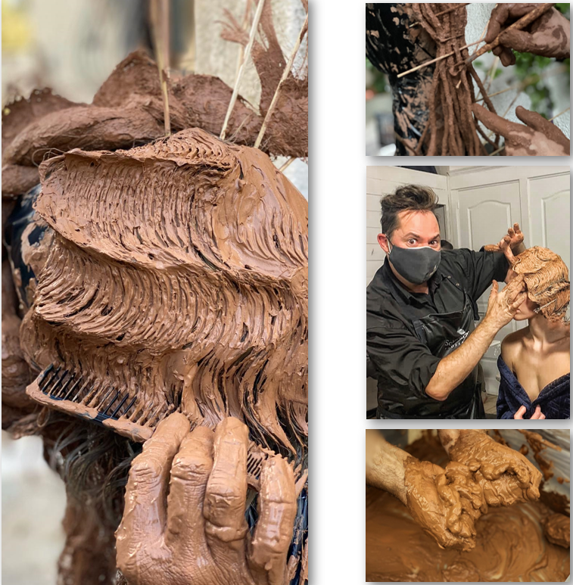
The phase where we feel emotions of sadness, emptiness or intense pain, coupled with thoughts that lead us to memories and the real or lost situation.

ANGER:
Another phase that when connecting with the loss or situation that we are suffering, it awakens in us rage, wrath or anger.

ACCEPTATION:
Having gone through the three previous phases, the situation is now accepted as part of our lives, a reality with which we must live and learn. With the first rays of light, the emotional Golden color will appear and with it, a discovery of capacities that were latent within us.

THE CREATIVE PROCESS OF KINTSUGI

KINTSUGI is also a song to his homeland: Guadix, of which he is very proud. Guadix is ​​an artisan city and a dream place. Mainly it is the cradle of potters because it has the necessary raw material to make pottery outdoors, in its clay hills.

Its badlands, lands of reddish tones sculpted in capricious shapes by the erosive action of wind and water, create the magical tonality they are known of. Therefore, each image in this collection is made with red clay, reflecting not only our cracks but also his origins, which have led him where he is today, being able to give voice, visibility and empathy to these difficult moments.

Positive message: “I hope KINTSUGI touches your heart filling you with HOPE and illusion just as it has filled mine, reminding me that there is always a halo of light capable of penetrating the slightest crack." Juanmy Medialdea.

