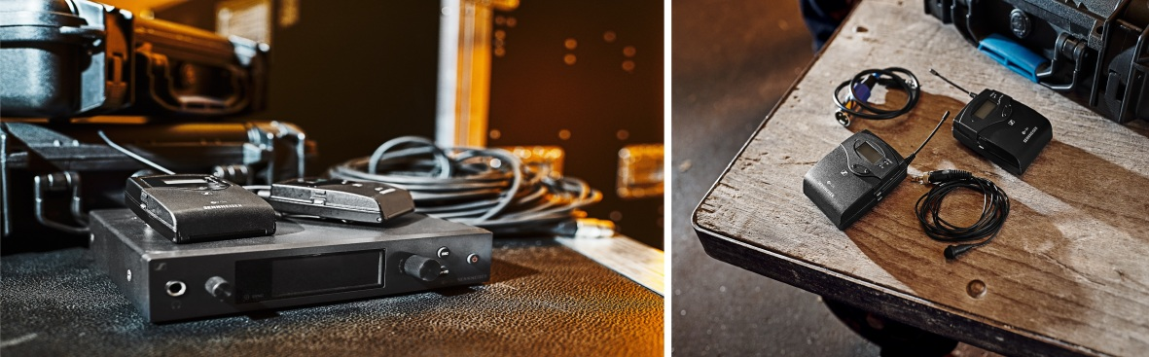

Anniversary offers on evolution wireless G4

Special deals in March for live sound and video professionals

Wedemark, 4 March 2020 – The month of March holds special deals for bands and videographers alike: Get up to 25% off the ew IEM G4 TWIN in-ear monitoring system and the ew 112-p G4 system for camera use.

For the live sound pro
Wireless monitoring has become a standard on stages across the globe – and evolution wireless G4 is one of the top choices for artists and engineers alike. In March, the ew IEM G4 TWIN is available for EUR/USD 999 instead of the usual price of EUR/USD 1,295. The UHF system is comprised of the SR IEM G4 wireless monitoring transmitter including rack-mount set, rod antenna and power supply, and two EK IEM G4 stereo bodypack receivers including batteries and IE 4 earphones. In brief: everything included for stepping up your performance with professional wireless monitoring.

Special deal for March: the ew IEM G4 TWIN monitoring system | 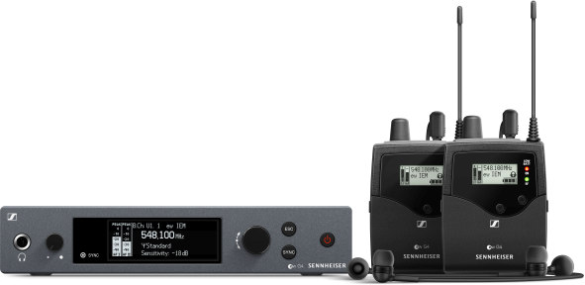

For the camera pro
Your upgrade to broadcast-quality sound: Throughout March, the evolution wireless ew 112-p G4 is available at EUR 499/USD 499.95 instead of EUR/USD 599. The UHF system consists of the SK 100 G4 bodypack transmitter with ME 2-II lavalier microphone and the EK 100 G4 portable camera receiver, complete with camera mount and output cables. The rugged wireless mic system has up to 8 hours of operating time and is a flexible solution for outdoor shoots and field recording.

Wireless camera audio: the ew 112-p G4 | 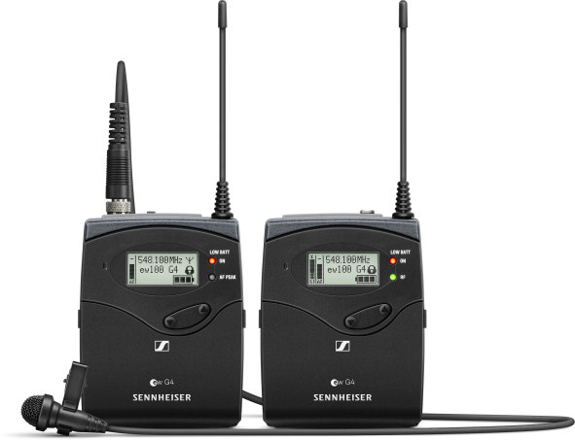

The images to accompany this press release can be downloaded at https://sennheiser-brandzone.com/c/181/6a5Jn498.

About Sennheiser
Founded in 1945, Sennheiser is celebrating its 75th anniversary this year. Shaping the future of audio and creating unique sound experiences for customers – this aim unites Sennheiser employees and partners worldwide. The independent family company, which is managed in the third generation by Dr. Andreas Sennheiser and Daniel Sennheiser, is today one of the world’s leading manufacturers of headphones, loudspeakers, microphones and wireless transmission systems. In 2018, the Sennheiser Group generated turnover totaling €710.7 million. www.sennheiser.com

Global Press Contact

Stephanie Schmidt
Stephanie.schmidt@sennheiser.com
+49 (5130) 600 – 1275

