Sennheiser @ ISE 2025



Sennheiser Keeps Focus on Global Partnerships and Alliances at ISE 2025
Attendees can once again experience an on booth interactive partner-focused touchscreen and partner-involved scavenger hunt during ISE’s largest show to date

Wedemark, Germany - January 28, 2025 – Sennheiser, the first choice for advanced audio technology that makes collaboration and learning easier, is excited to showcase its industry partnerships and alliances at Integrated Systems Europe (ISE) 2025 in Barcelona, Spain on February 4 - 6.

At this year’s ISE, the Business Communication Zone at Sennheiser booth 3B500 will showcase innovative solutions that redefine meeting, collaboration and learning spaces. Within the dedicated Partnerships and Alliances area, an interactive touchscreen invites visitors to explore the versatility of Sennheiser’s partnerships, uncovering how seamless integration, streamlined workflows, and intuitive control enhance professional environments.

While exploring the show floor, integrators, consultants, and end-users can experience the full potential of Sennheiser products through its collaborations with global partners and alliances. Sennheiser products will be featured on 18 partner booths, including Airtame, Barco, Datavideo, Heckler, Lightware, Lumens, MAXHUB, Q-SYS, Xilica, and more. Additionally, 28 partners are joining Sennheiser’s in-show campaign, the Perfect Pair scavenger hunt, which highlights the benefits of combined solutions through an engaging and interactive experience.

Sennheiser + Partners and Alliances = The Perfect Pair
Sennheiser has teamed up with its partners to bring exciting rewards and interactive experiences to ISE25 attendees. At the heart of this collaboration is the Sennheiser ISE25 Perfect Pair Scavenger Hunt, an app-led activity that takes participants on a journey across Sennheiser and partner booths.

Attendees can explore these booths to complete challenges—such as scanning QR codes, tackling photo and video tasks, and joining live demonstrations—all while accumulating points to boost their chances of winning fantastic prizes. Along the way, participants will also receive exclusive Sennheiser-branded socks as a reward.

Visitors to ISE can join in the scavenger hunt by completing the following steps:
- Download the Scavify app from the Apple App Store or Google Play.
- Search for ISE25 and join the hunt.
- Complete tasks at their own pace to accumulate points and increase their chances of winning.

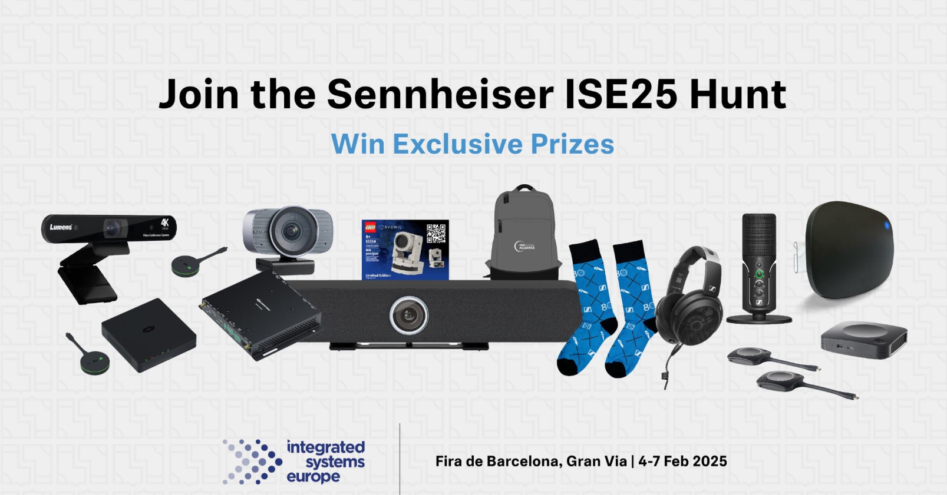

With numerous prizes to be won, the Sennheiser ISE25 Perfect Pair Scavenger Hunt provides a dynamic and rewarding way for attendees to discover how Sennheiser and its partners deliver cutting-edge AV solutions for collaboration and learning.

Stay Tuned for More
Be on the lookout for exciting news from Sennheiser and its partners at ISE 2025 and in the weeks that follow. Sennheiser continues to expand and strengthen its partnerships and alliances to drive innovation and simplify the integration of its solutions into collaboration and learning spaces. Partners such as Audinate and TeamMate—who will be showcasing the TeamConnect Bar with their new Active Learning Terminal—Wall-SMART, Valens, and Avonic will join Sennheiser in announcing innovative new collaborations.

More information about Sennheiser’s partner and alliance activity at ISE can be found here.

About the Sennheiser brand
We live and breathe audio. We are driven by the passion to create audio solutions that make a difference. Building the future of audio and bringing remarkable sound experiences to our customers – this is what the Sennheiser brand has represented for more than 75 years. While professional audio solutions such as microphones, meeting solutions, streaming technologies and monitoring systems are part of the business of Sennheiser electronic GmbH & Co. KG, the business with consumer devices such as headphones, soundbars and speech-enhanced hearables is operated by Sonova Holding AG under the license of Sennheiser.

www.sennheiser.com
www.sennheiser-hearing.com

Global Press Contact
Jeff Horan
+1 860-598-7539
jeffrey.horan@sennheiser.com

