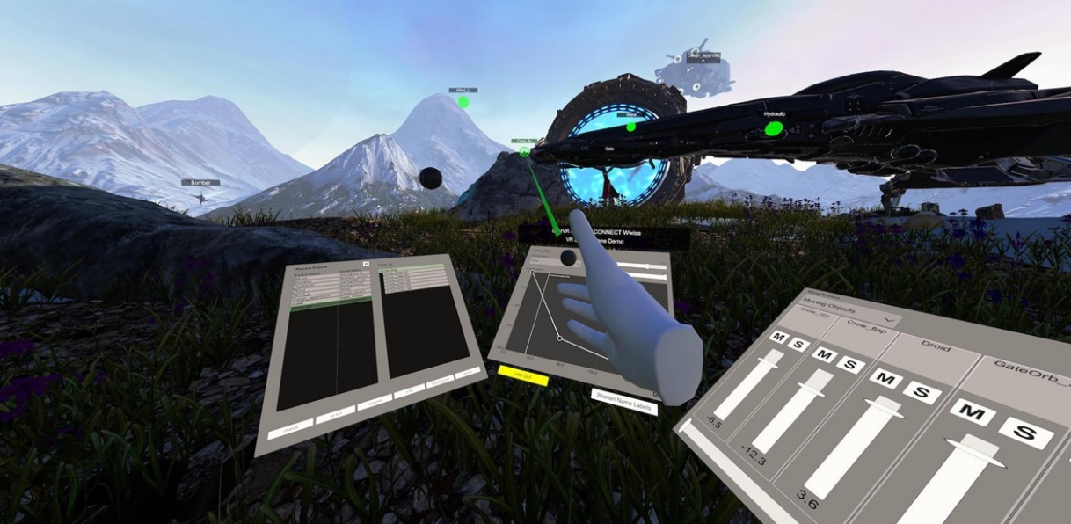
(Screenshot of Dear Reality demo footage)

The future of game audio mixing is in-headset
Dear Reality announces SPATIAL CONNECT for Wwise® – The next level of interactive XR audio production

Düsseldorf, Germany, July 3, 2023 – Immersive audio expert Dear Reality has announced its “SPATIAL CONNECT for Wwise” project, which will enable game audio designers to work fully immersed in interactive VR and AR audio productions. This in-game, in-headset mixing workflow was developed in close collaboration with game studios and with technical support from Audiokinetic, manufacturer of the Wwise audio middleware. SPATIAL CONNECT for Wwise will massively improve the workflow for next-generation XR productions, providing a revolutionary in-headset control of Wwise sessions.

Audio production for VR and AR games or XR experiences can be tiresome, as today’s workflow requires audio designers to switch between previewing their work with a VR headset and making changes on a desktop PC. With SPATIAL CONNECT for Wwise, game audio engineers can mix directly in the headset, reducing context switching and enabling them to work intuitively on spatial audio in the immersive environment itself. The project is technically supported by Audiokinetic, whose development team added certain features in their Wwise audio middleware that allowed for that new workflow. Watch a demo video here.

“Dear Reality’s SPATIAL CONNECT for Wwise is a game changer when mixing immersive audio for XR projects,” says Christian Sander, CEO and co-founder of Dear Reality. “Eliminating the tiresome and time-consuming switching between the in-headset review of the VR experience and the Wwise editing process on a desktop screen is a dream come true for game audio designers.”

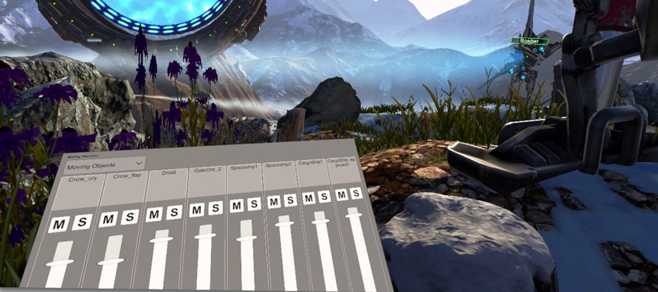 | Game audio designers will have direct in-headset access to the Wwise mixers, including the ability to solo and mute  (Screenshot of Dear Reality demo footage)

Dear Reality started out with a comprehensive analysis of existing production workflows and carefully selected the steps that were to be transferred to the virtual space. Here, gesture-controlled audio mixing offers an enhanced perception of the scene and enables game audio designers to handle the 3D space more intuitively by working in context. Audio designers can control levels, attenuation curves as well as maximum distances and are immediately able to perceive the final user experience and spatial mix.

SPATIAL CONNECT for Wwise enables comprehensive insights into the spatial audio session  (Screenshot of Dear Reality demo footage) | 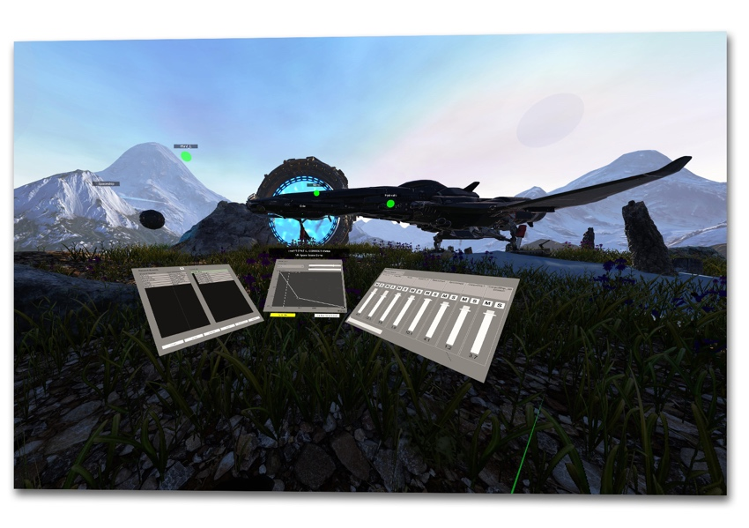

SPATIAL CONNECT for Wwise also allows game audio engineers to spot hard-to-find problematic sounds and understand the spatial audio session in the game by visualizing the location of active sound events directly in the VR headset and providing the means to intuitively modify the most critical audio parameters.

“We are very excited about the SPATIAL CONNECT for Wwise project and will soon be sharing more updates on the project,” concludes Sander. “We also welcome new collaborations within the gaming and XR industries.”

Join the Priority List
If you’re interested in updates on the project, join the priority list at https://www.dear-reality.com/wwise to stay tuned. You can obtain more background information in this blog article.

(Ends)

Wwise is a trademark of Audiokinetic Inc., registered in the U.S. and other countries.

The images accompanying this media release can be downloaded here.

About Dear Reality
Dear Reality is a leading company in the field of immersive audio controllers and best known for its binaural, Ambisonics, and multichannel encoders spatializers with totally realistic room virtualization. Sound engineers, sound designers, broadcasters, and musicians use the company’s products worldwide. Founded in 2014 by Achim Fell and Christian Sander, Dear Reality strives to deliver high-quality, cutting-edge 3D audio software for interactive and linear audio production. Since 2019, Dear Reality has been proud to be a part of the Sennheiser Group.

Global Press Contact

Kai Detlefsen
press@dear-reality.com

