Neumann introduces the V 402 Preamp

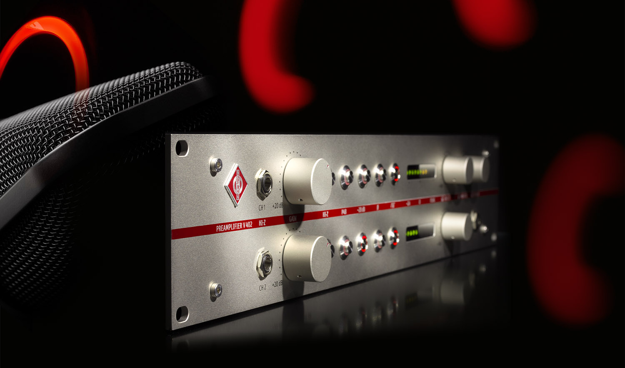

Berlin, July 2, 2020 – German studio specialist Neumann.Berlin introduces the V 402,
a state-of-the-art microphone preamplifier with integrated headphone monitoring. The V 402 is Neumann’s first-ever stand-alone microphone preamp – although the company has created several generations of top-quality preamp modules for its mixing consoles, such as the now legendary V 476 B of the 1980s. Like its predecessors, the V 402 preamplifier is conceived as the perfect complement to all Neumann and other high-class studio microphones.

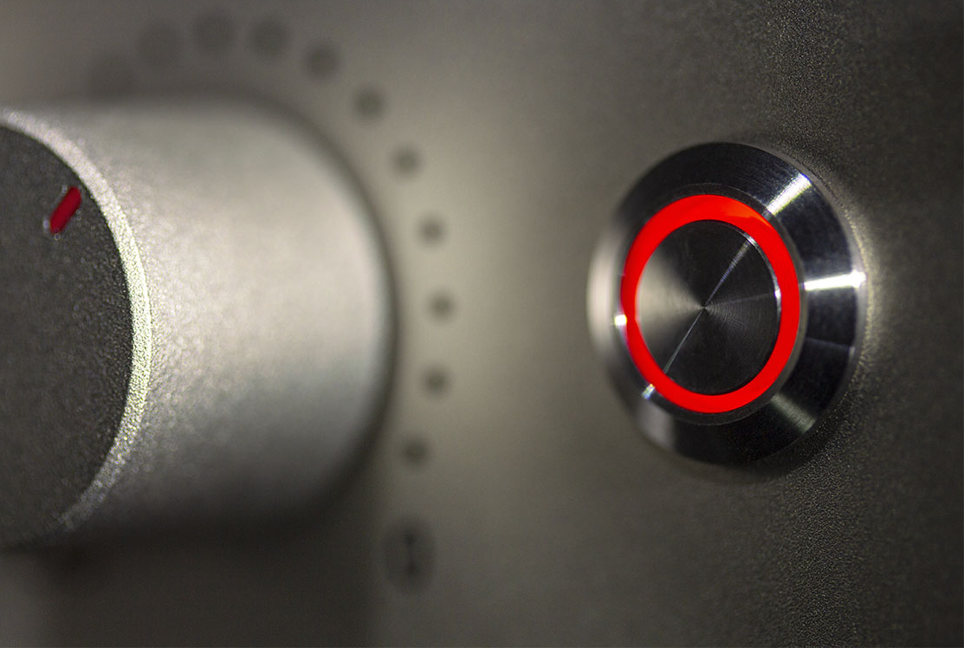
“All Neumann microphones, classics as well as current models, have highly unique sound characteristics”, explains Ralf Oehl, the Berlin company's new CEO. “Finding a preamplifier with the matching uncompromised sound fidelity wasn't always easy – until now! The V 402 provides the ideal signal path for all Neumann microphones because it is free from any coloration whatsoever. No artificial additives could make the sound of a Neumann U 47 or U 87 more desirable than it already is. Perfection cannot be perfected!”

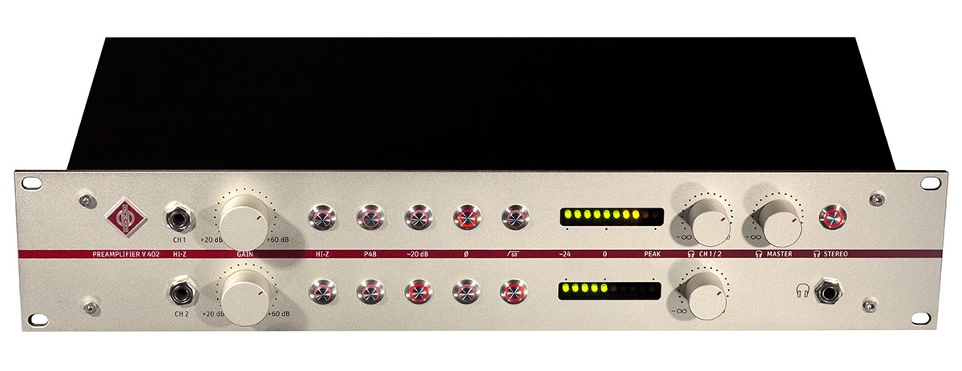
The V 402 is a dual channel microphone preamplifier carefully designed to maintain the sonic integrity of the original signal. Its unique transformerless circuitry amplifies the microphone signal without unwanted coloration or sonic artifacts, such as noise and distortion. While this is also often claimed for simple preamps such as those in audio interfaces, the V 402 is built to much higher standards.

“It took an elaborate development process with extensive series of measurements and critical listening tests to create a preamplifier worthy of the Neumann name,” comments Portfolio Manager Sebastian Schmitz. “And we’ve included the monitoring side, too. The V 402 establishes a fully transparent signal chain extending from the microphone all the way to the engineer’s ear. Finding the best microphone position has never been easier.”
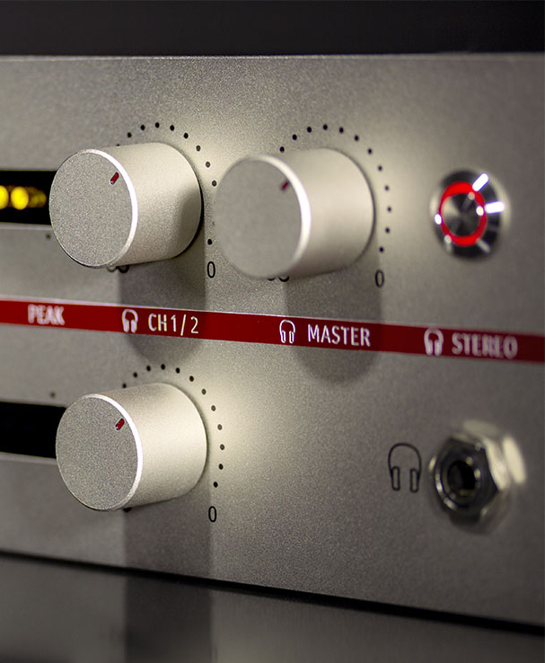
The V 402 is equipped with a studio grade headphone amplifier ensuring uncompromised monitoring quality at the recording stage. Independent volume controls for each channel allow to dial in a latency-free monitoring mix without affecting the recorded signal.

Handmade in Germany with Meticulous Attention to Detail
As a true Neumann product, the V 402 is characterized by exacting attention to every detail. For example, the DI input is also designed for sonic purity. Its novel high-impedance input stage captures the sound of electric guitars and basses as well as other instruments with no loss of detail and free from audible noise.

Its switchable high pass removes rumble and pops very effectively without signal degradation.
A 20-dB pad allows the V 402 to be used with high-level sources up to 28 dBu without distortion.

The V 402 comes in a 2U 19” rack enclosure measuring 89 mm x 483 mm x 242 mm.

Delivery starts in July 2020; the MSRP is € 2.749,00 EUR.

Features:
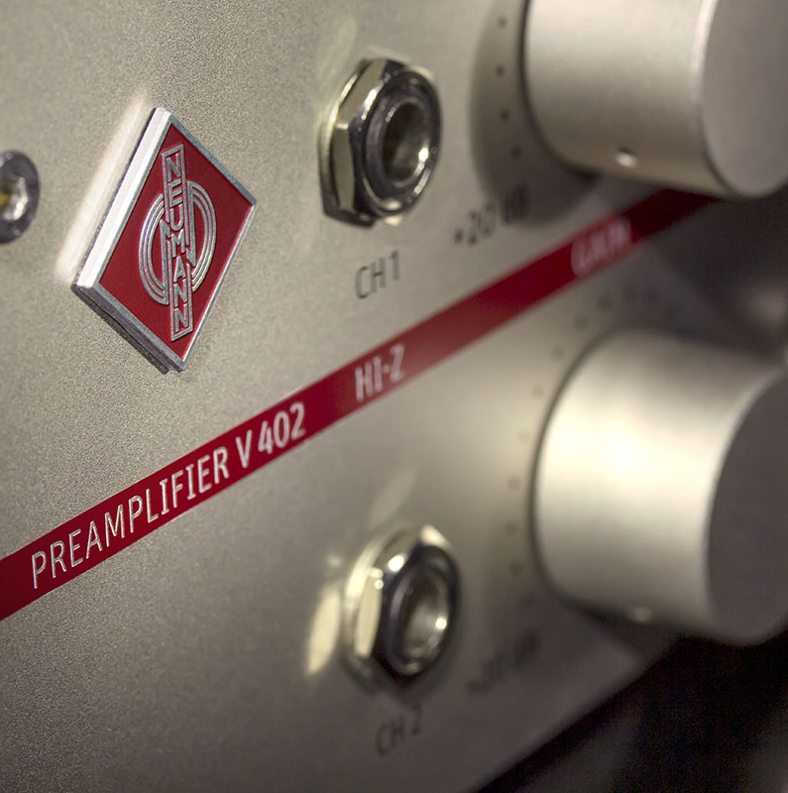
- Dual-channel state-of-the-art transformerless microphone preamp
- Two studio quality instrument inputs with very high impedance
- Switchable low cut removes rumble without signal degradation
- Exceptionally clean headphone amplifier
- Easy monitoring mix with volume control for each channel
- Handmade in Germany

Further product information at:
https://en-de.neumann.com/v-402

Link to photo and text material:
https://www.neumann.com/exchange/Neumann-V402.zip

About Neumann
Georg Neumann GmbH, known as “Neumann.Berlin”, is the world’s leading manufacturer of studio microphones and the creator of recording legends including the U 47, M 49, U 67 and U 87. Founded in 1928, the company has been recognized with numerous international awards for its technological innovations. Since 2010, Neumann.Berlin has expanded its expertise in electro-acoustic transducer design to also include the studio monitor market, mainly targeting TV and radio broadcasting, recording, and audio productions. The first Neumann studio headphone was introduced at the beginning of 2019. Georg Neumann GmbH has been part of the Sennheiser Group since 1991, and is represented worldwide by the Sennheiser network of subsidiaries and long-standing trading partners. www.neumann.com.

Press contact:
Andreas Sablotny
andreas.sablotny@neumann.com
T +49 (030) 417724-19

