HERE COMES CELLULARLINE’S WIRELESS ENERGY CHARGE

UNDER EMBARGO UNTIL 06 SEPT 9 AM
Cellularline S.p.A., the European leading company in the development and sales of accessories for smartphones and tablets, showcases at IFA 2019 (September 6-11) a brand new super technological line od products dedicated to wireless charge.

The new WIRELESS FAST CHARGER devices present two distinctive features: a new packaging and a new internal technology to give your smartphone an even faster and more efficient charge!
Provided with WIDEACTIVE INSIDE™ technology, the wireless fast chargers ensure a continuous and homogenous charge on the recharging surface. The Qi certification logo displayed on all three of the products, guarantees a reliable and efficient recharge.

WIRELESS FAST CHARGER PAD
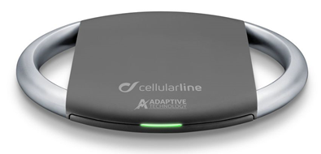
The new portable wireless fast charger pad, with a minimal design, guarantees maximum power. The led light signals the activation of the recharge whereas the device is able to indicate whether the Wireless Fast Charger Option is being employed. The adaptive charger and USB-C cable are included in the package.
Price: 49,95 €
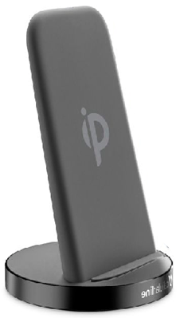
WIRELESS FAST CHARGER STAND
The new wireless charger, with an innovative design with soft touch is practical and handy and it allows to charge quickly all the devices compatible with Qi wireless charge. Equipped with WIDEACTIVE™ INSIDE technology, it enables to recharge your smartphone by placing it in any way you can. The adaptive charger and USB-C cable are included in the package
Price: 59,95 €

WIRELESS FAST CHARGER DUAL
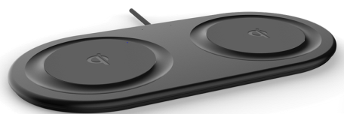
Wireless Fast Charger Dual provides double charge for the simultaneous wireless recharge of two devices. The Qi certification guarantees a reliable and efficient charge, whilst the WIDEACTIVE INSIDE technology provides your smartphone with an homogenous recharge. The adaptive charger and USB-C cable are included in the package
Price: 69,95 €

UNDER EMBARGO UNTIL 06 SEPT 9 AM
The OCTOPUS LINE is the absolute novelty in the wireless charge industry. A fresh new design features two products that, just like an octopus, securely attach to smartphones thanks to their small delicate suction cups. The Qi certification logo, well displayed on both products, guarantees an efficient and reliable wireless charge.
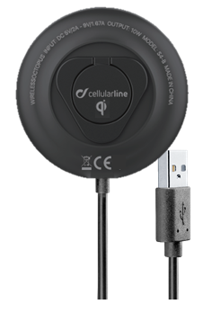
WIRELESS OCTOPUS
A brand new charger is ready to be discovered. Its suction cups, designed to perfectly adhere to the smartphone together with its ring, which serves as stand, guarantee a firm grip to the users, so that you can always bring your charging device along safely. The same elements can become a solid base if you need to work with your smartphone while travelling or working at your desk. Wireless Octopus enables to charge the devices at any moment without wires, even when you’re playing video games or watching your favorite TV show.
Price: 24,95 €
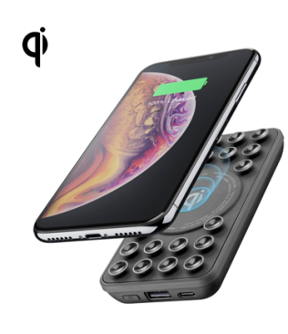

POWERTANK WIRELESS OCTOPUS

New, safe and handy: the Powertank Wireless Octopus is the perfect discreet accessory to bring anywhere in order to have your smartphone always loaded. Provided with a suction cup holder, the Powertank guarantees a full adherence to your smartphone’s surface, allowing a safe use and avoiding any risk of falling.
Price: 29,95 €

About Cellularline S.p.A.
Cellularline S.p.A. is the leading company in the accessories’ market for smartphone and tablet. Cellularline brand is the technological and creative landmark concerning the accessories for multimedia devices and aims to offer excellent performances and easy-to-use products for a unique user’s experience. Currently, Cellularline S.p.A. counts about 200 employees and boasts an intercontinental distribution in over 60 countries.

INTERNATIONAL PRESS CONTACTS: SAY WHAT? Srl (Milan, Italy)
Geraldina Soldadino, Senior Account Manager Media Relations: g.soldadino.cons@saywhat.it, Mob. + 39 388 3938334
Letizia Castiello, Junior Account Media Relations: l.castiello@saywhat.it, Tel. +39 02 3191181

PRESS CONTACTS BELGIUM: EVOKE (Etterbeek, Belgium)
Gilles Dujardin, PR Consultant : gilles@evokepr.be, Mob. +32 474 818 999
Ymke Deprez, PR Consultant : ymke@evokepr.be, Mob. +32 479 75 52 32

