RME to Demo Class-Leading Dante-Enabled Solutions at Trew Audio in Los Angeles
on April 19th
The company will demo its new Digiface Dante alongside the Ferrofish A32 Dante and PULSE 16 DX

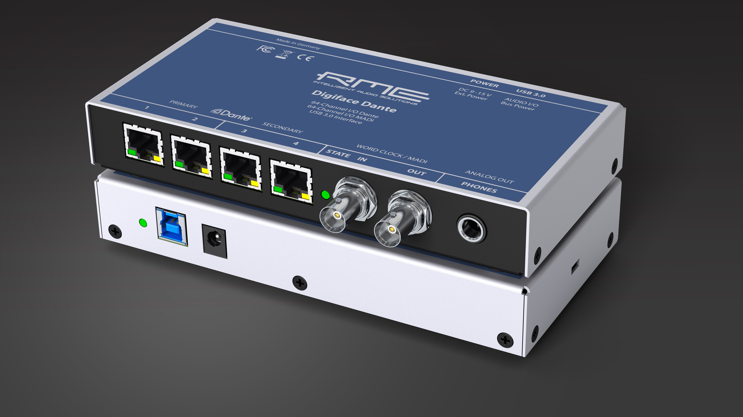
Burbank, CA – April 18, 2017 – Premier German interface manufacturer RME has announced that it will demo its brand new Digiface Dante interface alongside the new Ferrofish A32 Dante and the Ferrofish PULSE 16 DX at Trew Audio in Burbank, California, on April 19th at 10 am PST.
The demos — which will be hosted by RME Director of Sales Derek Badala — will showcase RME’s focus on Dante network connectivity and highlight the company’s best-in-class conversion solutions.

“We are excited to showcase these new Dante solutions at Trew Audio,” Badala said. “RME and Ferrofish have always been on the forefront of the industry’s needs, and Dante is the next generation of audio connectivity. We look forward to a productive learning session as we explore these innovative products together.”

Fresh off its debut at this month’s NAB and Musikmesse shows, the Digiface Dante is a 256-channel, 192 kHz USB audio interface that combines a lightweight design with Dante network connectivity and supports AES67. The BNC connections provide Word Clock I/O and can be switched to work with MADI, allowing for MADI and Dante to be used together, and the unit to work as a simple bidirectional format converter in standalone mode.
With its Dante networking capability and support for MADI and ADAT formats, the Ferrofish A32 Dante excels in professional broadcast environments, complex AV installations and live sound productions. Its intelligent design enables users to eliminate the masses of cables often associated with large sound installations by leveraging uncompressed, multi-channel digital media networking technology with near-zero latency and synchronization.
The new PULSE 16 DX is the latest addition to Ferrofish’s PULSE family of converters. The PULSE 16 DX is a 16-channel, AD/DA converter with Dante compatibility.
For more information on RME, visit http://www.rme-usa.com/
For more information on Ferrofish, visit https://ferrofish.com/en/

About Synthax, Incorporated
Synthax Inc. is the exclusive USA distributor for RME digital audio solutions, Ferrofish advanced audio applications, myMix audio products, and ALVA cableware. We supply a nationwide network of dealers with these products for professional audio, broadcast, music industry, commercial audio, theater, military and government applications. For additional information, visit the company online at http://www.synthax.com.
Media Contacts:
Katie Kailus
Public Relations
Hummingbird Media
+1 (630) 319-5226
katie@hummingbirdmedia.com

Jeff Touzeau
Public Relations
Hummingbird Media
+1 (914) 602 2913
jeff@hummingbirdmedia.com

