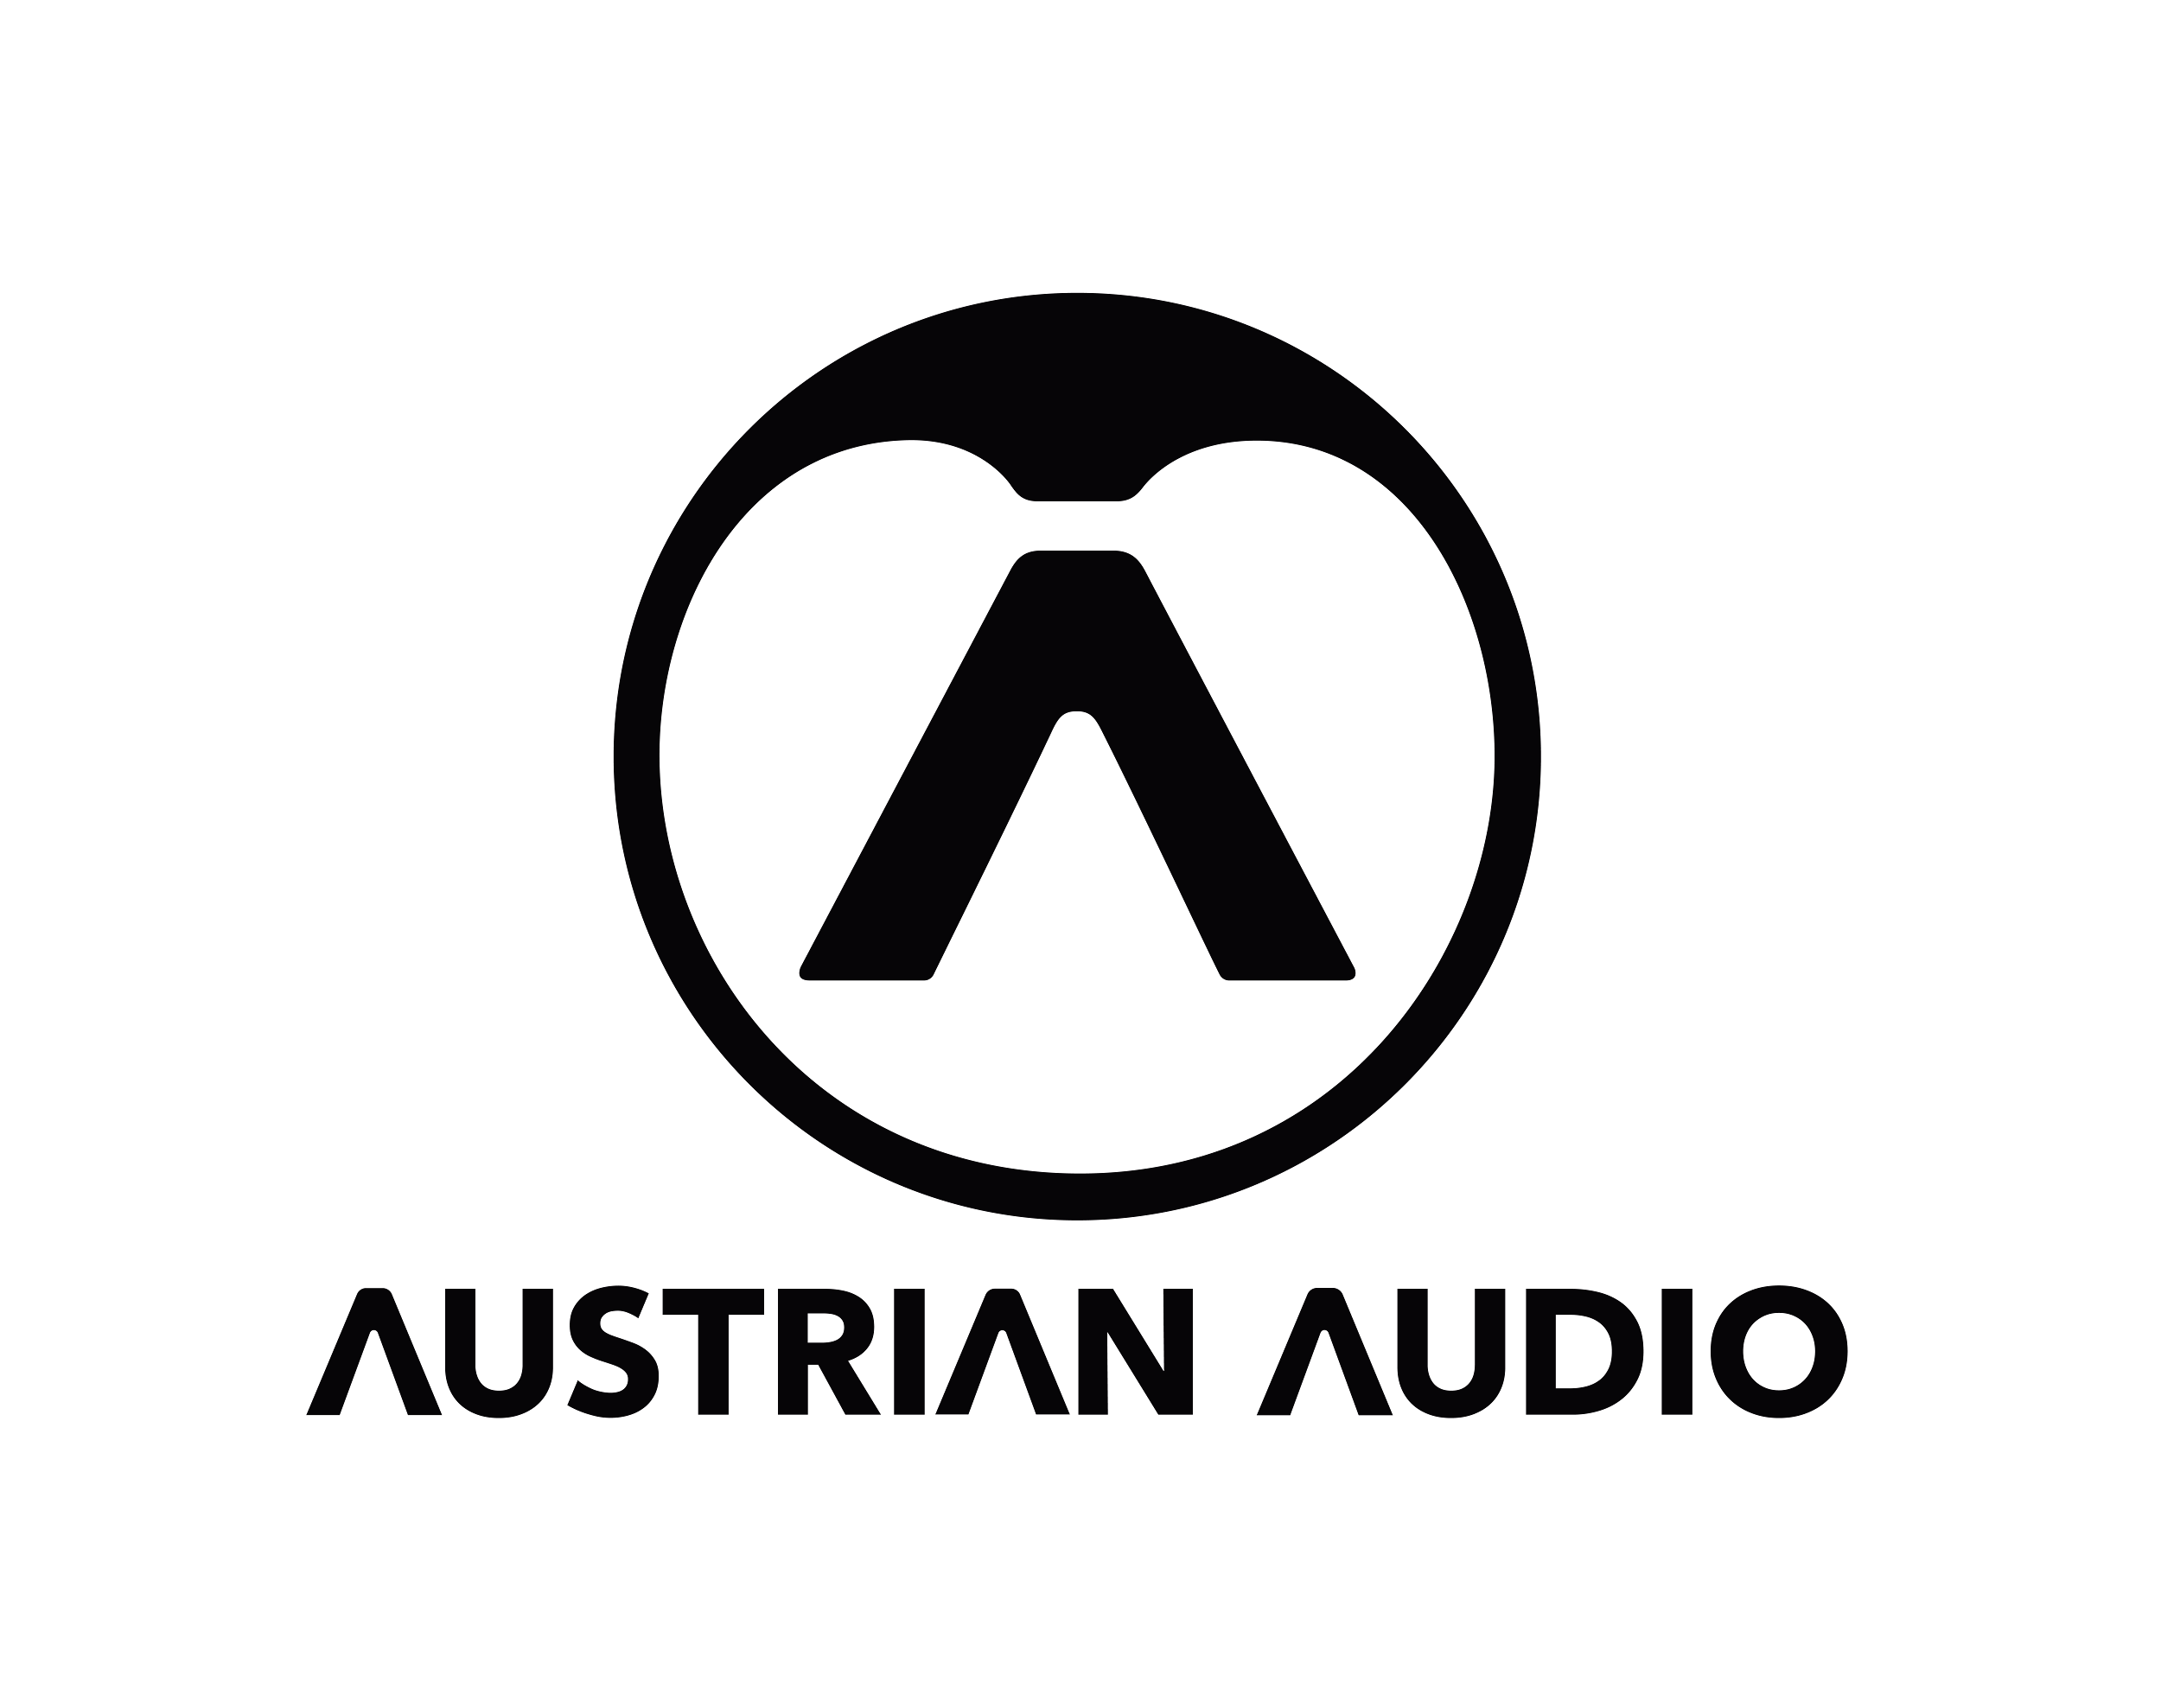

**Beauty and Freedom - Lisa Bella Donna Incorporates Found Sound Into *Hysteresis* with The Austrian Audio MiCreator Studio***Acclaimed composer and synthesist chases natural inspiration and evocative watery soundscapes*

**APPALACHIAN MOUNTAINS, USA, September 24, 2024 —** [**Lisa Bella Donna**](https://en.wikipedia.org/wiki/Lisa_Bella_Donna) **is one of the most visible and prolific figures in the world of synthesizer-based composition working today. Across dozens of full length releases, she has explored a vast array of evocative sonic landscapes created with a unique combination of intuitive modular composition techniques and natural found sounds. Her latest release,** [***Hysteresis***](https://lisabelladonna.bandcamp.com/album/hysteresis)**, dives even deeper into these possibilities across a diverse quartet of compositions that range from the gently hypnotic chimes of Gardens of Windfall to the pulsing rollercoaster of the title track. A key component in the creation of *Hysteresis* was the natural inspiration provided by Bella Donna’s home in Appalachia, which she incorporated through purposeful field recording. One of her favored microphones for capturing these natural sounds in-the-moment was the Austrian Audio MiCreator Studio.**

**An ever-evolving methodology**Nature plays an important role in Bella Donna’s musical sensibility. Describing the experience as ‘musical synesthesia’, she draws inspiration for her compositions from the layered combination of sounds that naturally evolve in a given landscape. “When I see a landscape or hear a specific unique combination of natural sounds, I absorb it compositionally,” she explains. “There’s a real beauty and freedom to this that relates to how I work with larger modular synthesizer systems. It’s an evolving method that’s happening in the moment which inspires me to creatively develop a series of details to create an involving and enchanted environment for the listener.”

“My art is electronic music but the goal is to make it feel like it’s a natural, human experience. To sonically and musically hydrate listeners with change and development in sounds and provide an experience that feels participatory.”

Although Bella Donna’s modular systems and vintage synthesizers — including the ARP 2600, ARP String Ensemble, Moog Muse, a mammoth, custom Moog Modular system, and others — make up the instrumental core of *Hysteresis*, the field recorded elements contribute substantially to its sonic and emotional vibe. In keeping with her dedication to chasing spontaneous inspiration, many of these elements were captured on the fly during long excursions into her Appalachian surroundings. “Some of the sound design for this album was me galavanting around with these amazing microphones recording material around the mountains and rivers where I live,” she said. “Often I would post up somewhere for a long time to just sit and listen and I needed reliable, portable gear to take with me on these excursions.”

“The Austrian Audio MiCreator Studio mics were the only ones I used for recording those sounds.”

**A natural arrangement masterclass**A recurring sonic element of *Hysteresis* is water, from gentle drops that blur the lines between real and synthesized sounds to the unmistakable rushing of streams and rivers. Bella Donna spent hours at various sections of the Muskingum, Toccoa, & Elk Rivers with MiCreator Studio and her tape recorders to capture a library of inspiration that she later blended into her compositions to enhance their emotional qualities.

“The water sounds were another instrument on *Hysteresis* and a lot of care went into capturing those sounds,” she explains. “I was really encouraged by having the flexibility of a fantastic sounding microphone like MiCreator Studio that I could just plug into my iPad and go — knowing I’d come back with amazing stereo recordings.”

“It’s so important to my process to be able to get my ideas down immediately and having a remarkable and reliable device like this to do that makes it possible to be creative without any hesitation or resistance.”

The flexibility of MiCreator Studio encouraged Bella Donna to get creative with how she captured different sounds. In addition to close miking various sections of the river, she also experimented with wide stereo captures that included the MiCreator Satellite microphone as well. “I would set up MiCreator Studio and MiCreator Satellite in stereo at different ends of intersecting streams to capture sounds with a high resonance possibility. I could then take that sound, slow it down to half speed on the reel to reel, and hear it in a different way. It was a beautiful way to bend and weave the sound into the synthesized elements for a cinematic effect.”

“It really is one of the best arrangement masterclasses you can take — going out into nature and just listening for a long time and how the sound around you develops and soon orchestrates within its environment. It’s a beautiful way to educate yourself about sound arrangement and that was a big part of my process for this album and many others.”

Never one to rest on her laurels, Bella Donna is already hard at work on her next set of compositions. Continually inspired by her surroundings and the tools she uses to bring them into her compositional world, she’s always looking for the next creative inspiration. “I’m always listening for the next idea and looking for ways to extrapolate it in whatever sonic environment I’m using at the moment,” she says. “It comes from decades of being a live musician — you gotta stay creative and always be finding new ways to translate your musical intentions to your listeners.”

“I really love the inclusion of adventure within my compositions and keeping that spontaneous, natural element in my work. MiCreator Studio has become a very fun, effective, and reliable part of doing that.”

*Hysteresis* is available now on Lisa Bella Donna’s Bandcamp and all streaming platforms. For more information, please visit: <https://lisabelladonna.bandcamp.com/>

For more information about the Austrian Audio MiCreator Studio, please visit: <https://austrian.audio/micreator/>

**About Austrian Audio**

Austrian Audio opened its doors in 2017 following the closure of the AKG offices in Vienna and set out to create something new, challenging, and respectful to its heritage. The new company started with a core team of previous AKG personnel from management, acoustics, electronics, test and measurement, mechanical design, RF/wireless, and software/firmware, bringing 350 years of cumulative engineering experience to the new company.

For more information, visit [austrian.audio](https://austrian.audio/).