SENNHEISER PARTNERS WITH PODCAST INDUSTRY LEADER STITCHER
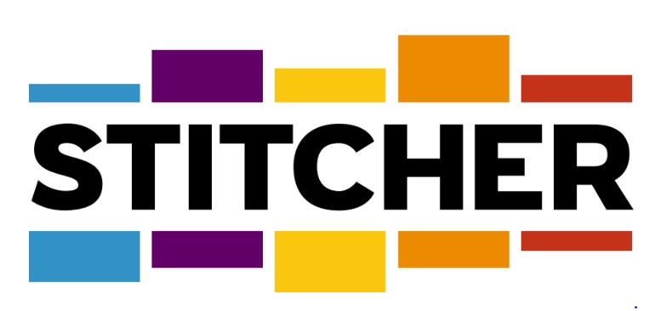
As official headphone brand of top podcasting platform, Sennheiser to outfit Stitcher’s New York and Los Angeles podcasting studios with category leading technology
New York, November 28, 2018 – Sennheiser announced it has partnered with Stitcher, an industry leader in podcast content creation, distribution and advertising. The partnership demonstrates Sennheiser’s ongoing commitment to emerging media platforms such as podcasting, which has become a ubiquitous form of information and entertainment for consumers around the world.

As a result of the partnership, Sennheiser will become the official headphone brand of Stitcher. Not only will Stitcher’s new, state of the art podcasting studios in Los Angeles and New York City have Sennheiser headphones in every room, but the studios will also be equipped with a selection of the latest in microphone, wireless and headphone technologies from Sennheiser. As the podcasting market continues to experience exponential year over year growth, the new partnership will strengthen Stitcher’s capability to create highly engaging content with the best possible audio quality.

“Podcasts are now a primary medium for content consumption and this is a trend that will continue to grow,” commented Greg Beebe, Director, Professional Audio, Sennheiser. “In this form of media, as in many others, the value and enjoyment depends on the quality of the audio — both during content creation and media consumption. At Sennheiser we want to deliver the best possible audio experience to customers therefore we are thrilled to be partnering with one of the leaders in content production in this space.”

According to Edison Research, podcasts’ share of total audio consumption has doubled over the last four years. Further, recent research from IAB and PwC states that advertising spending on podcasts has also increased 86 percent year over year. Stitcher is the parent company of Midroll — the leading podcast advertising network representing over 200 of the world’s largest podcasts.

Great content without compromise
In addition to becoming the official headphone brand of Stitcher, Sennheiser has furnished Stitcher’s world-class New York and Los Angeles-based podcasting facilities with its industry-standard HD 280 Pro professional monitoring headphones and a selection of its evolution series microphones and wireless systems.

Stitcher’s newly designed facility in New York includes three studios, two edit rooms, two ISO booths capable of accommodating a variety of show formats, from 6-8 participant discussions to one-on-one interviews and solo program recording sessions. The studios are also designed for live music and video recording, and feature floating floors for soundproofing across individual studios.

“Making great podcasts starts with having the best equipment available to our hosts and engineers,” said Chris Bannon, Stitcher’s chief content officer. “I'm delighted that we can offer them Sennheiser's latest and best audio tech, and I know our millions of Stitcher and Earwolf fans will love what they hear.”

For more information on podcasting and how to get started, please visit Sennheiser’s website at https://en-de.sennheiser.com/how-to-podcast, where you can find videos and a dedicated podcast guide.

Please visit www.sennheiser.com for more information.

About Sennheiser
Shaping the future of audio and creating unique sound experiences for customers – this aim unites Sennheiser employees and partners worldwide. Founded in 1945, Sennheiser is one of the world’s leading manufacturers of headphones, microphones and wireless transmission systems. With 21 sales subsidiaries and long-established trading partners, the company is active in more than 50 countries and operates its own production facilities in Germany, Ireland, Romania and the USA. Since 2013, Sennheiser has been managed by Daniel Sennheiser and Dr. Andreas Sennheiser, the third generation of the family to run the company. In 2017, the Sennheiser Group generated turnover totaling €667.7 million. www.sennheiser.com

About Stitcher
Stitcher is the best place to listen to, produce and monetize podcasts. The Stitcher app, available for iOS and Android devices, is one of the world’s most popular podcast listening platforms, with a growing network of original content and a premium subscription service. Stitcher is the parent company of Midroll Media, the leading podcast advertising network representing over 200 of the world’s largest podcasts, and top-ranked comedy podcast network Earwolf. With offices in Los Angeles, New York City and San Francisco, Stitcher was founded in 2007 and is a wholly owned subsidiary of The E.W. Scripps Company (NASDAQ: SSP).

Local Contact Global Contact

Jeff Touzeau Stephanie Schmidt
jeff@hummingbirdmedia.com stephanie.schmidt@sennheiser.com
+1 (914) 602-2913 +49 (5130) 600 – 1275

