Synthax Names Cassandra McNulty Marketing Manager, Americas
McNulty brings 14 years of marketing experience to the role and will focus efforts on
expanding the Synthax portfolio into new markets

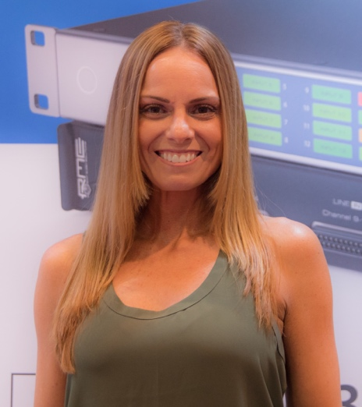
Fort Lauderdale, FL – June 26, 2018 – Synthax, distributor of best-in-class audio solution manufacturers RME, Ferrofish and myMix, has appointed Cassandra McNulty to the role of Marketing Manager, effective immediately. McNulty brings 14 years of experience in marketing to the new position and will report directly to Mathias Von Heydekampf, Managing Director of Synthax.
In her new role, McNulty will focus on building brand awareness and growth for the Synthax portfolio of brands, which include RME, Ferrofish and myMix. Prior to her appointment at Synthax, she served as Marketing, Communications and Business Development Manager at Cannery Casino and Hotel in Las Vegas where she helped develop and monitor digital marketing strategies and social media campaigns.
“I am very excited to join the Synthax team,” McNulty said. “With compelling, best-of-breed brands under the Synthax umbrella, I’m looking forward to helping showcase these companies and what they have to offer to a broader audience. I’m excited to use my background in digital strategy to help us achieve desired growth in multiple areas.”
“We are very excited to have Cassandra join our team in this newly created position,” said Mathias von Heydekampf, managing director of Synthax. “Her many years of experience coupled with her enthusiasm and drive will help play a key role in our strategy to continue Synthax’s growth and increased awareness of its diverse and innovative portfolio.”
New Market Initiatives
With high-end, digital audio offerings from RME, premium conversion solutions from Ferrofish and best-in-class personal monitoring and mixing from myMix, McNulty believes Synthax’s brands can fill needs in a variety of markets and plans to begin executing social media campaigns and webinars to help spread the word about the brands’ offerings.
“Coming from the casino world, this is a blank canvas for me,” McNulty said. “I’m very excited to navigate this ship in new directions and show other industries how RME, Ferrofish and myMix can fill their needs.”
For more on Synthax, visit http://www.synthax.com.

About Synthax, Incorporated
Synthax Inc. is the exclusive USA distributor for RME digital audio solutions, Ferrofish advanced audio applications, myMix audio products, and ALVA cableware. We supply a nationwide network of dealers with these products for professional audio, broadcast, music industry, commercial audio, theater, military and government applications. For additional information, visit the company online at http://www.synthax.com.
Media Contacts:
Katie Kailus
Public Relations
Hummingbird Media
+1 (630) 319-5226
katie@hummingbirdmedia.com

Jeff Touzeau
Public Relations
Hummingbird Media
+1 (914) 602 2913
jeff@hummingbirdmedia.com

