MA 1 – The First Automatic Monitor Alignment from Neumann
Jointly Developed with Fraunhofer IIS
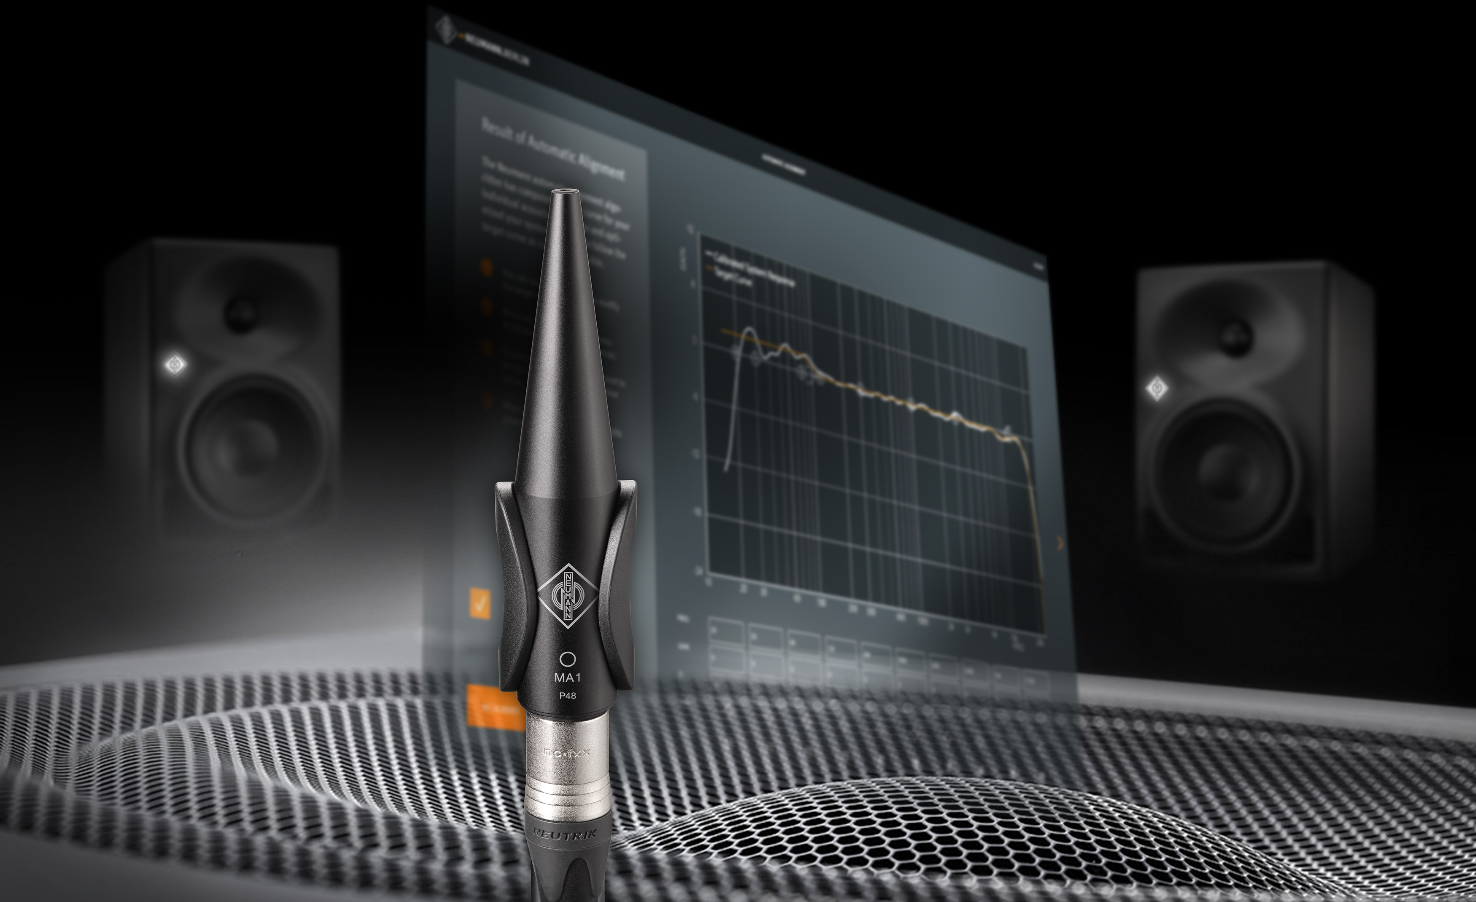

Marlow/UK, December 1, 2020 – German studio specialist Neumann.Berlin presents the MA 1, an integrated hard/software tool for acoustic calibration and room correction, tailor-made for Neumann studio monitors. Calibration algorithms, jointly developed with the world’s leading institute for audio signal processing, the Fraunhofer IIS, ensure best possible monitoring quality in any environment – from acoustically untreated bedroom studios to professional control rooms.

The system consists of an individually calibrated Neumann measurement microphone and the corresponding software for Mac and PC.

“The Neumann studio monitor portfolio is experiencing an enormous increase in demand; in some cases more than 60% compared to the previous year. According to user feedback, one of the main reasons is that our monitors have the highest acoustic consistency on the market; i.e. different models deliver identical mixing results in varying listening environments. This is of crucial importance, especially when different decentralized monitoring processes are involved. To further perfect this advantage for our customers, automatic room correction is the next logical step,” explains Ralf Oehl, CEO of Neumann.Berlin. “Together with our partner, the Fraunhofer Institute for Integrated Circuits (IIS), we want to create our own absolute reference for room correction in studio monitors, regardless of whether it is for small home studios or large control rooms of the highest professional standards.”

Neumann’s Automatic Monitor Alignment is available for all DSP-controlled stereo systems of the KH line, i.e. currently the KH 80 DSP as well as the analog studio monitors KH 120, KH 310, and KH 420 in combination with the subwoofer KH 750 DSP.

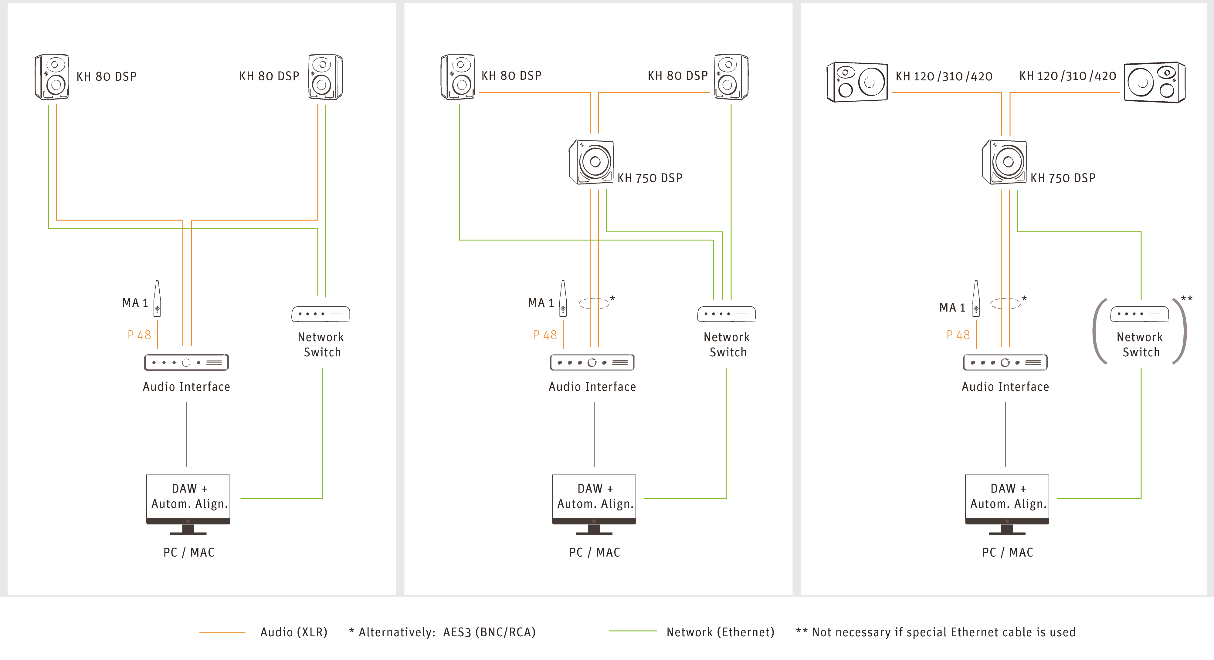

“It is an integrated system; all components are perfectly matched,” explains Portfolio Manager Markus Wolff. “This enables us to make much more accurate adjustments than third-party solutions, since only we have a deeper knowledge of all system-inherent parameters of our monitors and can take them into account accordingly. In addition, the Automatic Monitor Alignment uses novel calibration algorithms that generate a room-adaptive target curve and make precise adjustments to correct the respective acoustic problem. Depending on your preferences, the target curve can be further adjusted manually to meet individual requirements.”

Neumann’s Room Correction: A Simple Solution to Complex Problems

Neumann’s decades of experience in the calibration of studio monitoring systems has been incorporated into the software. Like a personal assistant, it guides the user step by step through the measurements and analyzes the respective listening environment; unnecessary “eye candy” has been deliberately omitted. The resulting correction data is stored and processed directly in the DSP-controlled monitors.

“This handling advantage is extremely important to us,” emphasizes Markus Wolff. “The user does not have to load a plug-in and deactivate it again for audio export, nor is potentially bug-ridden driver software required. After the alignment, the familiar workflow remains completely unaffected – except for the drastically improved sound!”

KH 80 DSP stereo pairs can be controlled directly by the software. All other – non-DSP-equipped – stereo pairs of the KH Line can be aligned by connecting them to the analog outputs of the KH 750 DSP subwoofer. Owners of KH 120, KH 310 and KH 420 monitors thus benefit not only from an extended bass response, but also from the room correction and – this is unique – the phase linearization of the analog speakers.

Ralf Oehl: “The Automatic Monitor Alignment MA 1 is the beginning of a new era in Neumann monitoring. The feedback from our test listeners has been very promising. Starting with a simple user interface and a focus on stereo systems we will, step by step, extend the user guidance and functionality with updates, based on our customers’ wishes. This will include an expansion to multichannel systems.”

The software contained in the MA 1 package is available for macOS and Windows 10. The MSRP of the MA 1 package including a high quality Neumann measuring microphone is
€ 249,00 EUR.

In addition, Neumann is offering attractive kits consisting of KH Line Monitors and the MA 1 package for the market launch:
- Monitor Alignment Kit 1 (1x KH 750 DSP + MA 1 package)
- Monitor Alignment Kit 2 (2x KH 80 DSP + MA 1 package)
- Monitor Alignment Kit 3 (2 x KH 80 DSP + 1x KH 750 DSP + MA 1 package)

Further product information at:
https://en-de.neumann.com/ma-1

Link to photo and text material:
https://www.neumann.com/exchange/Neumann-MA1.zip

About Neumann
Georg Neumann GmbH, known as “Neumann.Berlin”, is the world’s leading manufacturer of studio microphones and the creator of recording legends including the U 47, M 49, U 67 and U 87. Founded in 1928, the company has been recognized with numerous international awards for its technological innovations. Since 2010, Neumann.Berlin has expanded its expertise in electro-acoustic transducer design to also include the studio monitor market, mainly targeting TV and radio broadcasting, recording, and audio productions. The first Neumann studio headphone was introduced at the beginning of 2019. Georg Neumann GmbH has been part of the Sennheiser Group since 1991, and is represented worldwide by the Sennheiser network of subsidiaries and long-standing trading partners.

About Fraunhofer IIS
For over 30 years, the institute’s Audio and Media Technologies division has been shaping the globally deployed standards and technologies in the fields of audio and moving picture production. Starting with the creation of mp3 and continuing with the co-development of AAC and the Digital Cinema Initiative test plan, almost all consumer electronic devices, computers and mobile phones are equipped with systems and technologies from Erlangen today. Meanwhile, a new generation of best-in-class media technologies – such as MPEG-H Audio, xHE-AAC, EVS, LC3/LC3plus, Symphoria, Sonamic and upHear – is elevating the user experience to new heights. Always taking into account the demands of the market, Fraunhofer IIS develops technology that makes memorable moments.

Press contact Neumann:
Andreas Sablotny
andreas.sablotny@neumann.com
T +49 (030) 417724-19

Local Press Contacts

Sarah James Maik Robbe
sarahj@gasolinemedia.com maik.robbe@sennheiser.com
+44 (0) 1483 223333 +44 (0) 7393 462484

