Media Contact
Hannah Gornto
BRAVE Public Relations
404.233.3993
hgornto@emailbrave.com

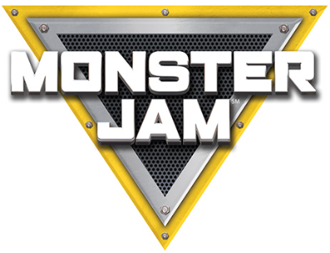

*MEDIA ADVISORY*

Monster Jam to host Revved Up for Reading event at Washington Park library branch
A Monster Jam driver will make a special visit to local library to read to children

WHAT: As part of Monster Jam’s Revved Up for Reading program, Monster Jam will visit the Washington Park library branch to read to children and give them a special interaction with Monster Jam driver Bryce Kenny.

Monster Jam has partnered with Atlanta area libraries on a reading program that is easy and fun for kids to participate in and gives them the opportunity to earn a free ticket to the show of their choice. This engaging reading program encourages children to not only read, but also to discover, dream and learn.

WHERE/ Washington Park Branch
WHEN: 1116 Martin Luther King Jr. Dr., SW
Atlanta, GA 30314

Thursday, Feb. 20
3:30 p.m.

WHO: Bryce Kenny, Monster Jam driver

HOW: This event is FREE and open to the public. Visit monsterjam.com to learn more about the show and to purchase tickets to Monster Jam at Mercedes-Benz Stadium on Feb. 22 and 23.
###

ABOUT FELD ENTERTAINMENT, INC.
Feld Entertainment® is the worldwide leader in producing and presenting live family entertainment experiences that bring people together and uplift the human spirit. Properties include Monster Jam®, Monster Energy Supercross, Disney On Ice, Disney Live!, Marvel Universe LIVE!, Sesame Street Live!, DreamWorks Trolls The Experience and Jurassic World Live Tour. Across the brand portfolio, Feld Entertainment has entertained millions of families in more than 75 countries and on six continents. Visit feldentertainment.com for more information.

