For immediate distribution

The Future of Top 40: Crē•8 Music Academy Trains the Next Generation of Pop Music Producers
Curriculum of timeless recording techniques and latest technologies Includes Sonarworks Reference 4
Los Angeles, March 13, 2019 – When Al Machera and Steve Burdick, the owners of Westlake Recording Studio in West Hollywood, first conceived of Crē•8 Music Academy in 2014 they knew just who to call to help craft the curriculum. Record producer and recording/mixing engineer Doug Fenske had already made a name in the industry, based on his session work with high-profile artists like Bruno Mars, Britney Spears, John Legend, and Quincy Jones, among many others, plus a string of successful albums — including Frank Ocean's Channel ORANGE, for which Fenske Received a Grammy nod — and had become a sought-after music education instructor in L.A.

Based on Westlake’s storied history as ground zero for some of the most celebrated records of the 20th century the focus of the curriculum was obvious. "I kept coming back to the same question," Fenske says, "'Why don't we teach what's already been successful in these walls for all these decades?'” Thus, a pop-focused curriculum was created -- distilling the best production techniques from the history of recorded music.

Next-Generation Pop Production
Westlake Recording Studios has played host to a star-studded artist roster since its founding in the early 1970s, including the likes of Michael Jackson, Madonna, Rihanna, and Adele. Crē•8 Music Academy follows in this legacy by teaching its student producers time-tested production techniques to bring the music they love to a larger audience. Focusing on what Fenske calls "the five foremost sub-genres of popular music: organic, electronic, urban, singer-songwriter and rock," which he says are cyclical, Crē•8 defines "Pop" as any music meant for commerce. While students generally come in a with high-level understanding of at least one of those sub-genres, Fenske uses a sports analogy to describe what taking courses at Crē•8 Music Academy can do for its student producers.

"It's kind of like shooting a free-throw," Fenske explains. "If you just pick up a basketball and practice shooting free-throws on your own, you may be able to hit six or seven out of 10. But it's not until you have someone teach you the proper form that you'll be able to shoot properly. The frustrating part is that as you're learning how to properly shoot a free-throw, you regress before you progress, because that motion and that skill of shooting properly is not familiar you. However, by practicing at shooting the proper way, all of a sudden you will start to progress exponentially," to the point where you might be able to hit nine or 10 out of 10 each time. "The biggest challenge for anyone is understanding that gap and being able to work through learning the proper techniques, then coming out on the other side."

Similarly, with music production, "It's really just a matter of exercise, through active listening and ear-training," Fenske continues, "making student producers aware of what their approach to production is going to be — of what went into their favorite songs, and why they sound a certain way."
Top-of-the-Line Technology
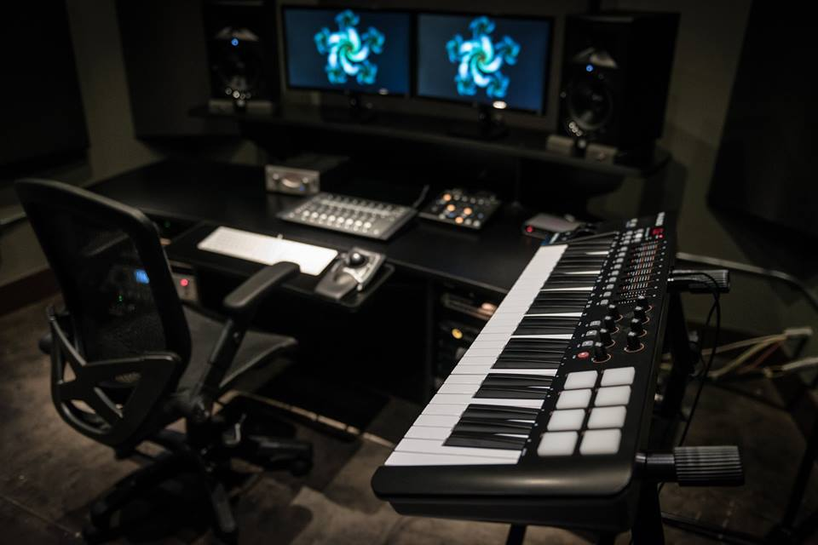
Each course at Crē•8 Music Academy consists of 15 hours of in-depth classroom instruction, including hands-on projects, access to the academy's recording studio, new production workstations and published course materials. The courses — titled Initi•8, Activ•8, Stimul•8 and Liber•8 — build a foundation of relevant production skills, encompassing commercial composition and arrangement, creative DAW operation, professional vocal production, synthesizers and sound selection, as well as mixing and mastering. Although many classic techniques are taught, Fenske is quick to point out that the school is always on the look-out for the latest in studio technology so that students can stay ahead of the curve. "Twice a year we go in and make sure that everything is fresh, and we’re always looking into new tech to make sure that we’re on top of what could be the next great tool in our toolbox.”

The courses are held in the on-campus studio and lab, which houses 10 workstations, each of which has a Mac mini, Kensington Trackball, Apogee Pro Tools Duet and an M-Audio Oxygen 49 MIDI controller. Every lab computer has over 500 GB of music production software, including Logic Pro X, Pro Tools 2018, Melodyne, AutoTune, Vocalign, Omnisphere 2.6, Serum, Komplete, Gold Baby 808 instruments, EVOXA, and more, while studio hardware includes JBL LSR308 speakers, Summit mic preamps and compressors, a vocal booth and an array of microphones for recording any vocals or pieces of instrumentation. The last class of the final course, Liber•8, teaches mixing in one of Westlake Recording Studios' control rooms.

Reaching the Masses
The ability for student producers to make a mix translate to any set of speakers is essential to the curriculum. For that reason, Fenske — who uses Sonarworks Reference 4 in his own session work — brought the software plugin into Crē•8 Music Academy's classrooms three years ago and it has quickly become a key tool. “For starters, I’ll run Reference across the stereo BUS during active listening experiences to ensure we have balanced audio in the room,” Fenske explains. “We then can make critical observations about the sound during our discussion.” From there, Reference is a key part of the mixing process. "Mix translation goes hand-in-hand with the production tactics we teach," Fenske says. "We want our songs to be able to be consumed by the hi-fi head, as well as the average person driving down the street in an Accord."

It’s reaching this wide array of audiences that is ultimately defining Crē•8. Alumni of the school have already seen success working with artists like Big Sean, Enrique Iglesias, and The Ying Yang Twins as well as doing work with CBS, MTV, and other major brands. For Fenske, it’s allowing his students to build a successful career by using their creativity to reach that audience. "Music as a career is a lot different than music as a hobby," Fenske says. "That's not to say that one is necessarily better than the other. However, when making music for self-expression, you can't really expect to have any sort of monetary return from that. So, what we do is teach the genre-neutral production tactics that have been successful at Westlake Recording Studios for 40-plus years and how to apply your creativity into those production tactics to allow your creativity to reach a much wider audience."

For more information about Crē•8 Music Academy, please visit https://www.cre8musicacademy.com/
For more information about Sonarworks Reference 4, please visit https://www.sonarworks.com/reference

About Sonarworks
Sonarworks began in 2012 when two music lovers met a scientist — a perfect storm of acoustic know-how and passion for good sound soon became the software that's currently transforming sound monitoring. Sonarworks’ flagship professional audio product, Reference 4 software, removes unwanted coloration and delivers the same accurate studio reference sound on all speakers and headphones. The software has since been endorsed by many Grammy-award winning mixing and mastering engineers and has won several industry awards and accolades.

Media Contact:
Steve Bailey
Hummingbird Media, Inc.
+1 (508) 596-9321
steve@hummingbirdmedia.com

Jeff Touzeau
Hummingbird Media, Inc.
+1 (914) 602-2913
jeff@hummingbirdmedia.com

