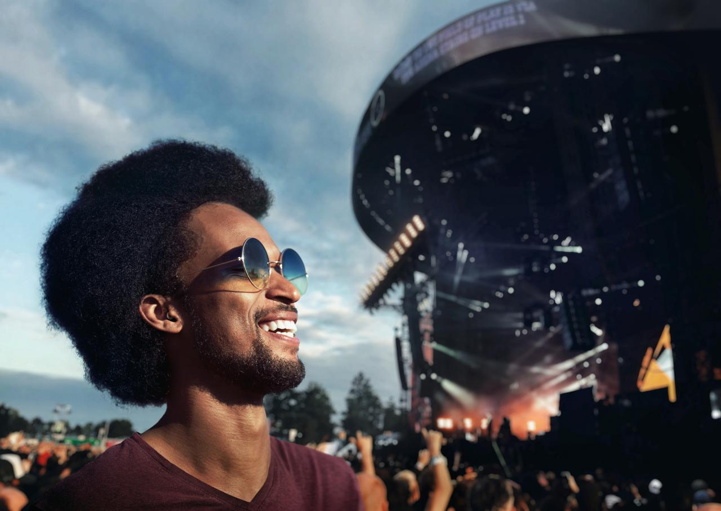
SAFE LISTENING THAT SOUNDS GREAT
Sennheiser presents SoundProtex hearing protection earplugs

Marlow, UK, May 16, 2023 – The new Sennheiser SoundProtex hearing protection earplugs enable wearers to hear the best possible sound at concerts and loud environments without having to worry about damaging their hearing. Many people will be familiar with that ringing sound in the ears after a concert, and that’s not a healthy thing. Music fans are often turned off from using earplugs as they can make it feel like the band or DJ is playing under water, which can ruin the concert experience. Utilising the brand’s extensive knowledge of sound, the Sennheiser SoundProtex enhances the live music experience in a safe way.
Perfect for enjoying concerts and festivals
The advanced high-fidelity ear plugs have patented membrane filter technology. This gives users the opportunity to enjoy perfectly balanced and full frequency sound without damaging their hearing. It preserves all the sonic details that make music brilliant and beautiful. By reducing the sound pressure that reaches your ear, the filter lowers potentially harmful volume levels so that users can listen safely for longer. The decibel level at many rock concerts, for example, is above 100 dB, and exposure to such decibel levels for more than 15 minutes already puts the listener at risk of hearing damage.

Balanced sound to preserve ambient awareness
The two-stage filters in SoundProtex are uniquely capable of passing on only clear, balanced sound to a user’s ears. The combination of a tuned membrane and a sound dampening mesh reduces high and low frequencies in equal measure. To understand speech, people rely heavily on higher frequency details. But standard earplugs can mask those details. The perfectly balanced SoundProtex filters keep enough of the higher frequencies to preserve ambient awareness —so users can still have a normal conversation at a concert.
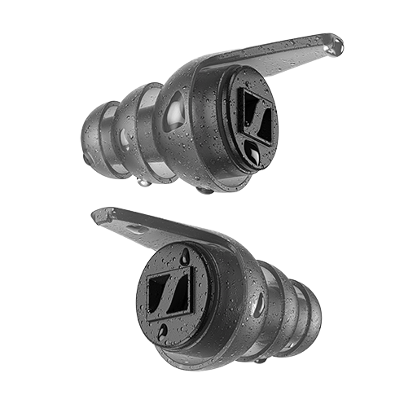
Long lifetime
Unlike single-use earplugs, SoundProtex can be used as often as users like. Just wipe them off after use or rinse them under water. Three sizes of ear tips are included in the standard package which also comes with a small pouch bag. This way, everyone can enjoy a comfortable, secure fit for hours on end. The soft, flexible, medical-grade TPE material is free of plasticisers and other substances that could irritate the sensitive skin in ears.

Multiple use cases
SoundProtex is also great to enjoy some peace and quiet on the road or in a noisy office when users need to concentrate. And whenever the goal is to eliminate as much sound as possible, pop in the included full block filter. It’s perfect any time a user wants complete quiet to relax or sleep and as it is air-and water-tight, it even protects ears from water when swimming.

SoundProtex Plus
The Sennheiser SoundProtex Plus comes with everything included in SoundProtex as well as two additional acoustic filters allowing people to choose between three different levels of sound attenuation to cover any situation from noisy offices to loud concerts.

Choose the strongest filter with an estimated single number rating (SNR) of 20 dB for loud music, motorsports, or power tool use. Medium is perfect for festivals, events, or travelling, with an estimated SNR of 17 dB. The low filter is suitable for quieter or non-amplified concerts, noisy offices, or visiting bars and restaurants and has an estimated SNR of 10 dB. Or, when you want nothing but silence, pop in the total block filter. SoundProtex Plus has the right filters for practically any situation.
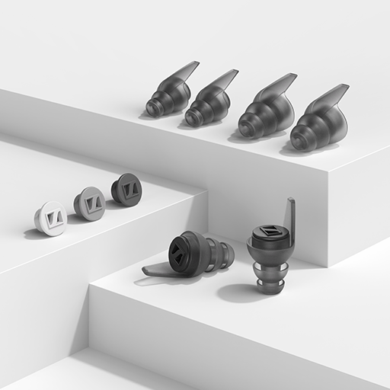
Pricing and availability
The Sennheiser SoundProtex and SoundProtex Plus will be available for pre-order on May 16, 2023, and will go on sale on May 30, with an MSRP of 34.99 and 69.99 GBP respectively.
www.sennheiser-hearing.com

About the Sennheiser brand
We live and breathe audio. We are driven by the passion to create audio solutions that make a difference. Building the future of audio and bringing remarkable sound experiences to our customers – this is what the Sennheiser brand has represented for more than 75 years. While professional audio solutions such as microphones, meeting solutions, streaming technologies and monitoring systems are part of the business of Sennheiser electronic GmbH & Co. KG, the business with consumer devices such as headphones, soundbars and speech-enhanced hearables is operated by Sonova Holding AG under the license of Sennheiser.
www.sennheiser.com
www.sennheiser-hearing.com

Press contact

Milan Schlegel
PR and Influencer Manager Consumer – EMEA Sennheiser Consumer Audio GmbH
milan.schlegel@sennheiser-ce.com
T +49 (0)5130 600 1139

Sennheiser UK&I PR agency
sennheiser@harvard.co.uk

