Jana Hunter | You Belong Here
Lower Dens mastermind Jana Hunter sits down with Moog Music to talk legendary synths, the importance of music as a form of expression, and the making of the group’s latest single “Galapagos.”

Jana Hunter | You Belong Here

Follow a chapter of musician Jana Hunter’s personal and creative journey in “You Belong Here,” a collection of moments between Moog’s home in Asheville, NC, and Hunter’s in Baltimore. The story begins with a recount of the artist’s first impressions of the Moog Sound Lab.

“It is both intimidating to be around them, and then very exciting when you realize what they’re capable of,” Hunter says of the Moog Sound Lab’s historical synths.

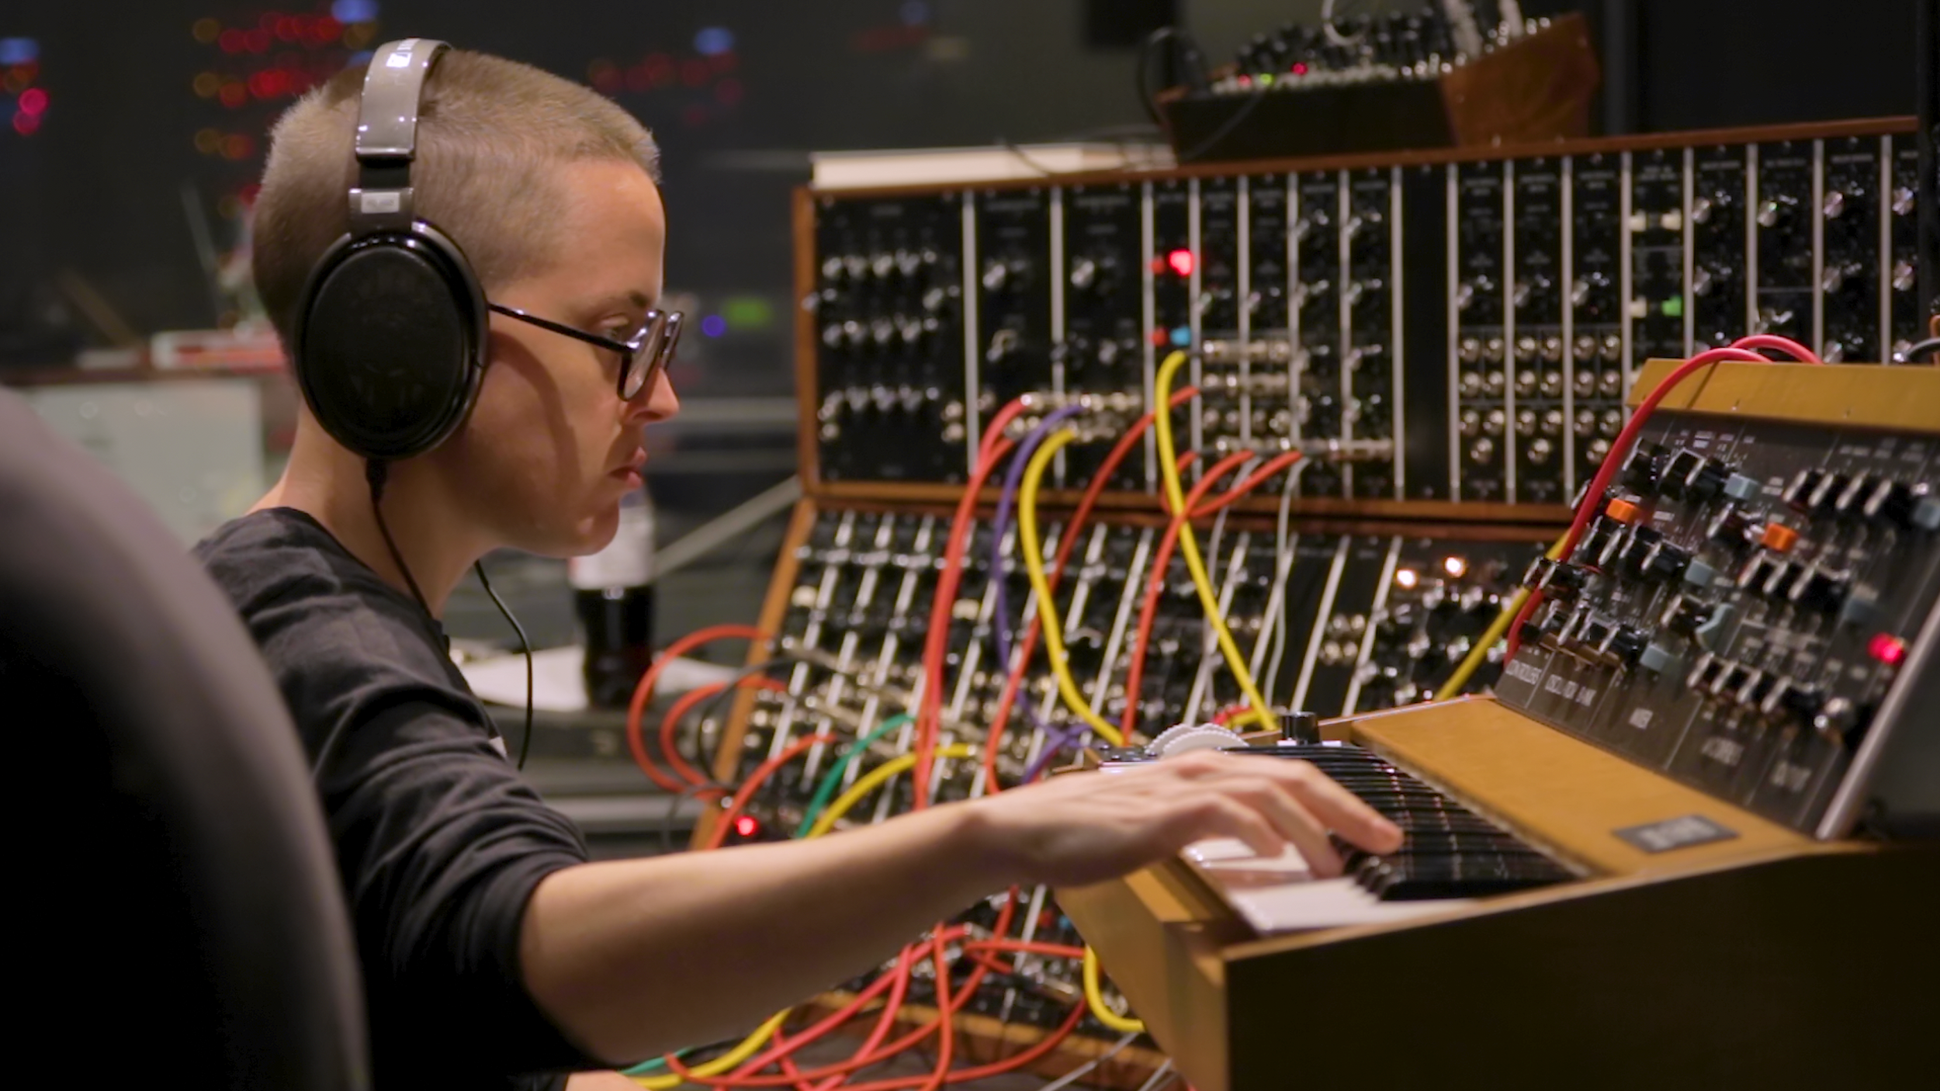
(** CLICK HERE FOR HIGH RESOLUTION PHOTOS **)

The founding member of now-LA-based indie pop outfit Lower Dens is no stranger to the Moog Factory. In fact, Lower Dens’ newest single, “Galapagos,” was formed using the Sound Lab’s resident System 55 and Minimoog Model D synthesizers.

Listen to “Galapagos” and more from The Competition.

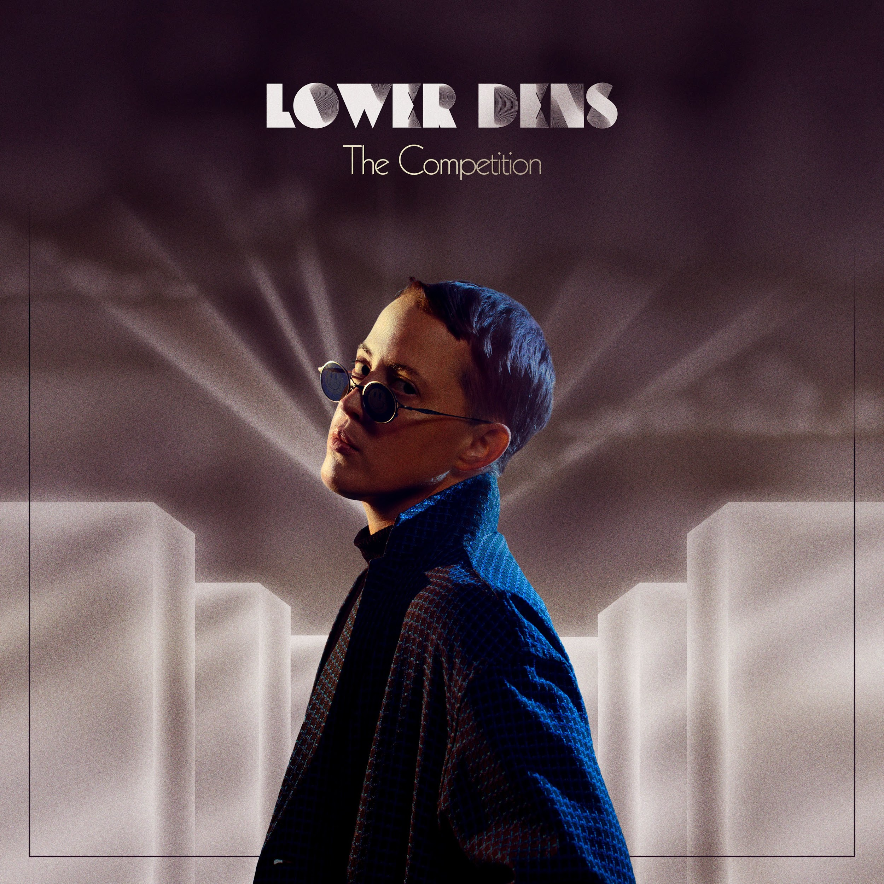
(** CLICK HERE FOR HIGH RESOLUTION PHOTOS **)

In conversation and in lyrics throughout Lower Dens’ fourth and latest album, The Competition, Hunter touches on themes of renewal, acceptance, and honesty. He opens up about the importance of building meaningful goals and relationships—despite expectations of others—and reminds us that creating art can be a fun, liberating part of that cathartic experience.

“Everybody should make music. I think a lot of people feel like music is intimidating—the tools are intimidating—but it’s an important form of expression.”

(** CLICK HERE FOR HIGH RESOLUTION PHOTOS **)

“I don’t feel like I fit into the world,” the artist shares. “But I think it’s important to remember that anybody worth knowing feels that way at least some of the time.” Get to know Jana Hunter and Lower Dens here.

