March 31, 2017
Toyota Motor Corporation
Motorsport Marketing Division

Tour de Corse: Preview
Twists and turns of Corsica up next for TOYOTA GAZOO Racing

TOYOTA GAZOO Racing World Rally Team and its drivers, Jari-Matti Latvala and Juho Hänninen head to the island of Corsica for round four of the FIA World Rally Championship (WRC) from April 6 to 9. The classic Tour de Corse is France’s round of the WRC and the first pure asphalt event of the season, following the ice-coated roads of Monte-Carlo, snow of Sweden and gravel of Mexico. Learning and developing the Yaris WRC remains the clear priority in the first season of Toyota’s WRC return, despite an extremely positive start with the team currently second in both the manufacturers’ and drivers’ standings.

Yaris WRC test

An event that returned to the calendar in 2015 after six years away, the Tour de Corse is famous for its narrow and twisty asphalt stages, which give it the nickname ‘The Rally of 10,000 Corners’. With mountainous stages lined by rock faces on one side and steep drops on the other, as well as numerous surface changes, there is plenty to catch drivers out. Abrasive asphalt and long stages also mean that tyre wear is a factor.

The rally is based in Bastia but will begin in the island’s capital Ajaccio on Friday April 7, with the day’s action consisting of two loops of two stages, averaging 30 kilometres each, which are run twice. There is no full midday service; instead just a change of tyres. Saturday contains two runs over two stages in the north near Bastia, totalling 131.96 kilometres. The rally concludes on Sunday with a 10.42-kilometre Power Stage near Porto Vecchio following the longest stage of the event, the 53.78 kilometres from Antisanti to Poggio di Nazza.

Latvala won the Tour de Corse on its WRC return in 2015, having also won in France (but this time in Alsace) the previous season. Hänninen has one previous start in Corsica in 2008, winning the production class. Prior to the start of the rally, each driver experienced two days of testing in Corsica itself,using roads that were very similar to those that will be seen on the rally.

Quotes:
Tommi Mäkinen (Team Principal)
“We had a very good test, introducing more new elements to the car, and from what we can see so far our performance on asphalt seems quite promising. We hope that we have the car to get a result but of course our objective does not change: we just want to gain experience and learn. There are a lot of positive things I can see heading into this rally: firstly, Jari-Matti likes the event and is in a very good mood, so when drivers are in this frame of mind it means they can perform well. He is second on the road but in Corsica that should not be a problem, as there is very little corner-cutting so road conditions should be good for him. Also Juho is now fully recovered from his illness. Despite not feeling well he still managed to finish the last rally in Mexico and get some points with a great performance, so this should give him even more confidence now that he is fully recovered.”

Jari-Matti Latvala (Driver car 10)
“Corsica is a special event for me: when I won there it meant so much to me because for Finns it was always a difficult place, after the accident with Henri Toivonen in 1986, and as a nation we never used to do very well there. Now I think it is different, and of course rallying is a lot safer. We had a very good test completing 380 kilometres over two days, with one day on narrow and bumpy roads and the second day on fast and abrasive roads. On the rally we will have both, so I think we found a good set-up between those two conditions, trying a few different damper settings. We already have an idea about the potential of the car on asphalt after Monte-Carlo, and my feeling with the car now is much better than it was after the test for Monte. However, our rivals will be very strong, as we saw already on all the rallies so far, so we take nothing for granted. We are just staying focussed on our task of improving the car with every rally. Up to now that objective is being met, so I am happy.”

Juho Hänninen (Driver car 11)
“I feel so much better now than I did before so I am looking forward to Corsica: it feels good to be back on Tarmac. I have only done the rally once before and that was a long time ago, although I also did the recce last year. So I have been relying a lot on the advice from Jari-Matti about how to set up the car and this is working very well. To me, the car actually feels quite similar to what we had in Monte-Carlo, but that is good as I had a very nice feeling with the car there. The main difference in Corsica is the tyres, so we have been learning how to get the best out of them, especially for the long stages. Mexico showed that if you persist you can have a good result even if the circumstances are against you and that is also a little bit the philosophy of Toyota this year: we are going to keep trying to make the car better and better.”

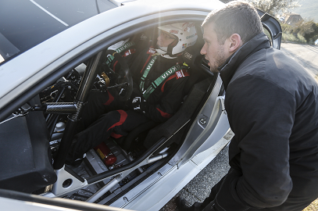
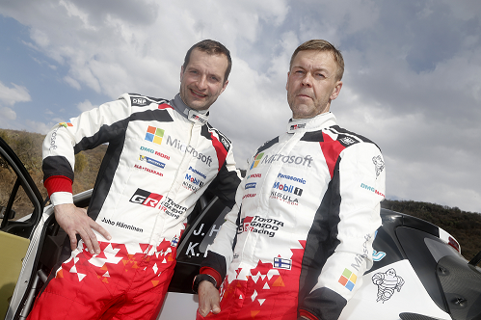

Juho Hänninen and Kaj Lindström
Jari-Matti Latvala and Antony Sharpe

The statistics (Tour de Corse):
Year | Jari-Matti Latvala | Juho Hänninen
2016 | 4 | -
2015 | 1 | -
Tour de Corse not part of WRC from 2009-14
2008 | 4 | 24
2007 | 4 | -
2006 | DNF | -

2017 FIA World Rally Championship for drivers after round three:
1 Sebastien Ogier 66
2 Jari-Matti Latvala 58
3 Ott Tanak 48
4 Dani Sordo 30
5 Thierry Neuville 28
6 Kris Meeke 27
7 Craig Breen 20
8 Elfyn Evans 20
9 Hayden Paddon 17
10 Stephane Lefebvre 10
11 Juho Hänninen 9

2017 FIA World Rally Championship for manufacturers after round three:
1 M-Sport World Rally Team 103
2 TOYOTA GAZOO Racing WRT 67
3 Hyundai Motorsport 65
4 Citroen Total Abu Dhabi World Rally Team 55

Press release
URL: http://toyotagazooracing.com/release/2017/wrc/rd04-preview.html

Pictures will be uploaded here during the event
URL: https://www.tgrwrt.com/ (ID and Password needed)

Follow us!
Follow TOYOTA GAZOO Racing WRT:
∇Facebook: https://www.facebook.com/TOYOTAGAZOORacingWRC
∇Twitter: https://www.twitter.com/TGR_WRC (@TGR_WRC)
∇Instagram: https://www.instagram.com/tgr_wrc/ (@TGR_WRC)
∇YouTube: https://www.youtube.com/channel/UCCtALHup92q5xIFb7n9UXVg

<Contact>

TOYOTA GAZOO Racing PR Office
Email: tgr_pr @rights-apartment.com

TOYOTA GAZOO Racing Official website
http://toyotagazooracing.com/

TOYOTA GAZOO Racing World Rally Team is supported by following partners:
