EMBARGOED UNTIL FRIDAY 15 SEPTEMBER 10:00 A.M. CET
Xytech Launches MediaPulse Managed Cloud at IBC 2017

MediaPulse Managed Cloud features real-time, cloud-based facility management capabilities with groundbreaking iOS/Andriod-compatible web-based hosted applications

Amsterdam, 15 September 2017 — Xytech [IBC 2017, stand #6.C22], the market leader in facility management software for the broadcast, production, media services and video transmission industries, announced its new Cloud and managed Services offering: MediaPulse Managed Cloud. Hosted in Microsoft Azure platform, MediaPulse Managed Cloud is a secure, hosted platform from Xytech offering full system management. With MediaPulse Managed Cloud, companies of all sizes can avoid the cost and ongoing distraction of an on premises installation.

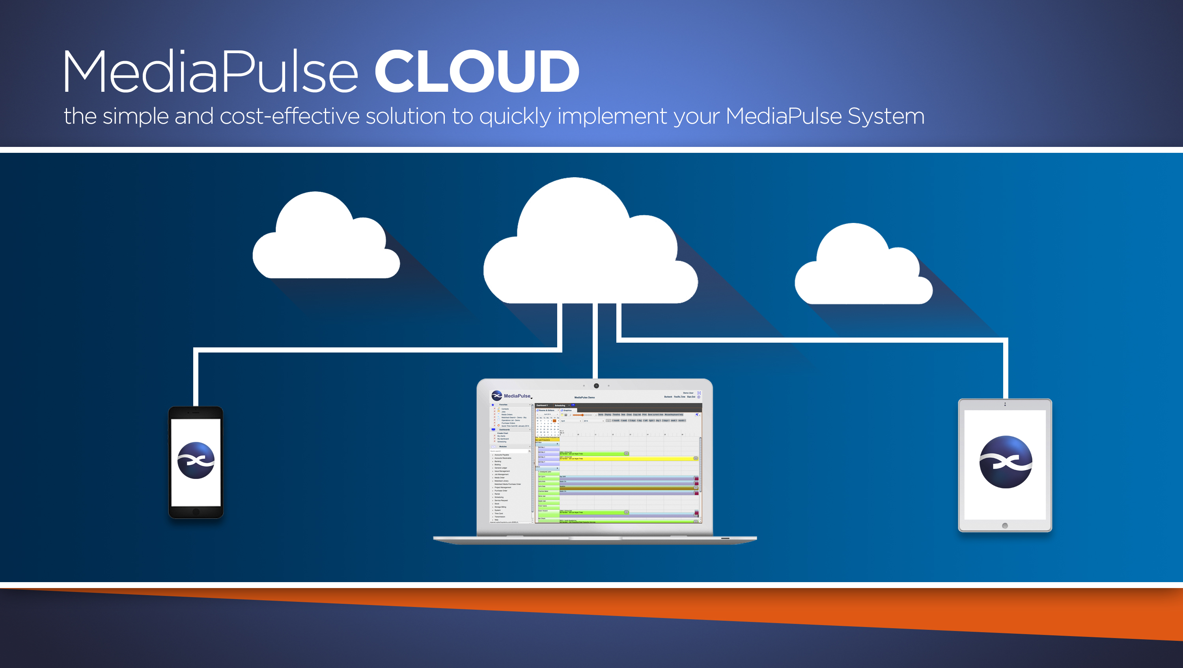
MediaPulse Managed Cloud is available through any web browser and compatible with iOS, Android and Windows mobile devices. Xytech's new managed services handle most administrative functions including daily backups, user permissions and screen layouts and is an ideal, cost-effective solution for any facility.

"MediaPulse Managed Cloud makes the installation, maintenance and constant evolution of each client’s solution easy and cost effective. It allows our clients to focus on what they do best, while insuring they have the latest software in a secure and reliable platform" explains Greg Dolan, COO of Xytech. "This managed services offering is available with several options so our customers can choose the one best fitting their business."

Key features of The MediaPulse Cloud and Managed Services:
- Always available and always current software
- Secured through Microsoft Azure
- Web and Mobile accessible
- Localized installations with language packs
- Multiple Azure datacenters

The MediaPulse Managed Cloud, now available in October is compliant with European privacy laws and enables secure data transmission across multiple geographies. As such, users of The MediaPulse Cloud are able to share data with their clients confidently knowing their information is protected.

Xytech staff will offer The MediaPulse Cloud at this year's IBC. Those interested in scheduling an appointment may contact Alexandra Kuipers at akuipers@xytechsystems.com, + 1 (818) 698-4958 or Aurore Gilewicz at agilewicz@xytechsystems.com, +44 203 478 1462.

About Xytech Systems: For over 25 years, the world’s premiere media companies have depended on Xytech to run their businesses. MediaPulse is the only end-to-end solution for the complete content lifecycle. MediaPulse provides scheduling, automation, asset management, billing and cost recovery for broadcasters, media services companies and transmission facilities in a scalable platform-independent solution.

For more information, visit xytechsystems.com

Media contacts:

Jeff Touzeau
Public Relations
Hummingbird Media
+1 (914) 602 2913
jeff@hummingbirdmedia.com

Katie Kailus
Public Relations
Hummingbird Media
+1 (630) 319-5226
katie@hummingbirdmedia.com

