NAB 2019 News: Synthax Names Dennis Stafford Marketing Manager, Americas
Stafford brings decades of music industry experience to his new role and will focus on
broadening Synthax’s portfolio into new verticals, including podcasting

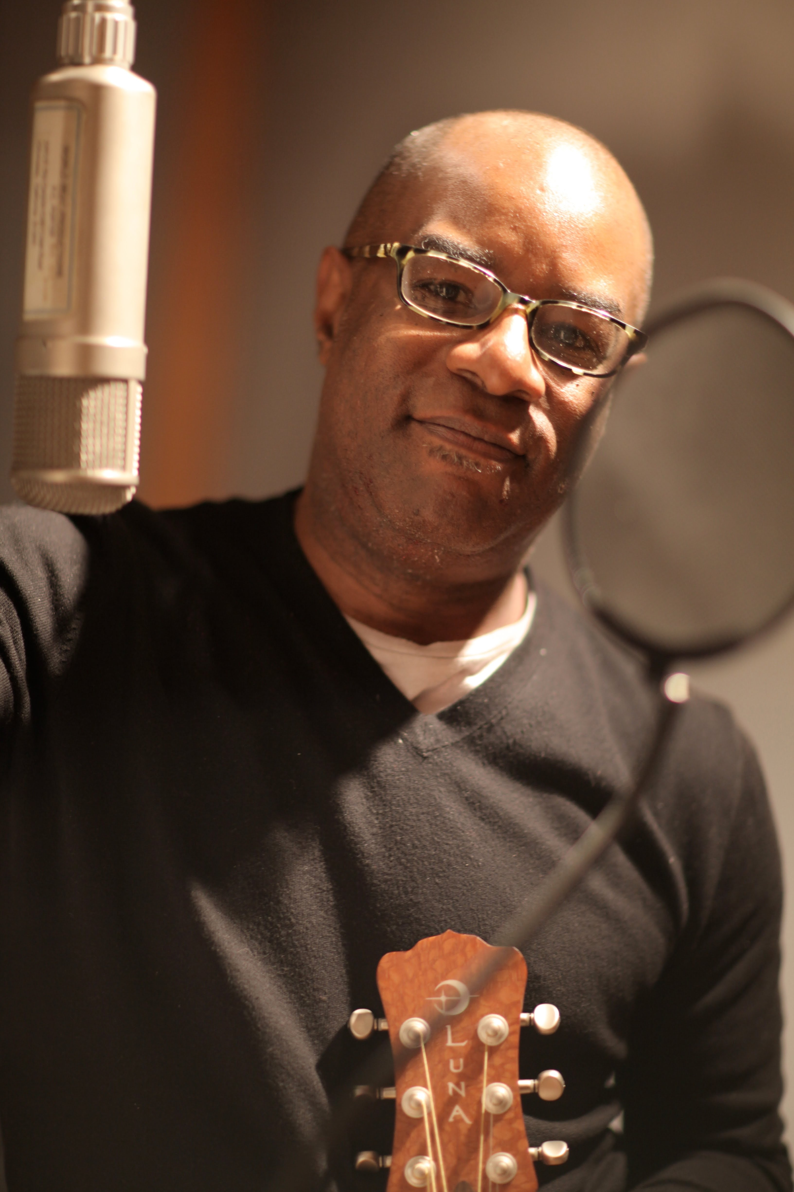
Fort Lauderdale, FL – April 3, 2019 – Synthax [NAB booth C7506], distributor of best-in-class audio solution manufacturers RME, Ferrofish and myMix, has appointed industry-veteran Dennis Stafford to the role of Marketing Manager, effective immediately. Stafford brings decades of experience in the MI industry to the team and will report directly to Mathias von Heydekampf, Managing Director of Synthax.
In his new role, Stafford will focus on expanding the Synthax portfolio of brands, which includes RME, Ferrofish and myMix, into new verticals — including the burgeoning podcasting and teleconferencing markets.
Stafford started his career in the music industry in the early 1990s serving in marketing roles at both MTV and BET. He later helped head up marketing efforts at the House of Blues in Chicago which consistently ranked among the top revenue-generating venues during his tenure. Stafford then switched to the MI side of the business in 2014 working as Marketing Director for Armadillo Enterprises which included Luna Guitars, Dean Guitars and ddrum.
“Our industry is going through a major transition, and RME is in a strategic position to exponentially increase its user base,” Stafford said. “I am looking forward to helping introduce these best-in-class brands to a wider audience. Often in marketing you are asked to create stories for subpar products. I am excited to tell the story of these truly superior brands.”
“We are very excited to have Dennis join our team,” said Mathias von Heydekampf, managing director of Synthax. “His extensive experience in the music industry coupled with his background in MI marketing will help him play a key role in our strategy to continue to expand Synthax’s growing footprint.”
Mastering Audio — in All Markets
With high-end, digital audio offerings from RME, premium conversion solutions from Ferrofish and best-in-class personal monitoring and mixing from myMix, Stafford believes Synthax’s brands can fill needs in a variety of markets, including the quickly growing podcasting market.
“Our brands’ products offer a wide range of solutions for a wide range of professionals,” Stafford said. “More and more podcasters are turning to RME to enhance their audio setups when looking for a quality audio interface with two mic inputs and low latency. The expanding podcast market is just one area I’m looking forward to continuing to support and grow.”
Additionally, Stafford is looking forward to widening the Synthax family of brand’s footprint into the DJ and teleconferencing sectors.
For more on Synthax, visit http://www.synthax.com.

About Synthax, Incorporated
Synthax Inc. is the exclusive USA distributor for RME digital audio solutions, Ferrofish advanced audio applications, myMix audio products, and ALVA cableware. We supply a nationwide network of dealers with these products for professional audio, broadcast, music industry, commercial audio, theater, military and government applications. For additional information, visit the company online at http://www.synthax.com.
Media Contacts:
Katie Kailus
Public Relations
Hummingbird Media
+1 (630) 319-5226
katie@hummingbirdmedia.com

Jeff Touzeau
Public Relations
Hummingbird Media
+1 (914) 602 2913
jeff@hummingbirdmedia.com

