BJOOKS RELEASES ‘SYNTH GEMS 1’ — A VISUAL EXPLORATION HONORING AND CELEBRATING VINTAGE SYNTHS AND THEIR CREATORS

320-page hardcover book from the creators of PUSH TURN MOVE, PATCH & TWEAK, and PEDAL CRUSH takes readers on an awe-inspiring ride through the world of vintage synthesizers

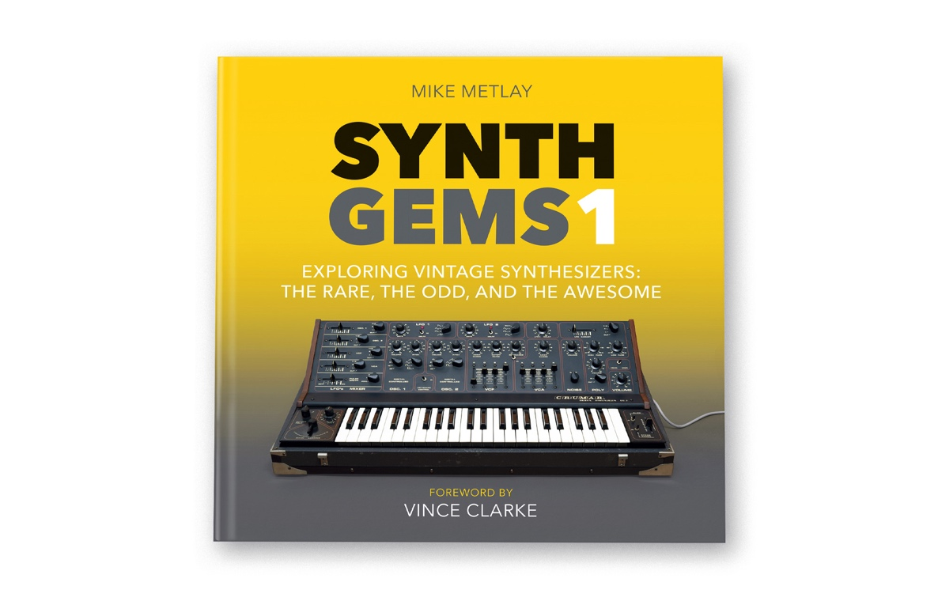

COPENHAGEN, DENMARK — Bjooks, a preeminent publisher of musical instrument book titles including PUSH TURN MOVE, PATCH & TWEAK, PEDAL CRUSH, and PATCH & TWEAK with Moog, has announced the release of its latest title. SYNTH GEMS 1 – available at resellers and Bjooks.com — is a beautifully photographed 320-page hardcover art book celebrating vintage synthesizers and the people who created them.

Authored and curated by well-known synth expert and music technology writer “Dr. Mike” Metlay, SYNTH GEMS 1 takes readers on a chronological journey through a unique selection of over 60 synthesizers – some popular, some rare, all beautiful. Meant for newcomers to synthesis as well as experienced electronic musicians, SYNTH GEMS 1 spans the critical historical period from 1970 to 2000 with stunning photography and detailed articles that explain the history, technology, and legacy of each instrument.

“I think of the SYNTH GEMS Series as a set of exhibition catalogs, like the ones sold at art galleries that allow visitors to take home the essence of the works on display,” Metlay explains. “In each volume, we provide a guided tour of an incredible synth exhibition — curated from different museums around the world — that could never exist in one location. Readers can walk around these beautiful instruments, examine them in detail via high-quality photos, and learn about how they influenced the world of music.”

“SYNTH GEMS is truly an ode to the synthesizer in all its forms,” adds Kim Bjørn, CEO and founder of Bjooks. “Paging through the book, readers will come across popular favorites like the Sequential Circuits Prophet-5, as well as rare instruments like the Lord Synthesisers Skywave. SYNTH GEMS is a must-have for any fan of electronic music — whether they’re a lifelong musician or just starting out.”
A Revolutionary Voyage
Featuring a foreword by renowned songwriter Vince Clarke (Depeche Mode, Yazoo, Erasure), SYNTH GEMS 1 takes readers on a visual voyage through dozens of synthesizers that shaped the last three decades of the 20th Century. Fittingly, the book opens in 1970 with the remarkable story of the Minimoog, including high-quality photos of the prototypes that led to its final design. From there, the reader will encounter historical milestones like the Yamaha GX-1, Korg PS-3300, and Oberheim Matrix-12, and rare and unusual treasures like the RSF Kobol, Gleeman Pentaphonic Clear, and Waldorf Wave – ending in the year 2000 with the Alesis Andromeda.

Each instrument is stunningly photographed, and the accompanying text gives readers a detailed breakdown of its historical context, sonic design, visual aesthetics, and impact in the contemporary music world. These articles — meticulously researched and verified by industry authorities, including many of the instruments’ original creators — turn SYNTH GEMS 1 into an unprecedented reference volume.
As the synthesizer’s role in modern music grows, more and more people are exploring the idea of creating electronic music themselves rather than simply listening to it. To help this growing audience, SYNTH GEMS 1 begins with ‘The Synthesizer: An Introduction’ — a detailed 6-page breakdown that discusses some of the most common synthesizer features and provides a brief education on how they work. Supplemented by a comprehensive Glossary in the book’s Appendix, it offers amateur enthusiasts a well-rounded foundation on the ins and outs of synthesis – as well as an increased appreciation for each of the instruments featured in this volume.

“Over the last few years, there’s been a massive increase in interest in these beautiful vintage instruments,” Bjørn says. “As a result, we wanted the SYNTH GEMS series to provide those just starting out with a solid basis and unique insight into the history of synthesizers. We hope that some of these pages might inspire creative musical journeys among our readers."

SYNTH GEMS explores a unique selection of vintage synthesizers from the 1970s to the year 2000.

Synth Rarities
Mike Metlay left the field of Nuclear Physics in 1996 for a 23-year career on the Editorial staff of the US pro-audio magazine RECORDING, but he was already educating electronic musicians worldwide while earning his Ph.D. in the 1980s. With over four decades of experience as a recording artist, engineer, producer and music technology educator — as well as Editor-in-Chief of Bjooks — Metlay is well-positioned to discuss not only the most popular synths, but also the weird, wacky and hard-to-find. SYNTH GEMS 1 has been edited, refined and carefully refereed by industry authorities such as Chris Meyer, Gordon Reid, and Marc Doty.

The text serves to illuminate the real centerpiece of the book: well over 300 unique photos of some of the world’s most beautiful synthesizers, all new and taken specifically for this book. Bjørn traveled with photographer Peter M. Mahr to world-renowned museums SMEM and Synthorama in Switzerland, and worked with a photo team at EMEAPP in Philadelphia, to capture these sought-after instruments, with individual serial numbers for each exhibit carefully archived. SYNTH GEMS 1 is a truly unprecedented celebration of the synthesizer –— both as a creator of music and as a work of art.

SYNTH GEMS 1 will be available through authorized resellers, and at bjooks.com beginning on Oct. 1st in the EU and from Nov. 1st in the US. Pricing is as follows: 450 DKK / $69.95 USD / € 59,95 EUR / $89.95 CAD.

Bjooks is an environmentally responsible publisher with all of its books – including SYNTH GEMS 1 — printed on high-quality, environmentally friendly paper from responsible sources.

For more information on SYNTH GEMS 1 or any of the books in the Bjooks portfolio, or to purchase any of the books, please visit http://www.bjooks.com.

-----------

Text from the back cover:
SYNTH GEMS 1 is your guide to an eclectic and amazing collection of synthesizers as art. Experience the history, technology, and sonic innovation of electronic music in a completely new way.

With their widely diverse designs and intentions, synthesizers offer a world of fascination. What thoughts and emotions guided their creators? What do they say about the era when they were created? How do their form and function define one another, and the music they make?

As much for serious synth enthusiasts as for newcomers to electronic music, SYNTH GEMS 1 is an enlightening look into this wonderful world of vintage synthesizers.

An art gallery of electronic aesthetics
SYNTH GEMS 1 takes you on a tour of over 60 remarkable keyboards — large and small, famed and rare, elegant, beautiful, and brutal… and ranging from classics that define entire genres to rare oddities that bring their own grace to the world.

Each synthesizer is presented in a series of finely detailed photographs, with a discussion of its origins and importance. From the dawn of commercial synthesis to the close of the Twentieth Century, the lives and times of these unique instruments are chronicled in exquisite pictures and thoughtful stories – mingling music, technology, commerce, and visual art.

Meet the synthesizer
Besides a brief introduction to the basic elements of synthesizer design, as well as a comprehensive Glossary, the book is rounded out by tours of the three museums that opened their collections to be photographed, and a selection of resources
for further study: books, films, educational initiatives, online resources – even ways to play with these sounds at home.

Known classics and significant rarities
Explore the designs and read the stories behind instruments from famous brands such as ARP, Casio, Clavia, Korg, Moog, Oberheim, Roland, Sequential, and Yamaha – as well as vintage gems from Crumar, Electronic Dream Plant, Elgam,
E-mu, Ensoniq, Fairlight, Kawai, Gleeman, Lord Synthesisers, Steiner-Parker, Technics, Waldorf, and more.

The GEMS Series from Bjooks celebrate the inner and outer aesthetics of electronic musical instruments:
• Detailed and beautiful color photographs, taken specifically for this series
• Insightful discussion of the technical details — and the historical significance — of each instrument
• Clear and inviting introductions to the concepts that guide these designs

-----------

About Bjooks:
Bjooks is the boutique publishing company started and run by author, designer, and musician Kim Bjørn. His first book, PUSH TURN MOVE, was published in 2017. This was followed by PATCH & TWEAK in 2018, which has since been referred to as the 'Bible of Modular Synthesis’; PEDAL CRUSH - Stompbox Effects for Creative Music Making in 2019; and PATCH & TWEAK with Moog in 2020. The mission of Bjooks is to create exciting titles about music technology, artists, and makers, in order to document, inspire, and explore the world of music creation.

Press Contacts:
Katie Kailus
Hummingbird Media
katie@hummingbirdmedia.com
www.hummingbirdmedia.com

Jeff Touzeau
Hummingbird Media
jeff@hummingbirdmedia.com
www.hummingbirdmedia.com

