ISE 2021 Digital
Sennheiser reveals new software and Standalone Mode for MobileConnect; highlights TruVoicelift technology for TeamConnect Ceiling 2

Marlow, UK, May 24, 2021 – Participating in the digital edition of the world’s biggest AV event on June 1 and 2, Sennheiser is focusing on its audio solutions for corporate and education environments, in particular its TeamConnect Ceiling 2 microphone with TruVoicelift technology and the MobileConnect BYOD streaming solution, which now offers even more possibilities in the field of assistive listening over Wi-Fi thanks to a new software version and Standalone Mode.

Easy and scalable solutions for any assistive listening need
New features for the Sennheiser MobileConnect Wi-Fi streaming solution ensure a new level of operational simplicity, regardless of whether a few individual units or a large network of devices are in use.

Sennheiser’s MobileConnect BYOD streaming solution provides assistive listening support over Wi-Fi. A new Standalone Mode ensures fast integration and set-up, while a new version of the MobileConnect Manager software ensures even more convenience for large, networked systems

MobileConnect’s new Standalone Mode allows higher education institutions to quickly integrate MobileConnect into their existing Wi-Fi network for assistive listening support. “The benefits of the new Standalone Mode are its easy installation as well as the low integration and IT effort required,” says Jakub Kolacz, product manager for MobileConnect. This plug-and-play mode is especially attractive for smaller systems and first installations, yet the solution is still fully scalable, with each MobileConnect station providing two audio streams for up to 100 users.

The new update for the free MobileConnect Manager caters to large and software-controlled MobileConnect set-ups. Version 1.3.0 of the software will make workflows for large networks more convenient with a new Manager dashboard and API interface.
The MobileConnect Manager dashboard now gives ample system information at a glance, such as status messages for troubleshooting purposes, information about software updates, statistics for active MobileConnect Stations and streaming channels as well as the possibility to download a log of system status messages.

With the MobileConnect API, Sennheiser opens MobileConnect for connection to third-party systems. For example, IT managers are now able to have QR codes for the streaming channels automatically displayed on digital room signage solutions. “The API allows AV & IT managers to optimise their university’s workflows and add more convenience both for the team and for users,” explains Jakub Kolacz.

TeamConnect Ceiling 2 with TruVoicelift
Another highlight at ISE Digital is TeamConnect Ceiling 2. As well as being a leading microphone solution for distance learning and conferencing audio, TeamConnect Ceiling 2 has recently been enhanced to ensure clearly audible in-room audio for education and business settings, thanks to its free TruVoicelift feature.

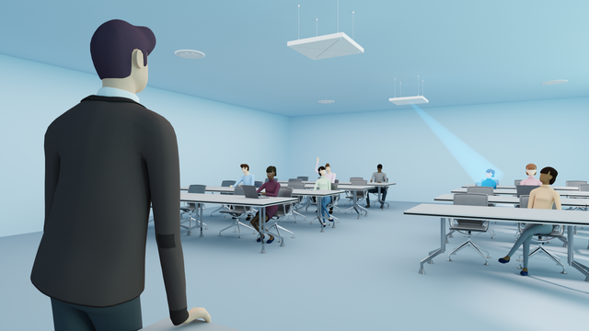 | 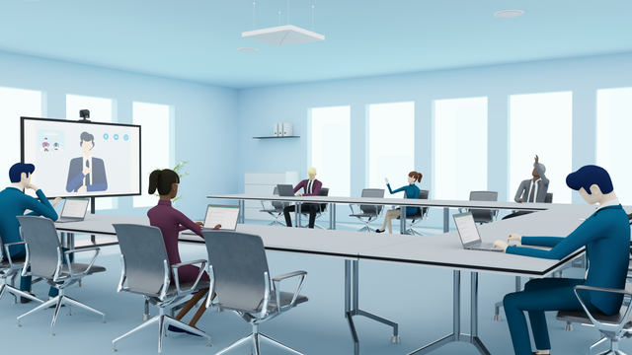
TeamConnect Ceiling 2 with TruVoicelift ensures clear audio, whether in education or conferencing settings

“With the latest TeamConnect Ceiling 2 firmware update and the 4.3.0 version of the Sennheiser Control Cockpit app, the touchless ceiling mic array now doubles as a voicelift microphone and ensures perfect audio all the way to – and from – the back row,” says Jens Werner, Portfolio Manager in Sennheiser’s Business Communication Division.

Easily controllable features make for a pleasant and clear listening experience, among them an advanced frequency shift algorithm that delivers a few crucial extra dB of gain and a feedback prevention mute function. Also, during pauses in speaking, a noise gate will be activated that mutes TeamConnect Ceiling 2 to prevent any background noise from being amplified.

Via the Sennheiser Control Cockpit app, priority zones and advanced exclusion zones can be created to define areas where audio is predominantly picked up and to exclude noise sources, respectively.

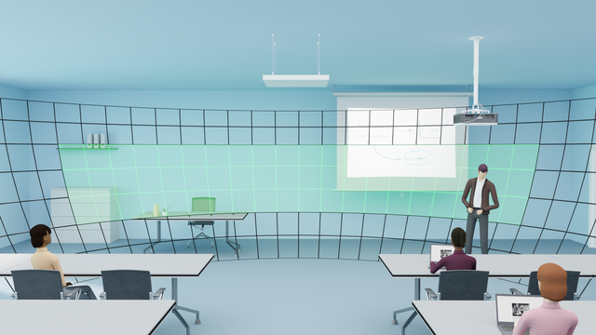 | TCC 2 allows you to determine priority zones (pictured green) for uninterrupted speech pick-up

Do not miss the Sennheiser events at ISE Digital

Digital Learning Tech Channel
June 2 at 14:45 CEST: TruVoiceLift & Camera Control with the Sennheiser TeamConnect Ceiling 2 beamforming ceiling microphone
June 2 at 15:20 CEST: Sennheiser Mobile Connect – Plug and play audio streaming over Wi-Fi featuring a new standalone mode

Innovation & Demo Showcase Channel
June 2 at 14:30 CEST: Sennheiser TeamConnect Ceiling 2, the beamforming ceiling microphone – now with TruVoiceLift
June 2 at 17:00 CEST: New Sennheiser digital wireless microphone series

Another highlight that Sennheiser is keen to draw attention to is an interview with Stephen Dishon, Development Team Manager of the University of Edinburgh. This will be broadcast from the ISE Main Stage on June 1, at 14:40 CEST. Stephen will describe the university’s AV requirements and how he and his team have prepared for hybrid learning.

Simply register here for a free ticket to ISE Digital.

The images accompanying this press release and additional photos can be downloaded here.

About Sennheiser
Shaping the future of audio and creating unique sound experiences for customers – this aim unites Sennheiser employees and partners worldwide. Founded in 1945, Sennheiser is one of the world’s leading manufacturers of headphones, loudspeakers, microphones and wireless transmission systems. Since 2013, Sennheiser has been managed by Daniel Sennheiser and Dr. Andreas Sennheiser, the third generation of the family to run the company. In 2019, the Sennheiser Group generated turnover totaling €756.7 million. www.sennheiser.com

Local Press Contacts

Sarah James Maik Robbe
sarahj@gasolinemedia.com maik.robbe@sennheiser.com
+44 (0) 1483 223333 +44 (0) 7393 462484

