# 

# Calvary Baptist Church adopts multi campus expansion, standardizes on Sennheiser Digital 6000 & Evolution Wireless Digital Systems

**With four different campus locations and 10,000 active members in the Tampa Bay area, Calvary plans to add two more campuses in three years — all with Sennheiser wireless**

***Tampa, FL, January 16, 2023 —* With an active membership of 10,000 congregants in the greater Tampa Bay area, Calvary Baptist Church has maintained an impressive growth trajectory over the last several years, adding three additional campuses to its Clearwater-based flagship location since 2013. With ambitious plans to expand even further by adding two more campuses over the next three years, the church also maintains a nimble, impressive technical infrastructure, complemented by several channels of Sennheiser's Digital 6000 and Evolution Wireless Digital wireless systems.**

Currently, all four Calvary campuses are tied together with a dark fiber ring and shared data cloud, enabling secure live streaming both internally and externally. This capability — in combination with multiple channels of Sennheiser wireless at each of its campuses — came in particularly handy during the COVID-19 pandemic. It has also proven to be an outstanding solution for streaming services and sermons to internal campus locations as well as to thousands of remote viewers around the world.

**Leveraging hybrid content channels**   
At its main campus in Clearwater, the auditorium seats 2,000 people. Nick Grosseibl, Director of Technology at Calvary Church, says that each of the services — up to 10 per week — is able to reach both in-person and remote congregants. “Our campus sites will pick up the service from our main broadcast site and watch our senior pastor preach through Resi, our streaming platform, on an LED wall at their own campus,” he says. “We will also put our services online, where we reach approximately 2,000 viewers each week.”

At the main campus, each service uses 10 channels of Sennheiser Digital 6000 wireless, with 8 additional channels of evolution wireless G4. These all run through a 128 channel Allen & Heath dLive console, which handles FOH, monitor and the two-channel stereo streaming broadcast mixes. Additionally, the newest two campuses utilize Evolution Wireless Digital, which provides an equidistant tuning grid for intermodulation free, robust performance.

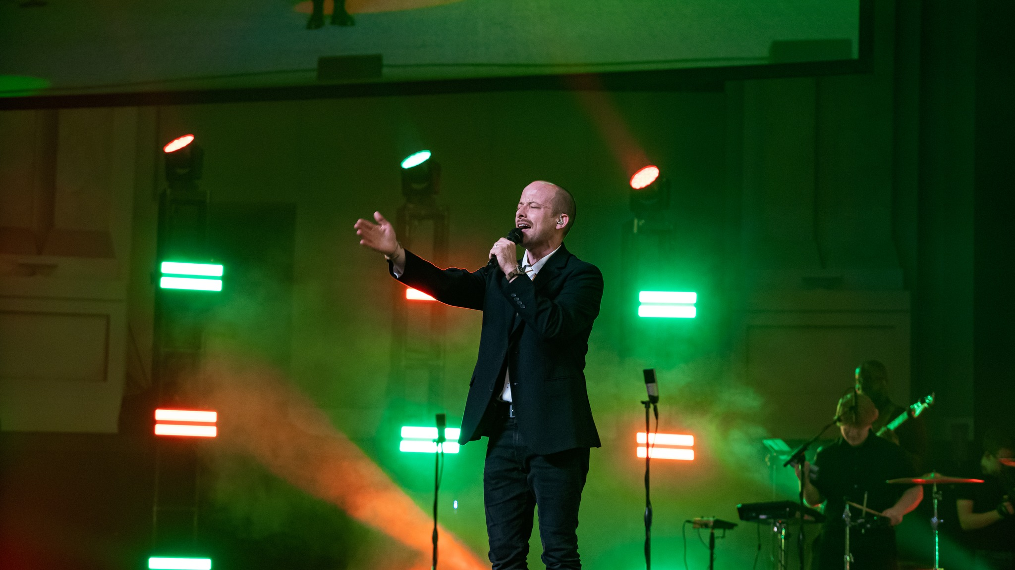

Calvary Baptist Church Choir members use SKM 6000 handheld transmitters and Sennheiser capsules. Photo credit: Jake Coonfare

**Digital 6000: Taking the audio to another level**  
“When Sennheiser came out with the Digital 6000 system, we tried it and just fell in love with how it sounds — it really was an eye opener,” says Grosseibl, who says that Calvary has been using Sennheiser wireless for more than 20 years. “The Digital 6000 just takes the audio to another professional level in this environment.”

One of the first projects on which Grosseibl was able to deploy the new Digital 6000 system was for a special performance by the Brooklyn Tabernacle Choir back in February. “We had 36 channels of Sennheiser wireless onstage running at the same time, and we had everybody on Sennheiser in-ears as well,” he recalls. "That was a big feat because there were so many microphones on stage at once." Members of the Brooklyn Tabernacle Choir were using SKM 6000 handheld transmitters, coupled with MMK 965 condenser capsules with the featured vocalist performing on a Neumann KK205. “It was one of those nights where you get goose bumps on your arm just thinking about the sound,” says Grosseibl.

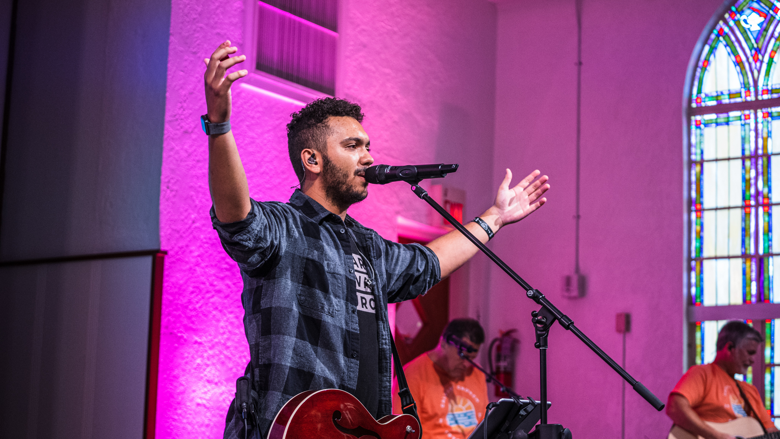

Calvary Baptist Church relies on Sennheiser wireless systems across all campuses for dozens of services each month. Photo credit: Jake Coonfare

**Bulletproof RF reception where it counts**  
While Grosseibl is a fan of Sennheiser's high quality sonic performance, solid RF performance is a ‘must have’ — particularly in the greater Tampa Bay area, where RF congestion can be unforgiving: “Our wireless systems need to adapt to whatever environment we are working in,” he explains. "Each of our four campuses are located in very different parts of the county; some are located in densely populated areas and others are more rural. Some are located directly beside cellphone towers, and others are not. With our Sennheiser wireless systems — particularly the Digital 6000 — we have never experienced dropouts or lost signals. They have been completely bulletproof."

Grosseibl, along with his staffers and volunteers, use Sennheiser's Wireless Systems Manager (WSM) software to set up and coordinate frequencies prior to any performances and broadcasts. "This allows us to easily scan the RF environment and set up frequencies." The team also uses the Sennheiser Control Cockpit software to remotely manage mutes and monitor transmitter battery life and other functions. "This can be useful if somebody accidentally mutes their microphone," he says. "We can manage that remotely from an iPad using the app, as well as access other functions."



Calvary Baptist Church’s choir and band are ‘all in’ with Sennheiser and Neumann microphones across vocals and instruments. Photo credit: Jake Coonfare

**An all-Sennheiser and Neumann microphone campus**

From a microphone perspective, Calvary Baptist is 'all in' with Sennheiser. "Every single microphone at the Clearwater campus is a Sennheiser or Neumann-based product," he says. “All of our singers are on the 965 capsules, and we just got all of our drums on the Sennheiser evolution series.” For the toms and snare, they are utilizing e 904 microphones, with a pair of e 914s mics as overheads and an e 902 mic on the kick drum. Meanwhile, the grand piano at Calvary's main campus is miked up with Neumann’s new MCM 114 Stereo Set for Piano that employs two KK 14 capsules.

Grosseibl says that in all the years he has been working there, it has been smooth sailing with Sennheiser: "We've never had any problems and our Sennheiser equipment delivers what our worship team expects every week," he says, noting that the support and communication from Sennheiser has been exceptional. "Our representative, Matt Buckner, has been very responsive to any technical questions we've ever had, and the relationship between Calvary and Sennheiser has been great. I truly believe that we would not be able to do what we do without our Sennheiser products."

###

**About the Sennheiser Group**

Building the future of audio and creating unique sound experiences for our customers - this is the aspiration that unites the employees of the Sennheiser Group worldwide. The independent family-owned company Sennheiser was founded in 1945. Today, it is managed in the third generation by Dr. Andreas Sennheiser and Daniel Sennheiser, and is one of the leading manufacturers in the field of professional audio technology. Within the Sennheiser Group are Georg Neumann GmbH (Berlin, Germany), manufacturer of studio-grade audio equipment; Dear Reality GmbH (Düsseldorf, Germany), known for its binaural, Ambisonics, and multichannel encoders with realistic room virtualization; and Merging Technologies SA (Puidoux, Switzerland), specialist in high-resolution digital audio recording systems.

[sennheiser.com](https://protect-eu.mimecast.com/s/lUszCgxgJHAZzmKWSo3cGI?domain=sennheiser.com) | [neumann.com](https://protect-eu.mimecast.com/s/hW3dCm2oZUjNQA8YSDwLrJ?domain=neumann.com) | dear-reality.com | [merging.com](https://www.merging.com/)

**For more information please contact**

Daniella Kohan  
Communications Manager, Americas and ANZ, Sennheiser

Email: [daniella.kohan@sennheiser.com](mailto:daniella.kohan@sennheiser.com)   
Phone: +1 860 598 7420

Jeff Touzeau  
President, Hummingbird Media

Email: [jeff@hummingbirdmedia.com](mailto:jeff@hummingbirdmedia.com)

Phone: +1 914 602 2913