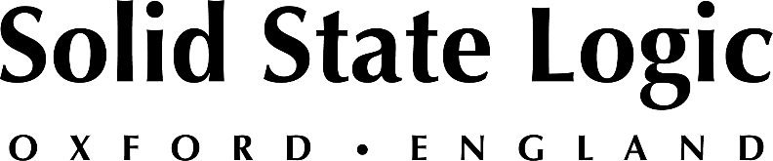

Denmark's TV 2 Integrates Several Solid State Logic System T Consoles at Headquarters and OB Trucks as Part of Ongoing Installation

Odense, Denmark, May 4, 2023 — TV 2 in Denmark is midway through upgrading to Solid State Logic System T broadcast audio mixing consoles across its galleries and OB trucks, taking advantage of the platform’s networking and remote-control capabilities, the platform’s agile DSP and its immersive broadcast production capabilities. To date, the national broadcaster, which is state-owned with public service obligations, has installed three SSL System T S300 and two S500 consoles of various configurations at its headquarters in Odense and in two OB trucks. Two more identically configured S500 consoles are scheduled for installation at TV 2’s headquarters, plus three at a second location in the country’s capital, Copenhagen, which will eventually bring TV 2’s complement of SSL System T consoles to 10 in total.

“The main thing we were looking for, when we were looking for some new consoles, was a solution where everything is within a single ecosystem,” says Jens Christensen, Broadcast Engineer, Media Technology, Production & Facility. “We were not interested in buying a lot of outboard gear; we wanted everything inside the console.” When TV 2 first went shopping for a replacement console a couple of years ago, he says, “SSL was pretty much the only company who provided that.” The installed SSL System T consoles have replaced older broadcast audio desks from another manufacturer that no longer services or supports them, he reports.

System T for largest remote production vehicle in Denmark
Over the past two years, TV 2 has installed a System T S500m three-bay, 32-fader console configured for mobile applications in the company’s 20-camera OB4 truck, the largest remote production vehicle in Denmark, and an S300-32 32-fader desk in a smaller, 10-camera truck, DNK 47. A compact 16-fader S300-16 surface is integrated into OB6 Flypack, a standard 40-foot shipping container that can be moved around the world for events and, when not on location, is based at the Odense facility where it is used as a gallery [control room] primarily for eSports. Additionally, a 32-fader System T S300-32 has been installed in Control Room D at TV 2’s Odense headquarters and an S500-32 is currently being prepared for integration into another gallery.

Networking is central to TV 2’s plans going forward. “Here at TV 2, we have quite a big audio-over-IP network between our two main locations in Odense and Copenhagen,” Christensen continues. “At the moment, we are building a new gallery in Copenhagen, which will be Control Room F. That is also going to be connected to the other galleries over the network, so we can remote-control the console from wherever we are in our facility.”

Leveraging world class remote capabilities of System T
TV 2 plans to make the most of the System T’s networking and remote control abilities. “We are in the process of separating our studios from our galleries so we can connect any studio to any gallery,” he says. Each of the main studio galleries at the Odense facility will house an identically configured System T S500-32 console, providing familiarity when moving between galleries. “Because of how the facilities were built we couldn’t do this before. But the IP infrastructure will make it much more flexible and easier to do that,” he says.

Currently, as standard, System T can remotely control a second system in the same building, in a different city or even in another country, a feature that TV 2 already uses, and has expanded upon, for its productions. “ We have a development department here at TV 2, who have used the flexible SSL protocols to create additional remote functionality to meet our specific needs” he reports.
Before he moved into TV 2’s engineering department Christensen previously worked in production and was very familiar with the operation of the consoles now being replaced. One thing that stood out for him when he first used a System T was the performance of the equalizer, he says: “When you turn the EQ knob something actually happens. I have a lot of experience with our previous mixers and I think the System T sounds a little bit better.”

The government of Denmark established TV 2 in 1986 and the channel began broadcasting in October 1988.

Solid State Logic is the world’s leading manufacturer of analogue and digital audio consoles and provider of creative tools for music, broadcast, live and post production professionals. For more information about our award-winning products, please visit: www.solidstatelogic.com.

###
For further information contact:
Jeff Touzeau
+1 (914) 602-2913
jeff@hummingbirdmedia.com

Ross Gilbert
+44 (0) 1865 842300
rossg@solidstatelogic.com

