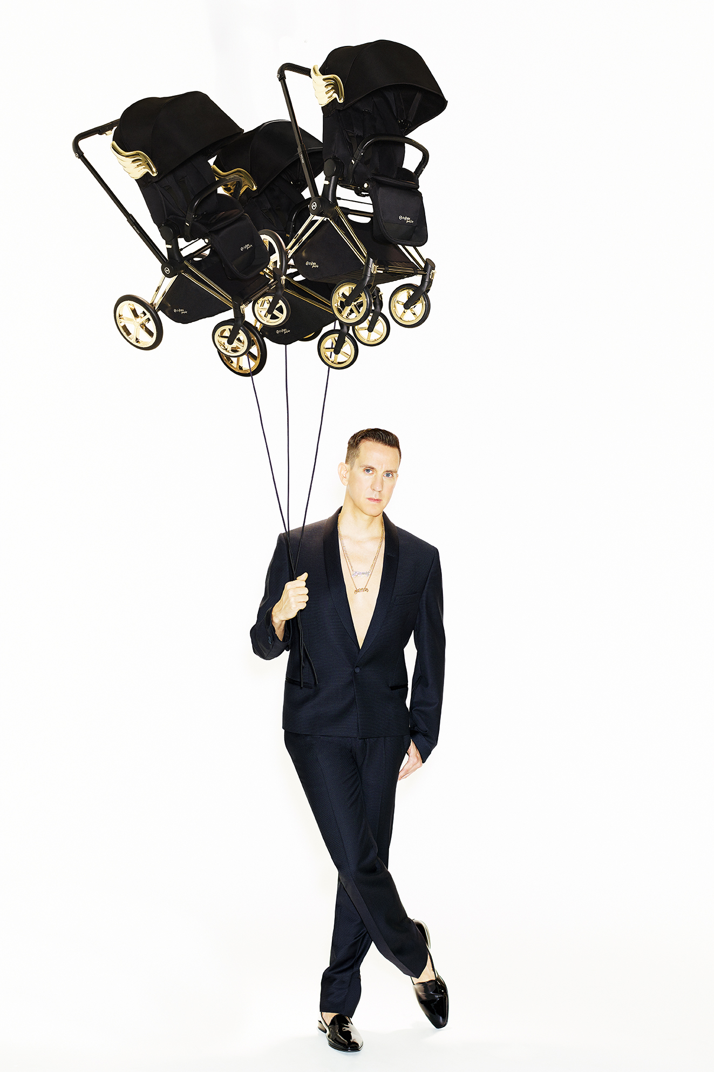CYBEX x JEREMY SCOTT

“Whimsical and unexpected”

*Fashion designer JEREMY SCOTT on his second collaboration with CYBEX, the wisdom of Bart Simpson, and bringing high fashion to parents.*

*Your work for CYBEX is child-friendly but not childlike, how do you walk the line?*

JEREMY SCOTT: I think “whimsical” is a great adjective to describe my design as it captures your imagination, with the contrast of the unexpected!

*Do you adopt an alternate mindset when working for children?*

Honestly, I approach each design the same way: how can I make it better? How can I make it unique? How can I make it visually clear that it comes from me?

*Has the discipline of designing in the children’s sector had any influence on your fashion work?*

The influence has been in the other direction – I have tried to bring my high fashion designs into a world that is for a child.

*Your last collection for CYBEX was a circus tent of colour, this one is black and gold. What is the direction?*

I wanted to show a contrast from the colourful and graphic first-season stroller set and pull ideas from a different part of my design vocabulary. This time I decided to do a rendition of my iconic wings in gold. The wings have a soft deco feel, and curve as well as volume, which make them look almost plush. I felt the perfect way for these wings to shine was to pair them with black – and just let all the details in the stroller, like the spokes of the wheels, go gold, so the gold can really sing!

*Wings feature in a lot of your work, including the critically-acclaimed Adidas by Jeremy Scott collection. What was your original inspiration for the wings?*

I’ve done wings in so many variations over so many years. From the very start of my collections there have been wing-like elements, from dresses and bustiers to jeans and, of course, later to my wing shoes. Freedom is what I express most: the wings are the ultimate expression that anything and everything is possible!

*What is it about your wings that have caught the popular imagination?*

I would say it is because they are whimsical and unexpected at the same time – an iconic element of our consciousness.

*You have used the slogan “adults suck then you are one” for your adult collections. Tell us more about your idea here.*

It’s a famous quote from the Great American Philosopher: Bart Simpson.

*Is there really no place like home?*

Yes it is true there is ‘no place like home’, as Dorothy says in ‘The Wizard of Oz’. But I’m from Kansas City, Missouri – Dorothy was from our neighbour state, Kansas.

*Your strollers and baby carriers are a beautiful matte black with shiny gold details. What would be a perfectly matching outfit for the parent?*

All black everything – with gold jewelry!

*What product would you most like to design, perhaps in partnership with CYBEX?*

A robot stork that really does fly, carrying your baby to you just like in the olden-day cartoons.

*What advice do you give to new parents to keep their style as they juggle careers, relationships and parenthood?*

‘Wipe and wear’ is a way for people to stay stylish with babies.

*CYBEX founder Martin Pos has built the company into a world leader in just 10 years, how does his kind of energy move you?*

Martin’s enthusiasm and passion for creating the best, most stylish and coolest products are, for sure, the reasons I chose to work with CYBEX again.

ABOUT CYBEX

*Founded in 2005 the German company CYBEX develops safe, innovative and lifestyle-led infant and children’s products for parents. The world of CYBEX is characterized by the desire not to only think the seemingly unthinkable but also to do it. This finds expression in the CYBEX D.S.F. Innovation Principle, which aims to combine distinctive Design, superior Safety and quality with ingenious Functionality. CYBEX delivers car seats, baby carriers and strollers to more than 100 countries, employing over 300 talented associates worldwide. For more information please visit* [*www.cybex-online.com*](http://www.cybex-online.com)

For all additional information:

Media Mania – Raf Caramin – 03/213 07 45 – [raf@mediamania.be](mailto:raf@mediamania.be) – [www.mediamania.be](http://www.mediamania.be)