

Biuro prasowe better. gaming agency
bettergamingagency.prowly.com

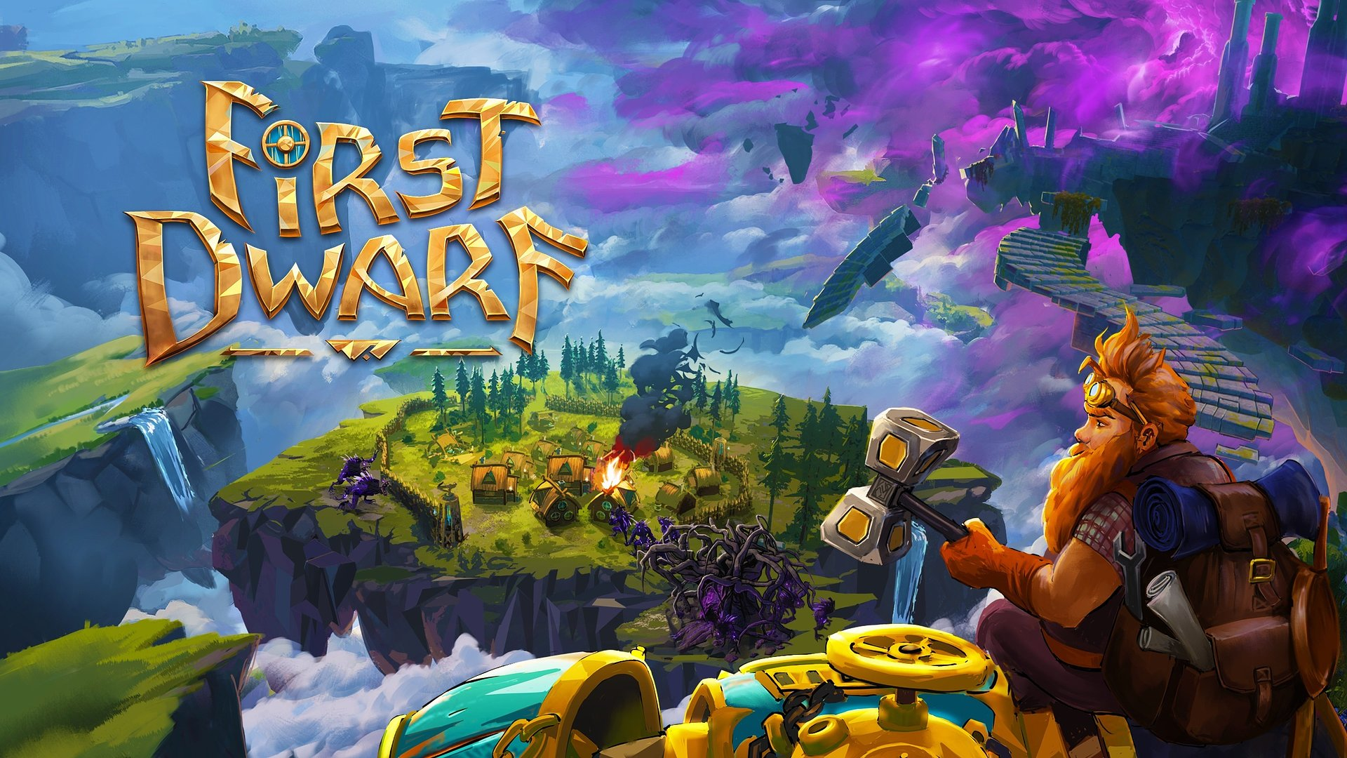

Off we go! First Dwarf available now

Today, Dwarf Tru, accompanied by the dragoness Ragna and thousands of players, will embark on a mission to find a new home for his clan. First Dwarf from Star Drifters studio is now available in Early Access on Steam. Specifically for this occasion, developers have prepared a brand new trailer and unveiled a roadmap outlining the game's Early Access development plans.

Engaging fans in creating the game was a fundamental principle for the developers. During open tests and demos, they have already seen how crucial the community support is. Star Drifters believe that together they can create a unique title. That's why the feedback provided during Early Access will be so important.

First Dwarf combines the best features of popular genres, so players should be prepared for a wide range of activities, such as exploring and gathering resources, building and managing a settlement, or even piloting a dwarven mech in battles. The story takes place in a unique world made of floating islands, where each of them brings new challenges.

First Dwarf - CGI - Early Access Launch Trailer

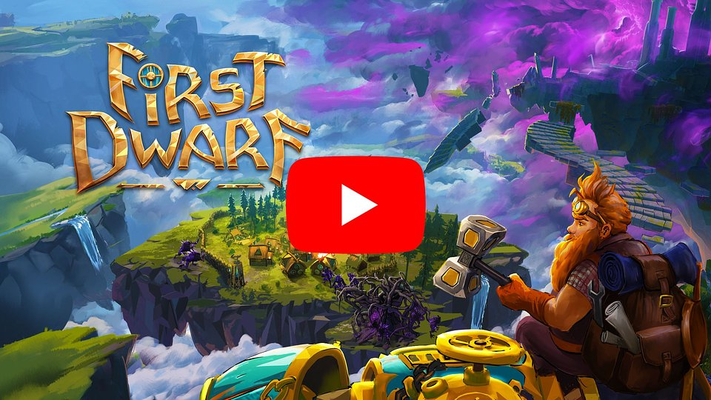
https://www.youtube.com/watch?v=NP93K8-3HbY

„We believe that Early Access is a powerful tool that allows us to involve the community in developing the game. Some of our previous titles were also released this way and we have many positive experiences with the program. The key here is honest communication between players and the team. First Dwarf is being created for players, so the opportunity to listen to their feedback and suggestions is incredibly helpful. Leading up to the version 1.0 release, there's a lot of hard work ahead of us, but we're looking forward with excitement to what the future brings”

- said Jakub Wójcik, Star Drifters' CEO.

The story developed by the team at Star Drifters will immerse players in the world of Driftland, a realm consisting of floating islands. Player’s main task is to find a place that can be inhabited by dwarves seeking refuge. However, the explorer's ship unexpectedly crashes on one of the islands, and the protagonist – dwarf Tru – must fight for survival in the hostile environment. He is supported not only by a powerful mech that he personally pilots, but also by an invaluable companion, dragoness Ragna.

First Dwarf - Early Access Launch Trailer

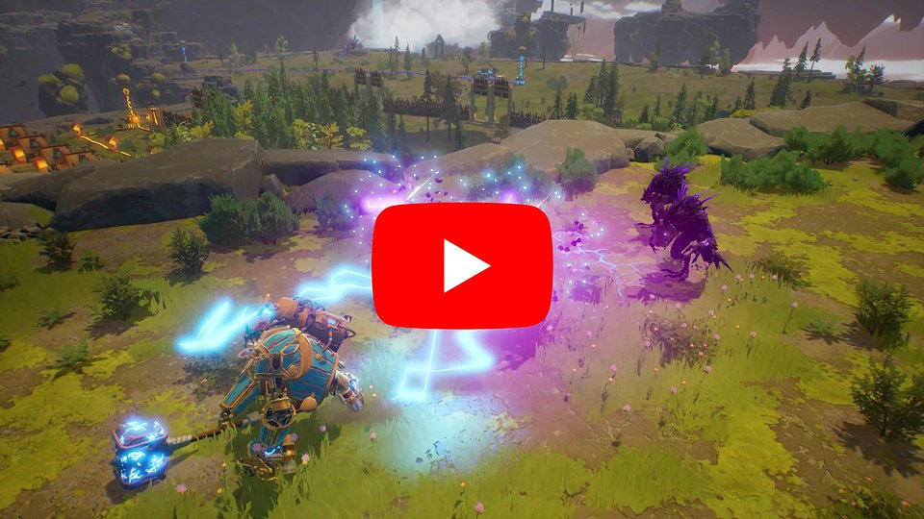
https://www.youtube.com/watch?v=SDAsV91QqDg

Building a colony and managing the settlers is another part of Tru’s job. With tower defense mechanisms, he can prepare his settlement for the worst. But it’s not all about survival - Tru will have to balance and fulfill the needs of new inhabitants, providing them with resources, shelter, and entertainment to boost their happiness. Only a prosperous society will allow our protagonist to pursue his own personal goal – discovering what evil taints these lands and what happened to the previous dwarven expeditions, including the one led by his father.

First Dwarf also features online and local co-op modes, allowing two players to join forces and take on the roles of either the dwarf or the dragoness, exploring, building, and uncovering new adventures together.

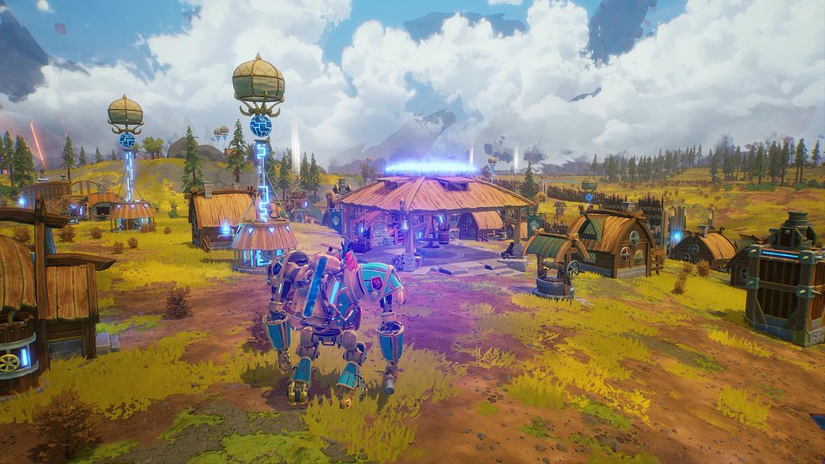

First Dwarf - key features:

⚒️ Control dwarf Tru, pilot a powerful mech and fly with Ragna the Dragon, each with their own skills to upgrade.
⚒️ Build, optimize and look after your colonies.
⚒️ Upgrade, craft and discover new structures, technologies, tools and weapons.
⚒️ Fight tainted enemies by engaging in close combat and by building defensive turrets and walls in advance, preparing not only for monster waves, but also natural disasters.
⚒️ Heal tainted animals or purge the island of them - the choice is yours.
⚒️ Unveil the hidden secrets of Driftland and learn the truth about Tru’s father’s past.
⚒️ Embark on an adventure alone or with a friend in co-op assist mode.

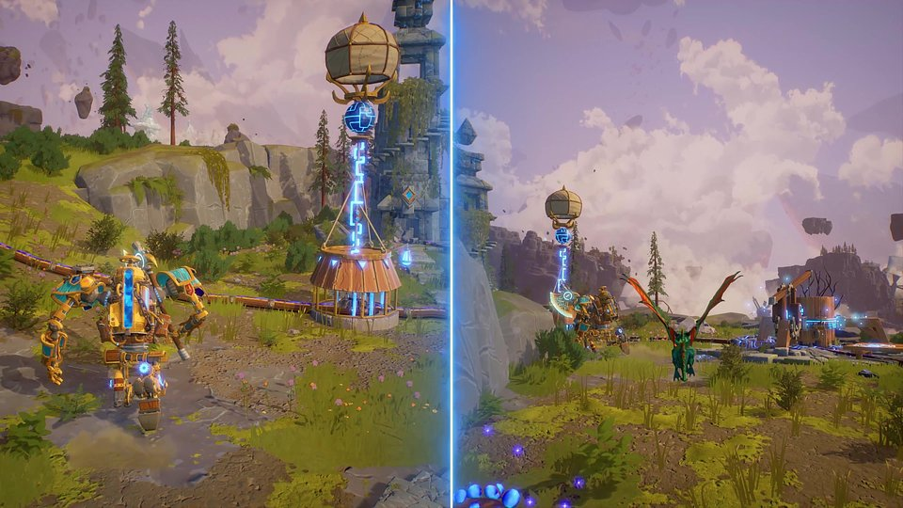

First Dwarf is now available in Early Access on Steam starting today (June 19th, 2024) for 24,99 USD/23,99 EUR with a 15% discount for two weeks after launch. The game is also being developed for consoles such as PlayStation 5, Xbox Series S/X, and Nintendo Switch, where it will be released shortly after the version 1.0 launch.

The full press kit is available here.

About Star Drifters:
Star Drifters is an independent game development studio based in Warsaw, Poland. The company was founded in 2014 by two industry veterans: Michal Sokolski and Krzysztof Jakubowski. During a nearly two-decades-long career, they’ve worked on numerous titles for all major gaming platforms and gained extensive experience in game development and management.Since 2020, the team has begun incubating selected indie titles and the teams behind them. The scope of support is individually tailored and covers areas from production, design, and positioning through financing to the sale of the final product. Star Drifters’ mission is to create engaging, challenging, and highly replayable games that will remain in players’ memories for a long time.The studio is known for creating and publishing the real-time 4X strategy game Driftland: The Magic Revival, the rogue-lite game Danger Scavenger, and the top-down shooter with base-building mechanics Lumencraft.

