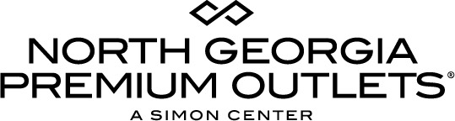
For more information:
McKenzie Riley
BRAVE Public Relations
404.233.3993
mriley@emailbrave.com

**MEDIA ADVISORY**

North Georgia Premium Outlets to celebrate military community with
Veterans Day Weekend Sale, November 10 – 12
Center offers additional discounts and reserved parking for military members and families!

Dawsonville, Ga. (November 1, 2018) – North Georgia Premium Outlets invites families to scope out deals on the latest fall fashions during its Veterans Day Weekend Sale from Saturday, November 10 – Monday, November 12. Dawsonville’s top shopping destination will host enormous savings of up to 65 percent off on sought-after brands throughout the holiday weekend, where shoppers can save on cozy sweaters at Tommy Hilfiger and True Religion, activewear from The North Face and Columbia Sportswear, trendy handbags from Vera Bradley and so much more!

To support veterans, active military members and their families, North Georgia Premium Outlets is proud to offer special military discounts with valid military ID at a selection of retailers marked with a patriotic star on the window. For a complete list of participating retailers, please visit premiumoutlets.com/northgeorgia Additionally, veterans and active members of the military can enjoy reserved veteran parking spaces around the center as a small token of the community’s gratitude for their service!

WHAT: North Georgia Premium Outlets Veterans Day Weekend Sale
Shop and save on fall fashions with special military discounts and reserved parking for those who serve!
WHERE: North Georgia Premium Outlets
800 U.S. Highway 400 S.
Dawsonville, GA 30534
WHEN: Saturday, November 10 – Monday, November 12

HOW: Veterans, military members and their families can enjoy special discounts at participating retailers and reserved veteran parking!

MORE INFO: Shoppers are invited to join the VIP Shopper Club at premiumoutlets.com/vip for a connection to FREE exclusive VIP offers, the latest on center promotions and events, VIP Savings Passport and much more, all available with convenient mobile phone access. For more information, visit North Georgia Premium Outlets at premiumoutlets.com/northgeorgia and connect on Facebook, Twitter and Instagram.

###

