Bring them closer to the music this Holiday Season with Sennheiser
With outstanding audio products for every passionate musician, Sennheiser has the perfect gift for performance, recording and monitoring

Wedemark, October 12, 2021 – This holiday season, why not help the musician in your life get even more from their music? Whether they’re taking to the stage or recording at home, listening to every beat or simply wanting to be heard above the band, audio specialist Sennheiser has your back this holiday season. With its range of world-class professional audio products, including legendary monitoring headphones, durable microphones that can take on any stage or even the most effortlessly simple advanced wireless audio, Sennheiser can help you find the perfect present for passionate musicians.

MK 4 – Sparkling quality in the studio, at home or on stage with a true all rounder
An outstanding all-rounder, the MK 4 is a large-diaphragm true condenser microphone that focuses on delivering the best possible sound quality, while still being an affordable choice for home recording. The MK 4 is a great gift choice thanks to its versatility – it’s an ideal match for vocals, acoustic guitars, grand pianos as well as for strings and wind instruments. The MK 4 is also tough enough to take on stage where it sounds fantastic miking guitar amplifiers, drums and percussion. In addition to suiting professional studio and stage work, it is also an ideal choice for voice-overs. The MK 4 is much loved for its powerful yet warm sound, which is both direct and tight with fine treble resolution.

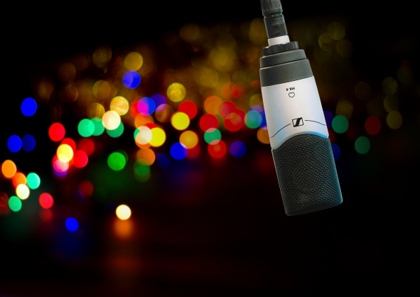 | The MK 4 is a large-diaphragm true condenser microphone for home, project, and professional studios. Ideal for vocals and acoustic instruments

- Large-diaphragm, true condenser microphone with cardioid pick-up pattern
- Harmonious presence, vivid mids and very detailed bass
- Excellent suppression of handling noise ensured by internal capsule mount which can be further optimised with an optional elastic suspension
- Effortlessly easy to handle and excellent value for money
- MSRP (incl. VAT): EUR 299

Stage confidence with the e 835 and e 835 S
It takes a special X factor to step on stage and project your voice, but having a great mic can really help to take a performance to new levels. Offering maximum flexibility and clarity for vocal performances, the e 835 is an incredibly popular choice for performers that demand to be heard. Picking up the rugged metal mic will instantly inspire confidence and the sound will let them truly soar. Forget muffled vocals – the e 835’s tight low mids and present treble deliver crystal-clear and natural singing or speech, without feedback, spill or handling noise.

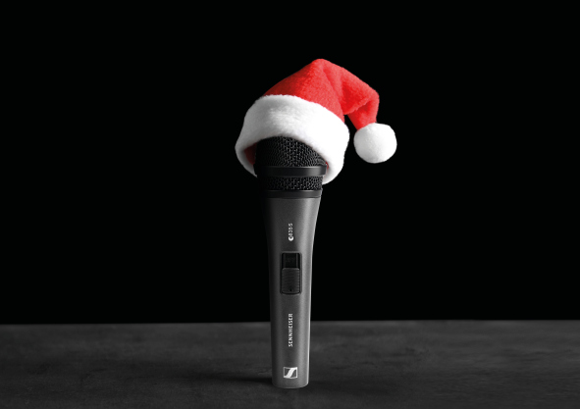 | A dynamic cardioid microphone that projects well and cuts through high volumes on stage, the e 835 S is intended for home recording, semi-pro studios and live sound

- Dynamic cardioid microphone for speech and vocals
- Cuts through high on-stage levels and ensures clear reproduction with a high presence
- Consistent sound quality at varying distances and when moving off axis
- Able to handle high sound pressure levels
- Available with (e 835 S) and without (e 835) silent on/off switch
- MSRP (incl. VAT): EUR 99

e 935 – The perfect choice for the most demanding on-stage performers
Looking for a mic for a truly demanding vocal performer who wants to bring more intensity to their voice – even during the most intense gigs? With the e 935, you’ll present the singer in your life with a New Year – and many years – of extraordinary sound. With a balanced frequency response that suits songs of every genre, the e 935 clearly gives the voice more space, and positions it cleanly in front of loud instruments. With a transparent high-end and warm but well defined lower mids, it lends even gentle voices an impressive intensity and size. And no matter how passionate the performer, its extremely rugged metal housing is more than ready for the hard knock life of gigs.

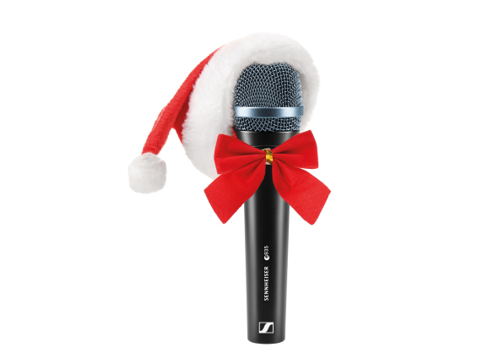 | With a transparent high-end and warm but well defined lower mids, the e 935 lends even gentle voices an impressive intensity and size, positioning them cleanly in front of loud instruments

- Dynamic cardioid microphone that clearly emphasizes voices on loud stages
- Transparent high-end and warm, defined lower mids
- Highly consistent directivity
- High feedback rejection
- Shock-mounted capsule and extremely rugged metal housing
- MSRP (incl. VAT): EUR 199

Give the gift of effortless digital wireless performance with Evolution Wireless Digital
The ground-breaking Evolution Wireless Digital offers wireless microphone solutions without complexity – but with all the amazing sound quality and dependability that artists love about Sennheiser wireless. With an EW-D microphone, you can give the freedom to perform, with fast set up and no intimidating tech challenges as the series introduces an easy, app-based workflow. At the same time, it still retains all the professionalism, multi-channel capability and pro reliability that musicians have come to expect of UHF and 1G8 microphones. The systems include everything you need to ditch the cables and hit the stage in style.

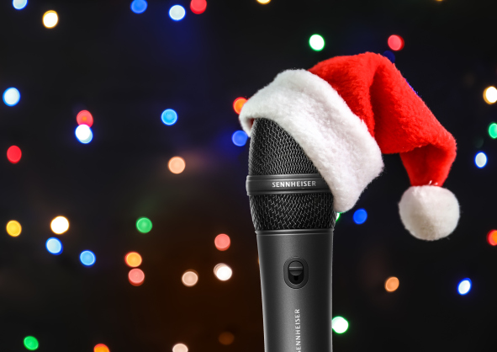 | The Evolution Wireless Digital series introduces an easy, app-based workflow while retaining all the professionality, multi-channel capability and reliability of UHF and 1G8 microphones

- All-in-one wireless systems with a choice of handheld, instrument, lavalier, headmic, combo and base sets
- The engineer in your pocket: the Smart Assist App guides users through the set-up of their wireless microphone system
- MSRPs (incl. VAT): EUR 699 for the EW-D 835-S SET for vocalists, or EUR 649 for the EW-D Ci1 SET for instruments

IE 100 PRO Wireless – Take precise in-ear listening from the stage to the streets
The passionate musician in your life is also sure to be passionate about listening to music. This is where Sennheiser’s IE 100 PRO Wireless in-ear monitors are the ideal present. They can take the top-grade monitor sound needed on stage to the street thanks to the inclusion of a Bluetooth® connector that can be swapped with the cable when preferred. The IE PRO BT connector features a built-in microphone, remote for call and music control and a battery life of up to ten hours. It’s a perfect two-in-one gift – top-quality monitoring for performing and outstanding wireless headphones for every other occasion.

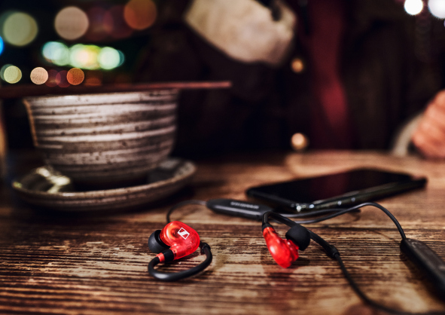 | The IE 100 PRO Wireless in-ears offer stellar stage sound to go and for home use

- IE 100 PRO in-ears offer a natural, warm and utterly precise monitoring sound that makes it easy to fine-tune performances with ease
- The IE 100 PRO Wireless additionally includes the IE PRO BT Connector. This lightweight semi-wireless cable lets users enjoy great audio with all the freedom of a Bluetooth connection
- MSRP (incl. VAT): IE 100 PRO Wireless for monitoring and everyday listening: EUR 149; IE 100 PRO for monitoring: EUR 99

A truly legendary gift: The Sennheiser HD 25
For a truly timeless gift, how about a timeless set of monitoring headphones with a legendary status? Revered across the music industry – and especially by DJs due to their low weight and the option of one-ear listening - the HD 25 headphones are indispensable for mobile monitoring. Capable of handling very high sound pressure levels and of extremely robust construction, the closed-back HD 25 perform exceptionally well in loud environments and offer high attenuation of background noise. As well as the iconic HD 25, with features like a split headband and rotating ear capsules for single-ear listening, the same legendary sound performance is also available in the incredibly affordable HD 25 LIGHT with simpler mechanics.

The industry standard for monitoring and DJs, the HD 25 headphones perform exceptionally well in loud environments and offer high attenuation of background noise

- Closed, supra-aural monitoring headphones
- High sensitivity due to lightweight aluminium voice coils
- Capable of handling very high sound pressure levels
- Very lightweight and comfortable
- MSRP (incl. VAT): HD 25 with split headband and rotatable capsule for single-ear listening: EUR 149; HD 25 LIGHT: EUR 99

Outstanding monitoring comfort with the HD 300 PRO
A comfortable pair of headphones are essential for anyone that has to perform at their best while maintaining their focus for long hours. With a sound design modelled on the legendary HD 250 Linear, Sennheiser’s top-of-the-range HD 300 PRO monitoring headphones are an ideal gift for demanding engineers and music-makers alike. Regardless of whether they are editing, playing or composing music, the HD 300 PRO will provide the precision, detail and linear sound reproduction they need to get everything perfect.

Sennheiser’s top-of-the-range HD 300 PRO monitoring headphones are an ideal gift for demanding engineers and music-makers, offering precision, detail, and linear sound reproduction

- Closed, circumaural monitoring headphones
- Audio and mechanics fine-tuned with professional users
- Precise, linear sound reproduction
- Designed for comfort and excellent shielding against outside noise
- Split headband padding, special fork design and comfort zone for the temples of those wearing glasses
- Detachable cables with improved protection against handling noise
- MSRP (incl. VAT): EUR 199

(Ends)

The images accompanying this press release can be downloaded here.
Standard product photos can be downloaded here.

About Sennheiser
Shaping the future of audio and creating unique sound experiences for customers – this aim unites Sennheiser employees and partners worldwide. The independent family company, which is managed in the third generation by Dr. Andreas Sennheiser and Daniel Sennheiser, is today one of the world’s leading manufacturers of headphones, loudspeakers, microphones and wireless transmission systems. In 2020, the Sennheiser Group generated turnover totaling €573.5 million. www.sennheiser.com

Global Press Contact

Stephanie Schmidt
Stephanie.schmidt@sennheiser.com
+49 (5130) 600 – 1275

