For more information, please contact Marta de Paco
On +34 670 780 664 or email press@comunicahair.com

Important:
These images are only available for editorial content.
Credits must be included.
Notification of their publication is expected.

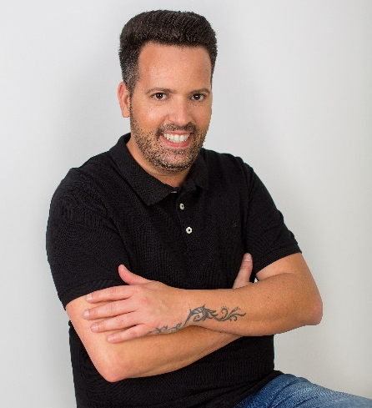
RAFAEL BUENO PELUQUEROS
THE WARRIOR OF THE LIGHT Collection

2021 FÍGARO AWARDS WINNER
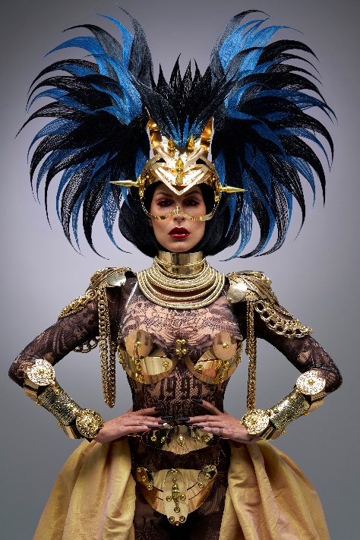
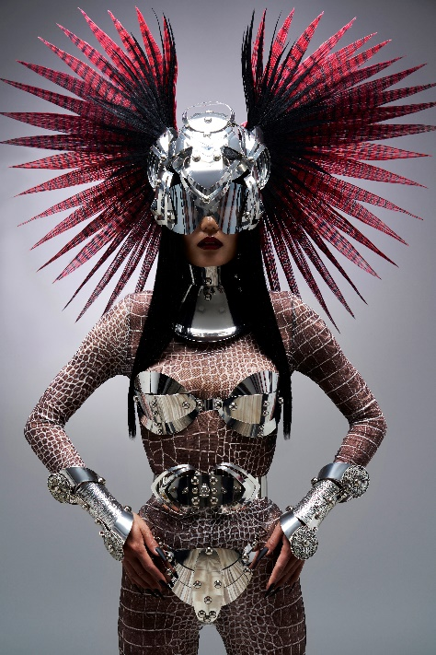
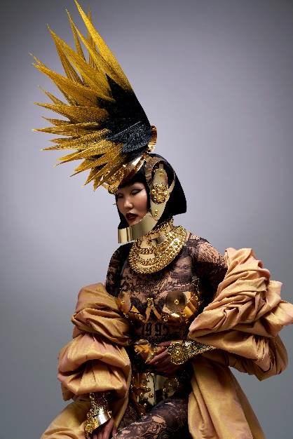
SPANISH HAIRDRESSER OF THE YEAR CATEGORY

Hair: Rafael Bueno Peluqueros @rafaelbuenopeluqueros
Hair Assistant: Moises Utrera @moysesutrera
Photography: Alberto Zaldivar @albertozaldivar
Retouche: Alberto Zaldivar @albertozaldivar
MUA: Lulú Pérez @_luluperez_
Styling: Julián @jeatelier
Models: Isabella @isabella_dana
Baira @baira_mlg
Products: Revlon Professional @revlonprofessional_es
Elegance Hair Extensions @elegancehairextensions
RAFAEL BUENO PELUQUEROS
THE WARRIOR OF THE LIGHT Collection

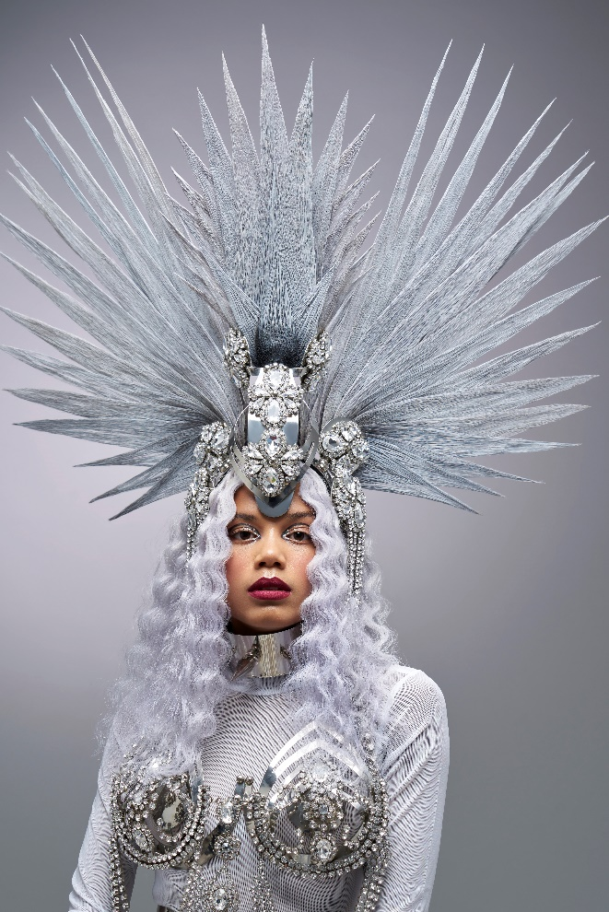

"The Warrior of Light" was born because it’s very important to remember the energy we carry within, that which is capable of endowing us with inordinate power and savage bravery to face life as it comes. That’s why the headpieces vindicate our personal power through shapes that simulate sparkles with finishes that also remind us of ancient deities. The result is majestic and full of symbolism.

