World Hearing Day: A smarter way towards more inclusive education Sennheiser’s MobileConnect helps make education more inclusive for hearing-impaired students

Wedemark, 27 February 2020 – March 3 is World Hearing Day, an initiative by the World Health Organisation (WHO) to raise awareness to prevent deafness and hearing loss and promote ear and hearing care across the world. The motto this year is “Don’t let hearing loss limit you”, focusing on how people with hearing impairments can achieve their full potential.

This is a vital message: According to the WHO, 466m people – 6.1 of the world’s population – are estimated to be living with hearing loss. Too often, hearing impairment can result in being excluded from full participation in society – with education being a key area where this exclusion can begin. In the wider context of disability, UNICEF notes that “nearly 50 per cent of children with disabilities are not in school, compared to just 13 per cent of their peers without disabilities”. This situation continues into higher education, where many deaf and hearing-impaired students struggle to fully achieve their potential due to the lack of support.

However, there are also opportunities to close the gaps through inclusive education that teaches people with diverse abilities side by side. This is a complex challenge, requiring solutions that combine advocacy, policy and training, but surprisingly it is also an area where smartphone technology is helping to play a role.

Many deaf and hearing-impaired students don’t receive the support needed to fully achieve their potential and benefit from education

Accessibility by smartphone
The accessibility of smartphones has become an increasingly hot topic over recent years, with recent iterations of iOS™ and Android™ making it easier for users with limited visual, hearing or mobility to operate devices themselves. Yet, as personal devices that are always on, always available, smartphones are increasingly also offering a way for users to take more control of how they interact with the outside world. At the simplest level, the transition of more services online, is making it easier for those with hearing impairments to navigate the world: from engaging with companies through online chat to shopping online, smart devices are making digital access ever more convenient.

Additionally, dedicated solutions and apps are increasingly available to make the information available in the audio world more accessible. For example, apps are now available that can transcribe speech in real time or detect important sounds and flash visible onscreen alerts, and even translate speech into sign language. British charity, Action of Hearing Loss, provides an overview of several helpful solutions here. What unites such mobile solutions is the unprecedented combination of user-friendliness, connectivity and computing power that smartphones place in the hands of users. And these very same qualities are also proving transformational in education.

BYOD in education – MobileConnect from Sennheiser
The simplicity and ubiquity of smartphones is the key to Sennheiser’s MobileConnect solution, which aims to enable easier accessibility for hearing impaired people in sectors such as higher education.

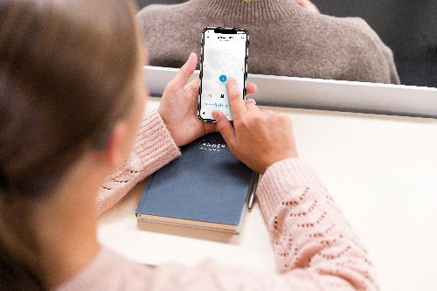 | The MobileConnect App turns the student’s smartphone into an audio receiver. The app enables the user to personalise the audio signal in a way that best suits their hearing requirements

MobileConnect – which is used by universities and organizations the world over, including the the Royal Society of Medicine (UK) and the Freie Universität Berlin (Germany) – is a streaming system for assistive listening that delivers high-definition sound to users’ own mobile phones, turning them into an audio receiver. MobileConnect converts lecturers’ microphone signals into audio streams that can be easily accessed via the campus Wi-Fi system. This lets students comfortably participate in lectures via hearing aids, cochlear implants or headphones, allowing them to follow the lecturer with a latency that is hardly noticeable.

Crucially, the easy-to-use app features a Personal Hearing Assistant, whose compressor algorithms were developed in conjunction with the Fraunhofer Institute for Digital Media Technology (IDMT). Via an intuitive touchscreen, the Assistant makes it simple to adjust the sound to an individual’s hearing deficiency and listening preferences, thus ensuring optimum speech intelligibility.

Unlike traditional systems such as those that work with induction loops, MobileConnect uses mainstream technologies such as Wi-Fi and smartphones to make it easier for venues to offer high-quality assistive hearing support. The solution has proved ideal for universities, which often have legal obligations to provide accessible solutions but struggle to deliver these across a large number of lecture halls, many of which can be difficult to retrofit with new technology.

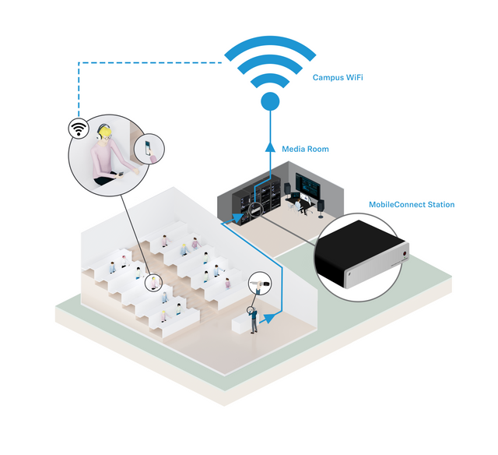 | MobileConnect uses the existing Wi-Fi network so that no special services have to be installed. Students can access the service anywhere throughout the campus by simply choosing the channel number in the smartphone app or scanning a QR code

“MobileConnect provides assistive listening in an extremely simple way via Wi-Fi and the students’ personal smartphones,” explains Jakub Kolacz, Manager Product & Commercialization at Sennheiser Streaming Technologies. “Students do not have to sit in a designated area or use a special receiver but can choose their seat wherever they like in the lecture hall – this is true inclusion.”

Kolacz adds, “By making access easier for students and also more cost-efficient for the operators, we believe that “bring your own device” solutions enabled by ubiquity of smartphones is proving a game changer.”

iOS is a trademark of Apple Inc. Android is a trademark of Google LLC.

The images to this press release can be downloaded at https://sennheiser-brandzone.com/c/181/okK4L8dz.

About Sennheiser
Shaping the future of audio and creating unique sound experiences for customers – this aim unites Sennheiser employees and partners worldwide. Founded in 1945, Sennheiser is one of the world’s leading manufacturers of headphones, loudspeakers, microphones and wireless transmission systems. Since 2013, Sennheiser has been managed by Daniel Sennheiser and Dr. Andreas Sennheiser, the third generation of the family to run the company. In 2018, the Sennheiser Group generated turnover totaling €710.7 million. www.sennheiser.com

Press contact

Stephanie Schmidt
Stephanie.schmidt@sennheiser.com
+49 (5130) 600 – 1275

World Health Organization 2020, Deafness and hearing loss: https://www.who.int/health-topics/hearing-loss
UNICEF, Inclusive education. Every child has the right to quality education and learning: https://www.unicef.org/education/inclusive-education

