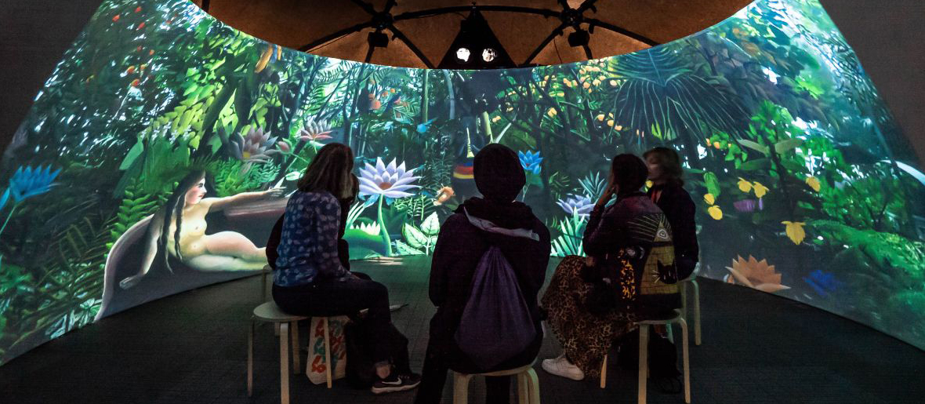

Sennheiser, Neumann and Igloo Vision cooperate on Shared VR
Shared VR turns “VR loneliness” into an exciting group 3D experience

Wedemark/Berlin/Shropshire, 1 October 2019 – Stunning entertainment, fully realistic training or inspirational video- and soundscapes – the new spatial audio solutions created by Shared VR company Igloo Vision and audio experts Sennheiser and Neumann are set to turn the individual VR experience into a new form of collective enjoyment. The solution lets museums, artists, education facilities, event spaces, architects and corporations offer attractive immersive experiences that can be fully tailored to their needs.

Creating totally realistic immersive scenarios for visitors: Igloo Vision has partnered with Sennheiser AMBEO and Neumann | 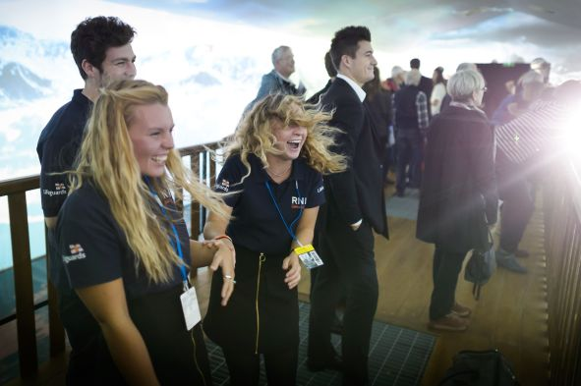

Igloo Vision has partnered with Sennheiser and Neumann to create the ultimate in immersive sound and vision: an Igloo Shared VR space equipped with an AMBEO 9.1 sound system created from compact Neumann KH 80 DSP studio monitors.

The environments act like a giant VR headset: Wraparound sound and vision immerse entire teams in 360° or VR content. With Igloo spaces ranging in size from 5 to 21 metres in diameter, up to 750 people can join the experience and be engaged, inspired or entertained. Adding the Sennheiser AMBEO 9.1 system means that true 3D spatial soundscapes can be reproduced, enabling sound designers to precisely pinpoint the locations and sources of different sounds, accurately linking what is seen with what is heard.

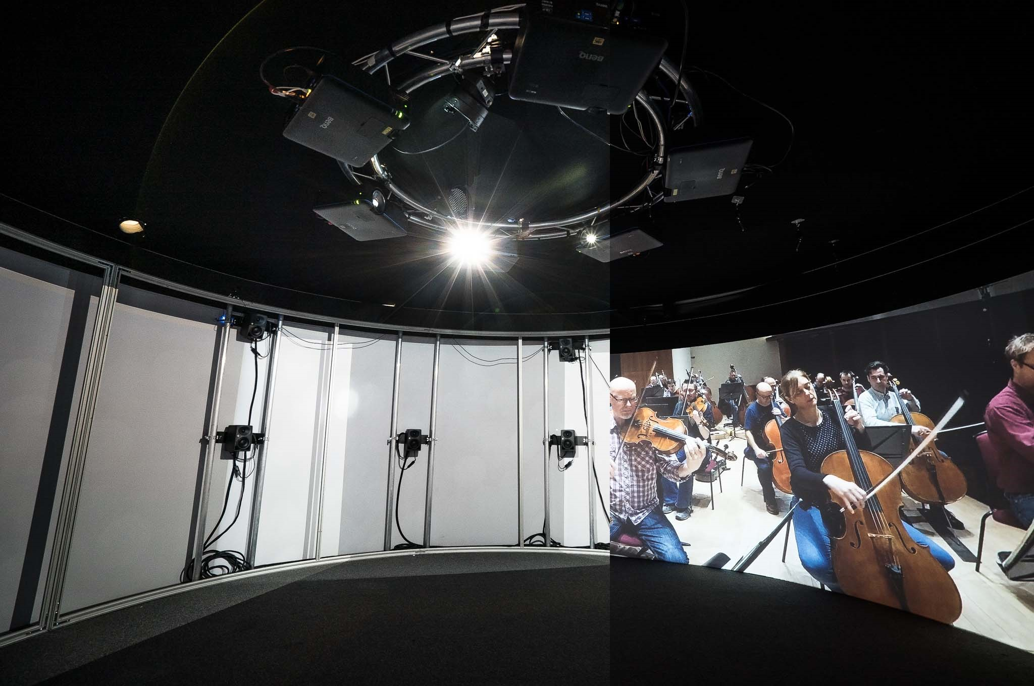  The Neumann KH 80 DSP loudspeakers are set up in a 9.1 arrangement behind the acoustically transparent screen of the Igloo cylinder, fully enveloping visitors in the orchestra sound | 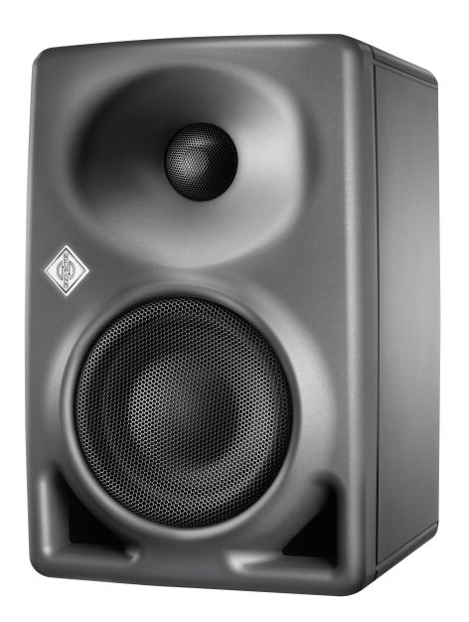  The Neumann KH 80 DSP

The first step in the partnership has been to install and calibrate the 9.1 loudspeaker system in the standard 6-metre Igloo Shared VR cylinder. The resulting AMBEO Igloo cylinder works with an acoustically transparent screen that lets the high-quality audio pass unhindered, allowing for full immersion in both audio and video.

As Véronique Larcher, Director of AMBEO Immersive Audio at Sennheiser, points out: “The spatial audio experience really makes or breaks the illusion – and this captivating combination of 360° video and spatial 3D audio creates a totally convincing experience of being in a different environment.”

Colin Yellowley, Founder and Head of R&D of Igloo Vision, added: “Besides the huge field of immersive experiences for brands, Igloo is active in the field of simulation, where real-life scenarios are recreated for training and education purposes, and also in visualisation, helping customers see how finished design concepts will look and feel. With three-dimensional audio added to the 360 vision, we can now create even more lifelike experiences for clients.”

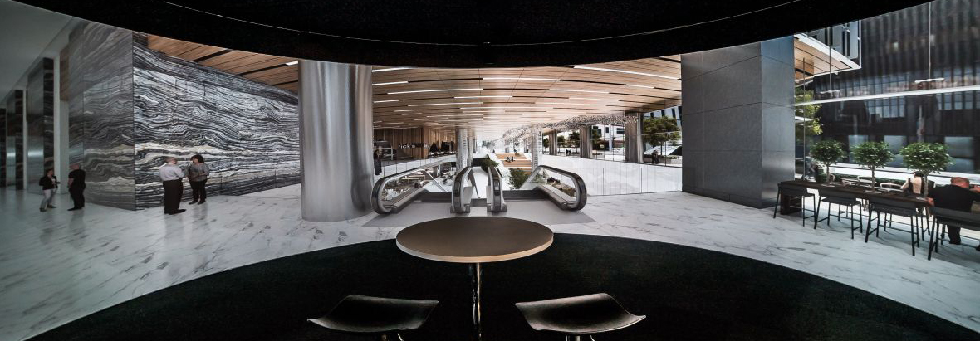
Igloo Vision invites you to take a walk in a building that yet needs to be erected…

Thanks to the partnership, Igloo is able to offer a wide range of ready-made spatial audio solutions: As well as the 6-metre Igloo cylinder, Sennheiser AMBEO systems can be specified and calibrated for any Igloo products – which range from 2.5-metre projection cubes right up to 21-metre projection domes. Clients and sound designers are invited to experience – and also to test their existing content – at Igloo Vision’s Shared VR demo centre in Wood Green, London.

To learn more about the cooperation, please view this video https://vimeo.com/352236322; for information on how Igloo projection spaces work view https://vimeo.com/350077240, or for a sample of Igloo content, please view https://vimeo.com/348564725. This video shows a screening of the 360° film Sea Prayer, by award-winning novelist Khaled Hosseini, produced in collaboration with UNHCR, the Guardian and Google.

The images accompanying this press release can be accessed here: https://www.flickr.com/photos/igloovision/albums/72157711126161342

About Igloo Vision
Igloo Vision, the Shared VR company, has been designing and developing immersive 360° projection spaces for over 10 years. With an in-house team of technologists, it creates immersive 360° projection domes and projection cylinders, all powered by the Igloo Media Player. Stepping inside an Igloo is a bit like stepping inside a giant VR headset. And because entire groups of people can get inside, it’s always a shared experience. It’s perfect for collaborative teamwork, training, and visualisation. Igloo has worked on several hundred assignments for many of the world’s biggest brands. Headquartered in rural Shropshire, it also has offices in London, New Jersey, Los Angeles, Melbourne and Toronto. Find out more at www.igloovision.com.

About Sennheiser and Neumann
Shaping the future of audio and creating unique sound experiences for customers – this aim unites Sennheiser employees and partners worldwide. Founded in 1945, Sennheiser is one of the world’s leading manufacturers of headphones, loudspeakers, microphones and wireless transmission systems. Since 2013, Sennheiser has been managed by Daniel Sennheiser and Dr. Andreas Sennheiser, the third generation of the family to run the company. As part of the Sennheiser Group, Georg Neumann GmbH, known as “Neumann.Berlin”, is the world’s leading manufacturer of studio microphones. Founded in 1928, the company has been recognized with numerous international awards for its technological innovations. Since 2010, Neumann.Berlin has expanded its expertise in electro-acoustic transducer design to also include the studio monitor market, and has recently added studio monitoring headphones to its portfolio. In 2018, the Sennheiser Group generated turnover totaling €710.7 million.
www.sennheiser.com | www.neumann.com

Igloo Vision PR Contact

Peter Halliday
peter.halliday@igloovision.com
+44 (0) 7974 231 690

Local press contacts
Sarah James Victoria Chernih
sarahj@gasolinemedia.com.com victoria.chernih@sennheiser.com
+44 1483 223333 +44 7881 091687

