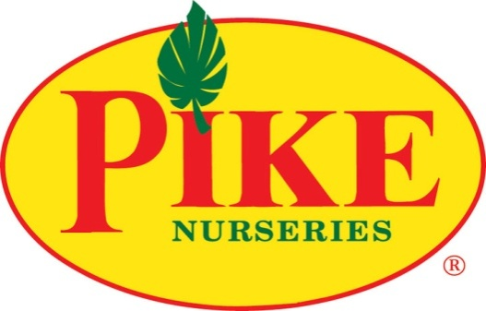

FOR MORE INFORMATION:
Laurel Haislip/Becca Meyer
BRAVE Public Relations, 404.233.3993
lhaislip@bravepublicrelations.com/
bmeyer@bravepublicrelations.com

FOR IMMEDIATE RELEASE
“Fall” into fall: Pike Nurseries offers limited-time landscape promotion through August 24!
Local garden center helps green thumbs beat fall rush with lowdown on landscaping
ATLANTA (August 10, 2017) – A hint of autumn is in the air, and gardeners everywhere are gearing up for luscious lawns this season! Thankfully, the experts at Pike Nurseries are lending a helping hand so homeowners can achieve garden and landscaping dreams. Gardeners looking to beat the fall rush can schedule a landscaping design appointment now through August 24 and receive FREE drip irrigation when the project is installed (up to a $1000 savings, some restrictions apply). By delivering water right to the root of the plants through tubing, drip irrigation is the perfect, money-saving solution for smart, efficient watering in all types of weather. Beyond keeping gardens and wallets green throughout the year, creating a strategic landscaping plan with Pike Nurseries has many benefits for homeowners with or without green thumbs.
Pump Up Property Value
A well-designed landscape can not only boost curb appeal, but can add up to 20 percent to the home’s value. By adding strategic lighting into the design, homeowners can also deter crime by making it more difficult for criminals to access the home unseen.
Lower Energy Costs
Planting trees around the exterior of the home can help avoid high air conditioning costs by providing natural shade and insulation to the house. Additionally, trees can block chilly winter winds to help decrease heating costs.
Maximize Fun in the Sun
Strategic landscaping can increase the overall size of the home by adding outdoor living space to allow more time spent outside with friends and family. In addition, landscaping can keep noise pollution at a minimum and block unsightly views. Homeowners seeking increased functionality from lawns can incorporate edible plants, like vegetables, fruits and herbs, to provide healthy and convenient sources of nutrition for the whole family.
Help Out Mother Earth
Animals can also benefit from strategic landscaping. Plants provide food and shelter for bees, birds, butterflies, squirrels and other animals. Plants decrease air pollution as well by absorbing carbon dioxide and releasing oxygen, which helps the earth (and its inhabitants) breathe easier.

Whether it’s a complete yard makeover or a simple planting, no landscape installation is too small or too big for the experts at Pike Nurseries. For more about Pike Nurseries’ landscaping services, visit www.pikenursery.com/landscaping. For discount details and to book an appointment, call 404-255-7526. Offer is valid only through August 24; some restrictions may apply.
ABOUT PIKE NURSERIES
Ever committed to its customers’ gardening success, Pike Nurseries takes pride in taking the guesswork out of gardening and helping its customers play in the dirt. Offering superior knowledge, quality and selection in a friendly, caring environment, Pike Nurseries has been an Atlanta icon for over 50 years. Founded in 1958 by Pete Pike, its ability to adapt to market conditions and community needs has made it a respected Southern institution. As Atlanta’s oldest garden chain, Pike Nurseries has 17 retail locations in the Atlanta, Ga. and Charlotte, N.C. areas. Now led by CEO Mike Kunce, Pike Nurseries looks forward to continued growth as it keeps Atlanta and Charlotte beautiful, one landscape at a time.
For more information, please visit Pike Nurseries online at pikenursery.com.
Visit Pike Nurseries on Facebook, Twitter, Pinterest and Instagram.

# # #

