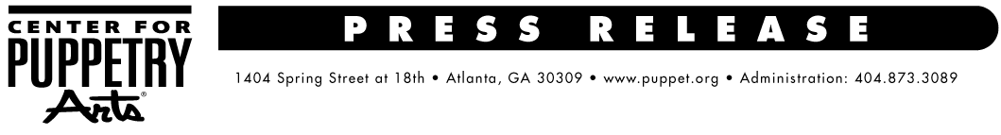

FOR MORE INFORMATION:
Chelsea Bohannon / Jennifer Walker
BRAVE Public Relations, 404.233.3993
cbohannon@bravepublicrelations.com/
jwalker@bravepublicrelations.com
FOR IMMEDIATE RELEASE
Center for Puppetry Arts to host Jim Henson 80th Birthday Celebration, September 24
Special activities to honor life of iconic puppeteer and visionary artist

ATLANTA (July 20, 2016) – A momentous occasion to celebrate Jim Henson’s 80th birthday, Center for Puppetry Arts will host a birthday bash on Saturday, September 24, 11 a.m. -5 p.m.! Festivities will include a special guided tour of the Jim Henson Collection, Henson-focused story time, puppet building, Henson gallery carts with an informal Q&A with Center conservators and will culminate with special film screenings of Jim Henson’s The Storyteller and Farscape at 8 p.m. All activities will take place in and around the Jim Henson Collection in the newly expanded Worlds of Puppetry Museum at the Center, which also includes a Global Collection.

Festivities are as follows:
- 11 a.m. Special Guided Tour of the Jim Henson Collection
- 12:30 & 2:30 p.m. Henson-Focused Story Time
- 1-4 p.m. Fantastical Friends Puppet Building in the Center’s Atrium
- 2-5 p.m. Henson Gallery Carts and an informal Q&A with the Center’s Jim Henson puppet conservators
- 8 p.m. Screening of The Storyteller and Farscape

With the exception of the special guided tour and the film screenings, all activities are FREE with Museum admission.

Continuing its Henson-related programming on Monday, September 26, the Center will host a special Explore Puppetry Series workshop, Costuming: Puppets, Muppets & Mascots, with Bonnie Erickson of the Jim Henson Legacy, Harrison/Erickson, Inc. and Acme Mascots. Erickson was part of the original design team for The Muppet Show and is credited as the designer and builder of Miss Piggy, now a part of the Center’s Jim Henson Collection. The workshop, for ages 18 and up, is from 7-9:30 p.m. The cost is $30 for members and $40 for non-members. Industry and student discounts are available with current student ID.

What: A Jim Henson 80th Birthday Celebration
When: September 24 & 26, 2016
Where: Center for Puppetry Arts
1404 Spring Street, NW at 18th
Atlanta, GA 30309
How: For ticket information, visit www.puppet.org or call 404-873-3391

###
The Center for Puppetry Arts is supported in part by: Fulton County Arts Council • City of Atlanta Mayor’s Office of Cultural Affairs • Georgia Council for the Arts • Zeist Foundation • The Wish Foundation Fund of the Community Foundation for Greater Atlanta • PNC • The Coca-Cola Foundation • Regency Suites Hotel • WSB-TV Family 2 Family Project • YP
For a complete list of the Center’s major supporters, visit www.puppet.org/about/sponsors.
Center for Puppetry Arts® is a unique cultural treasure – a magical place where children and adults are educated, enlightened, and entertained. Since 1978, the Center has introduced millions of visitors to the wonder and art of puppetry and has touched the lives of many through enchanting performances, curriculum-based workshops, and the hands-on Museum as well as Distance Learning and Outreach programs. Center for Puppetry Arts is a non-profit, 501(c)(3) organization and is supported in part by contributions from corporations, foundations, government agencies, and individuals. Major funding is provided by the Fulton County Board of Commissioners and the City of Atlanta Mayor’s Office of Cultural Affairs. These programs are also supported in part by the Georgia Council for the Arts through the appropriations of the Georgia General Assembly. GCA is a partner agency of the National Endowment for the Arts. The Center is a member of Theatre Communications Group (TCG), the national organization for the American theatre and Theatre for Young Audiences (TYA/USA/ASSITEJ).The Center also serves as headquarters of UNIMA-USA, the American branch of Union Internationale de la Marionnette, the international puppetry organization.

