

Biuro prasowe better. gaming agency
bettergamingagency.prowly.com



The experiments got out of control, creating Bear It. This action-packed parkour shooter is set to hit Steam next year

Humanity fears the uprising of machines, but in the future furious AI might not be mankind's greatest enemy. Dangerous experiments on animals can lead to the creation of unpredictable interspecies chimeras. Developers from Egobounds, along with the publishing team at Games Operators, are one step ahead, creating a super-soldier bear as the main protagonist of their upcoming game – Bear It. The release of this parkour-infused shooter with roguelite mechanics is set for 2024, and the title will be available on Steam.

The bear gained consciousness, discovering that he is a research subject undergoing experiments. The goal is to transform him into a super-soldier. Some of the experiments have been successful, turning him into a hybrid with formidable powers. However, the protagonist plans to escape from a lab jail and regain his freedom.

Bear It - announcement trailer


https://www.youtube.com/watch?v=Xpj7k-GiMpA&ab_channel=GamesOperators

Bear It is a first-person shooter that focuses on dynamic fights where parkour maneuvers are essential. Escaping from the lab won't be an easy task, even with supernatural abilities. Be prepared for a 'try, die, repeat' style of play, characteristic for the roguelite genre. The key to victory lies in constant movement, skillful use of diverse weapons and abilities, and taking advantage of the enemy's weak points.

Success will become possible thanks to a personalized set of skills that can be created and refined with each attempt. Additional abilities are acquired by injecting genes from other mutated animals, which, like the bear, have been imprisoned on the Ark. With the help of their talents, such as tearing, double jump, wall run, dash, or slide, you can devise the perfect strategy to overcome challenges of steadily increasing difficulty levels.

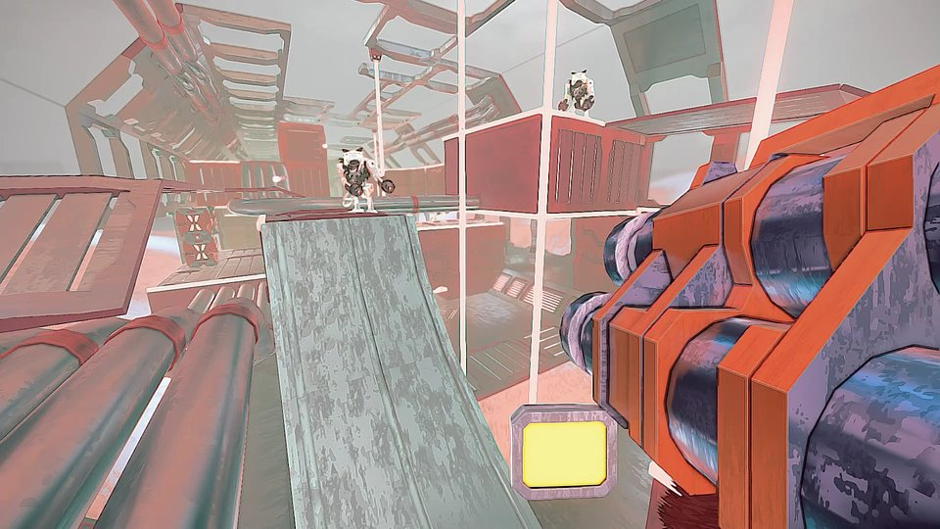

Bear It – key features:

🧬 Hear me roar – a human-bear chimera is not something one would want to meet on their way. This heavily armed beast can use a diverse arsenal of weapons, but also, thanks to its strength and agility, it is capable of tearing apart enemies only with its claws.

🧬 Sprint for Freedom – the bear has the upper hand over opponents due to his ability to move at lightning speed. Remaining in constant motion by taking advantage of the environment will make it difficult for enemies to hit him.

🧬 Try, die, repeat – the gameplay in Bear It shows features typical for roguelite games. Challenges crafted by the developers will be demanding, but each attempt introduces something new, bringing the player closer to victory.

🧬 The experiment continues – the bear can continuously mutate. Thanks to the abilities acquired during playthroughs, it is possible to create the perfect set of skills and weaponry, which is the key to success.

🧬 Battle test – each level is packed with enemies ready to stop you. Confront them using various strategies as you skillfully traverse through hordes of foes on your way to face formidable bosses.

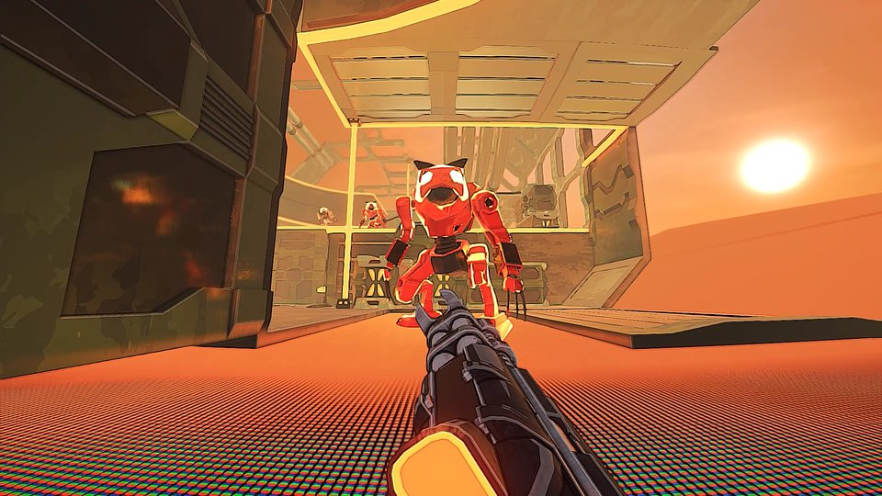

Store page of Bear It is now available on Steam, and we encourage everyone interested to add the title to their wishlist. The release is scheduled for next year, and if you want to stay updated with all the information, follow the publisher's profiles on Twitter andFacebook.A full press kit is available here.

About Games Operators:Games Operators is a publishing company that invests in, releases, and promotes video games. The company helps develop innovative and unique video games like 911 Operator, Radio Commander, 112 Operator, Infection Free Zone, and Transport INC. by getting involved in projects at various levels of progress – from the conceptual phase to nearly-finished products. For more information visit:www.gameops.plAbout Egobounds:Two brothers, Piotr and Krzysztof Woźnicki, established Egobounds as an independent studio in 2020. The company is based in Olsztyn, Poland, where enthusiasts focus on creating unique games for PC and consoles. The creators continuously evolve with each new project. For more information visit: www.egobounds.com



Jakub Smolak
PR Specialist at better. gaming agency
jakub.smolak@bettergaming.pro
Twitter

