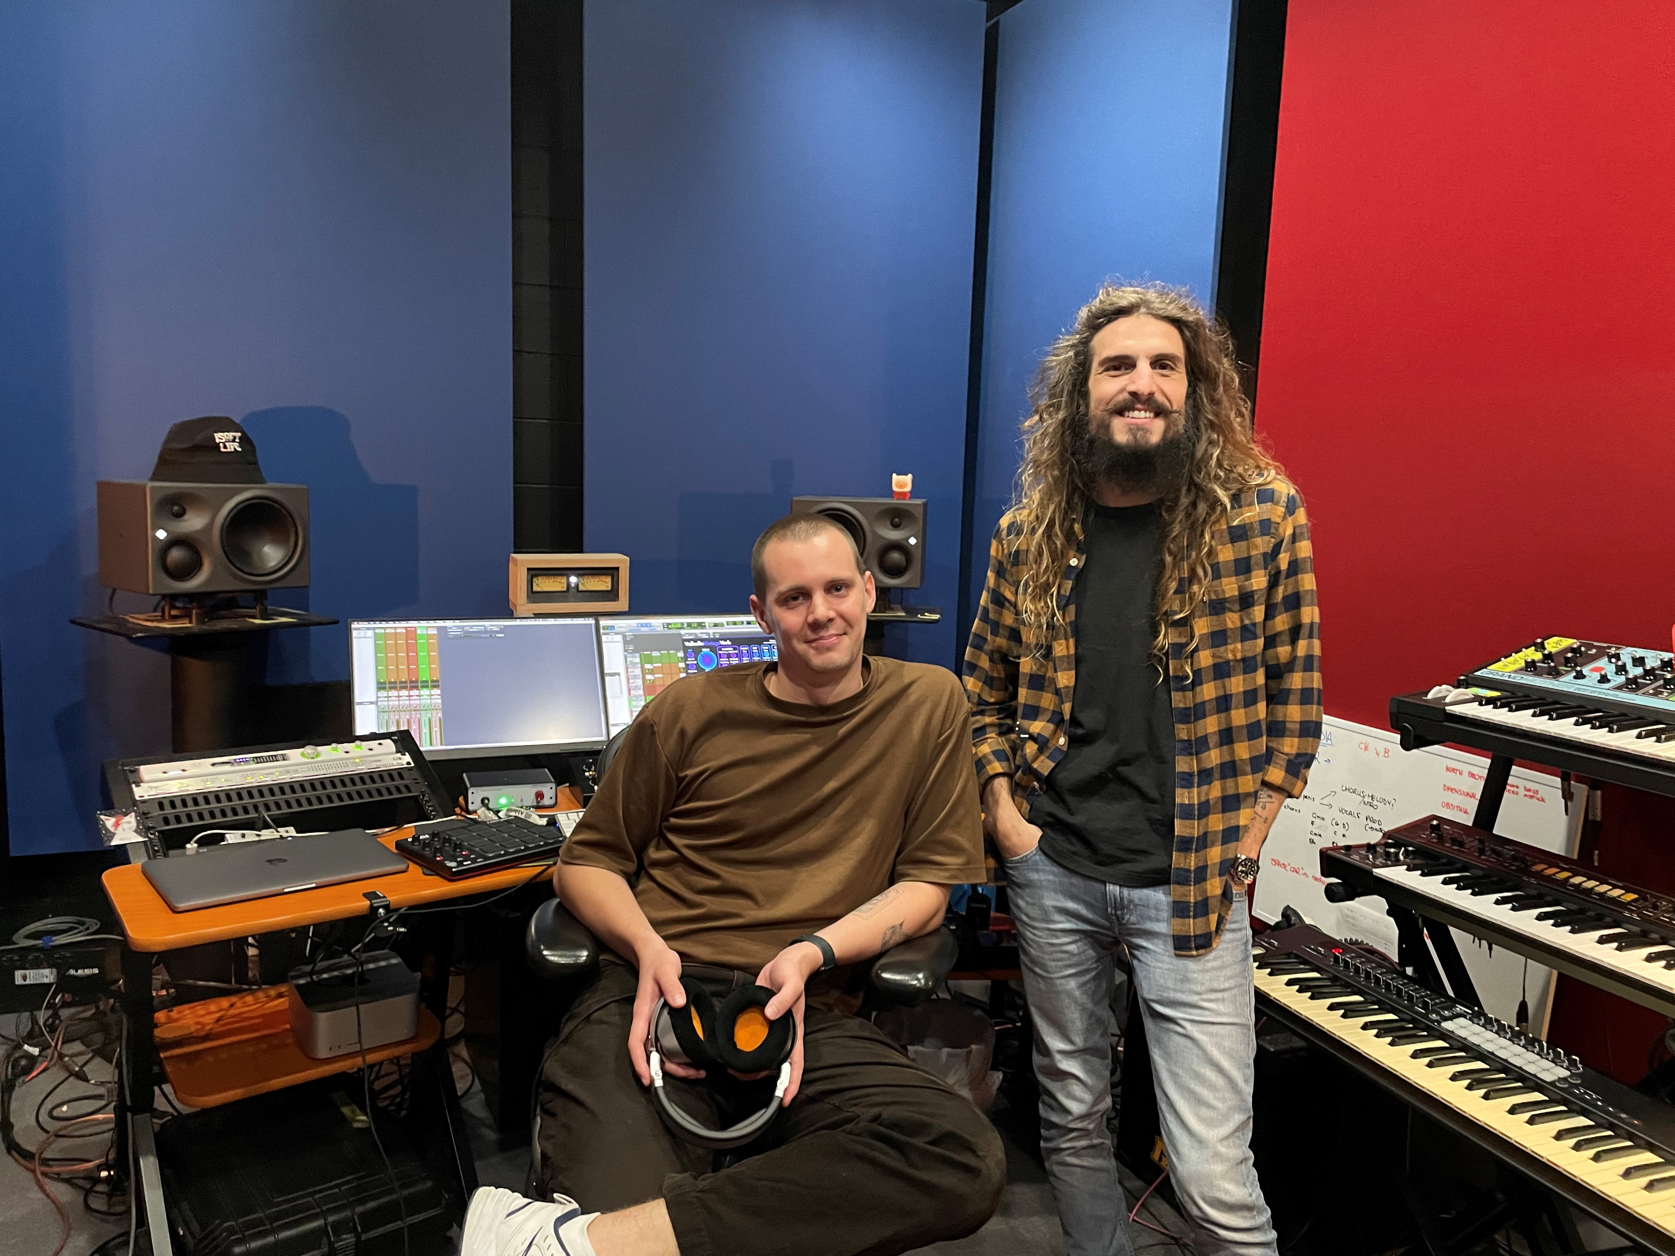

Audio excellence is brought to life at Studios 301 with Neumann world-class studio microphones
Audio engineers Jack Garzonio and Jesse Deskovic are at the forefront of the global music recording industry capturing unrivalled audio with a curated collection of Neumann studio equipment

Sydney, May 23, 2023 – With its 97-year-old history, Studios 301 boasts the largest recording space in the Southern Hemisphere and has hosted the biggest names in music. Coldplay, INXS, Black Eyed Peas, Sir Elton John, and more have graced the recording booths at Studios 301, rightfully building its profile as a world-renowned leader in professional audio. One of the many reasons for the studio’s longstanding success is its world-class facilities and tools, including but not limited to an impressive collection of Neumann.Berlin recording equipment. Studios 301 engineers Jack Garzonio and Jesse (Jess) Deskovic generously share a walkthrough of the studio’s expansive microphone locker, insight into life as an audio engineer, and how Neumann solutions capture the perfect sound.

A wide-ranging roster of modern and classic Neumann gear, from microphones to monitors, call Studios 301 home – a deliberate effort made to uphold a reputation that delivers first-class audio backed by years of ingenuity and expertise. Over a third of the microphones at Studios 301 sport the Neumann name, reflecting the shared decades-long commitment both Studios 301 and Sennheiser Group have to high quality audio.

Jack Garzonio has been working at Studios 301 for six years, having started as an assistant he now finds himself in the chair as an engineer working with celebrated local and international artists. On paper, Jack has not completed a formal education in sound design, but he has served what he describes as a “very long apprenticeship, with a lot of different people.”

The unique education and path to Studios 301 has given Jack the tools and range to work across an eclectic mix of genres and musicians. Jack explained “I love psychedelic music, but also acoustic stuff – pure, classic jazz or orchestral music, even chamber music, are some of my favourite things to record. I like music if I can relate to it, and if I can bring something to the table.” Born in Italy, Jack is no stranger to working abroad, an experience he attributes as enabling him to “adapt and create sounds, through creativity learnt from working in many different studios.”

Jess is part of the new generation of engineers whose passion, ideas and innovation shine at Studios 301. Having started his career in Beijing, China, Jess relocated back to Australia in 2014 where he continued to evolve his craft before finally settling at Studios 301 in 2018.

Often finding himself working on music that falls within the realm of pop, hip-hop and R&B, Jess most recently worked with American rapper Post Malone. For Jess, creating music is about the moment, ensuring that when he is working with artists they fully commit to their own sound and identity to create their signature ‘vibe’ in the studio and not in post-production. “I enjoy pop music because of the production process including vocal producing and mixing. I find it is a very particular approach that I like with the sound and technique,” shares Jess.

Jess and Jack’s passion and knowledge of the intricacies of their profession became abundantly clear, particularly in Studios 301’s microphone locker that houses over 140 microphones from dozens of manufacturers – at least 50 of them being Neumann innovation. Jack explains that “a good assistant or engineer must know how every mic sounds, Neumann microphones serve as a creative tool for us. For example, there are differences between the Neumann KM 84 and KM 184. The 84 can be very ‘Neumanny’ whereas the 184 is not as thick. So, if I was going to record a violin or something that is more of an older style of recording, I would use the 84 but if it was going to be more of a modern sound, I would pick the 184.”

Jess further explains that “if you were then going to record a vocalist the Neumann U87 would work really well as it’s a great all-rounder. I use it all the time if I’m recording a vocalist that I don’t know much about.” For Jess, context is key, understanding the details of the musician, what their genre of music is, and the instruments being used is the first step to identifying which microphone will create the best recording.

A studio favourite, that like Studios 301 is full of history is the Neumann U 48. Known for being the microphone of choice for Frank Sinatra, Jess describes it as “a gorgeous mic, which creates a very grainy, smoky sound, perfect for Jazz or Blues.”

Between the pair, their experience in understanding and debating the nuances of every microphone is endless. The coveted mic locker houses microphones suited to capture the ever-varying sounds of artists that step foot into the studio. The duo describes the Neumann M 149 as being their go-to for piano while the warm tones of the Neumann U 67 make it ideal to use for vocals.

According to Jack, “mic placement and angle is also key to creating good sound, rather than using an equaliser. In the studio sometimes you have to move quickly which is why I love Neumann mics; they take EQ and compression well.”

Beyond microphones, Jess and Jack produce and mix via utilising the Neumann KH 310A monitors for the level of clarity it brings to recordings. In Jess’ words, “I’ve been doing a lot of mixing for pop and jazz, and I quite like how open and clear the monitors are. It took me a while to come around to them because they have such a precise sound. They’re non-ported speakers that are super tight in the low-end. The top-end is all there, they are clinical and clean” he continues, “In a way, it makes mixing feel like you’re fighting against the monitors. You hear the things that need treatment and work, and it can be a little disheartening sometimes but when you’re done and take your recording out, it sounds so great because the 310s are one of the smoothest platforms.”

Jack summed up his analysis as, “[the KH 310As] are all you need.”

With several exciting projects upcoming, the effortless audio quality of Neumann gear is a vessel for the iconic music artists that rely on the audio engineering talents of Jack and Jess. The Neumann domination continues to reach new heights as the pair reveal the NDH 30 studio headphones have quickly become their go-to.

Jess especially chooses the headphones because they “allow me to focus on the small elements, which is so important... Open back headphones are my preference, letting sound spill out and clearing out resonance lets you get a more accurate frequency response.” He jokes the headphones are “less convenient than a closed back headphone because you can’t bring them on the train as everyone would hear what you’re listening, but for mixing it offers a wider sound stage and is less condensed in frequency ranges.”

About Neumann
Georg Neumann GmbH, known as “Neumann.Berlin”, is one of the world’s leading manufacturers of studio-grade audio equipment and the creator of recording microphone legends such as the U 47, M 49, U 67 and U 87. Founded in 1928, the company has been recognized with numerous international awards for its technological innovations. Since 2010, Neumann.Berlin has expanded its expertise in electro-acoustic transducer design to also include the studio monitor market, mainly targeting TV and radio broadcasting, recording, and audio production. The first Neumann studio headphones were introduced in 2019, and since 2022, the company has put an increased focus on reference solutions for live audio. Georg Neumann GmbH has been part of the Sennheiser Group since 1991, and is represented worldwide by the Sennheiser network of subsidiaries and long-standing trading partners. www.neumann.com.

Local Press Contacts
Daniella Kohan Hotwire Australia
daniella.kohan@sennheiser.com sennheiseranz@hotwireglobal.com
+1 (860) 227-2235

Global press contact:
Andreas Sablotny
andreas.sablotny@neumann.com
+49 (030) 417724-19

