never lose your rhythm again
Sennheiser Introduces new MOMENTUM Wireless

Wedemark/Berlin, September 5, 2019 – Sennheiser’s premium MOMENTUM headphone range enters its third generation, with the launch of the new MOMENTUM Wireless. The headphones are the latest addition to the audio specialist’s iconic range that offers superior sound, a modern design aesthetic, cutting-edge technology, and a touch of handcrafted indulgence to every moment. Designed to be supremely comfortable for all-day listening sessions, they feature genuine sheep leather and soft padding on the earpads and headband, while a unique feature combination provides you instant access to your music, and the rest of the world, so that you never miss a beat.

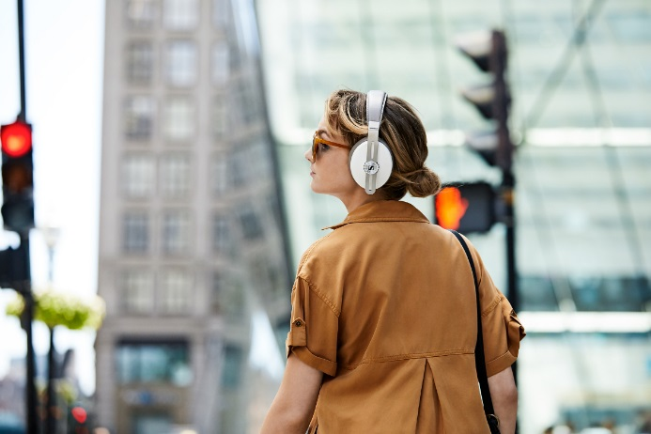
Never lose your rhythm again
Auto On/Off and Smart Pause features ensure you never miss a beat of your favorite song. The new MOMENTUM Wireless headphones start up instantly when unfolded. When you take the headphones off, the music stops. When you put them back on, the beat drops in – exactly where you left it.

In-tune with you, whenever, wherever
The Transparent Hearing function lets you enjoy your music and still be aware of your surroundings. Alternatively, Active Noise Cancellation with three different modes blocks out the outside world.

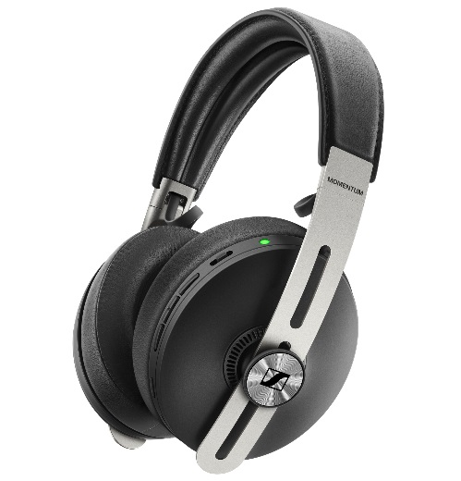
A touch of indulgence
Genuine, soft sheepskin leather on the
earpads and pearl-blasted stainless
steel sliders express a subtle luxury
and offer great wearing comfort, even
for longer listening sessions made
possible by the 17-hour battery life.

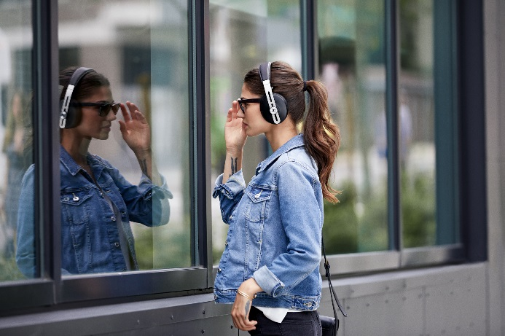
Superior sound for your content
The MOMENTUM Wireless reproduces the balanced depth and precision of a studio recording. Whether you are enjoying music, movies or podcasts, you can tailor your audio experience with the built-in equalizer via Sennheiser’s Smart Control app.

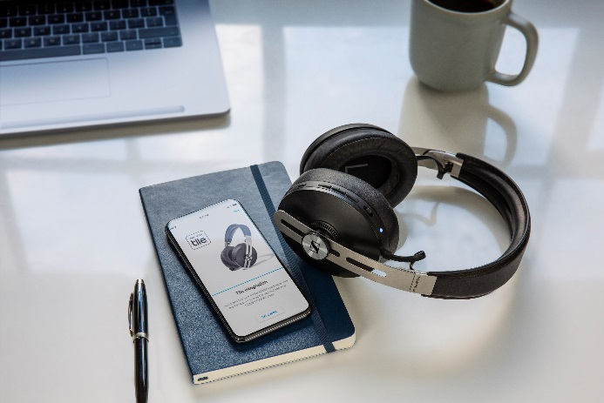
Effortlessly connected
Via a dedicated button, the MOMENTUM Wireless features one-touch access to voice assistants. Thanks to smart Tile technology, the headphones are almost impossible to misplace: The integrated Bluetooth tracker ensures you can find your headphones via the Tile app.

The new MOMENTUM Wireless is available in black as of now for 399 EUR (MSRP). A sandy white color variant will be available from November.
About Sennheiser
Shaping the future of audio and creating unique sound experiences for customers – this aim unites Sennheiser employees and partners worldwide. Founded in 1945, Sennheiser is one of the world’s leading manufacturers of headphones, loudspeakers, microphones and wireless transmission systems. Since 2013, Sennheiser has been managed by Daniel Sennheiser and Dr. Andreas Sennheiser, the third generation of the family to run the company. In 2018, the Sennheiser Group generated turnover totaling €710.7 million. www.sennheiser.com

Global Press Contact
Sennheiser electronic GmbH & Co. KG
Jacqueline Gusmag
Communications Manager Consumer
T +49 (0)5130 600-1540
jacqueline.gusmag@sennheiser.com

