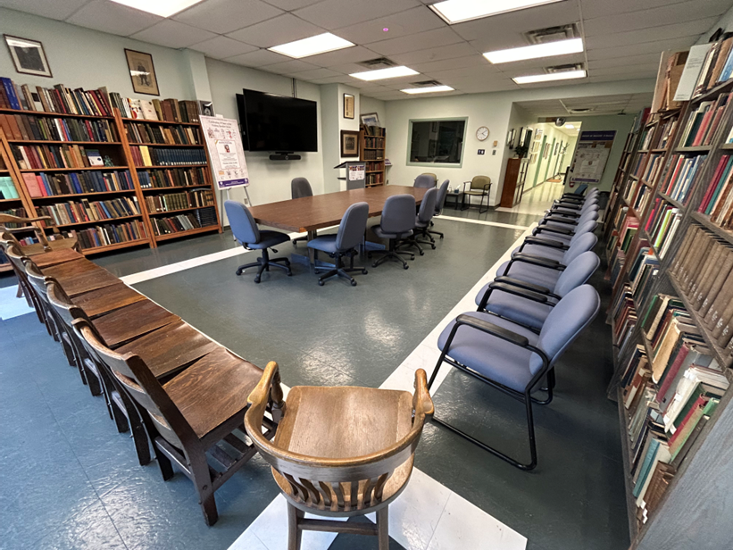
The History of Medicine Library at Schulich School of Medicine & Dentistry is used to host guest lecturers and small, multisite events.

Schulich School of Medicine & Dentistry Achieves 100% AV Reliability with Sennheiser TeamConnect Bars
High-Quality Audio-Visual Technology Transforms Remote and In-Class Instruction

London, Ontario, Canada — November 12, 2025 — The Schulich School of Medicine & Dentistry in London, Ontario, a leading institution in Canada, is renowned for its accredited Doctor of Medicine and Doctor of Dental Surgery programs, as well as its Bachelor of Medical Sciences degree. The school’s emphasis on experiential learning and research excellence prepares future physicians, dentists, and scientists to lead in their fields. In an effort to address chronic maintenance challenges associated with outdated UC equipment, the school set out to modernize its technology infrastructure with the help of Sennheiser TeamConnect solutions, including the TeamConnect (TC) Bar M collaboration bar, as well as the TeamConnect Ceiling 2 (TCC 2) and TeamConnect Ceiling Medium (TCC M) microphones. The goal was to reduce the need for on-site support and improve long-term system reliability.

The previous systems were prone to sporadic failures and required complex troubleshooting protocols, resulting in constant need for tech intervention in lecture halls, seminar rooms, and collaboration spaces, which created substantial and costly disruption to classes and essential recordings. As David Creces, Team Leader, Educational Technology and Media Services at Schulich, explained, "Prior to our current setup, we had used products that required a significant amount of support — leaps and bounds more than what the Sennheiser fleet we now have requires, which is practically zero."

As the UC equipment aged, classroom startups became increasingly unreliable, leading to frequent interruptions that disrupted instruction. This resulted in a dip in faculty confidence as well as an increase in operating costs, as IT staff spent more time maintaining outdated systems than supporting strategic initiatives. To address these challenges, the department sought a solution that would restore reliability, improve user confidence, and reduce the time and expense associated with ongoing maintenance.

The school chose to deploy Sennheiser’s TC Bar M, TCC 2 and TCC M across Schulich’s core teaching facilities, recognizing their ability to function as a unified, intelligent ecosystem, rather than simply a collection of disparate hardware components. The deployment included six TC Bar M units installed across small to medium collaboration spaces, 16 TCC M microphones in both medium collaboration rooms and classrooms, and eight TCC 2 microphones integrated into mid to large classrooms — establishing a consistent, scalable audio experience across the entire facility. This decision was largely driven by the quality of the sound capture, the solutions’ simple integration capabilities, and a design philosophy centered on intuitive, automated functionality.

The addition of the TCC 2 and TCC M microphones in concert with the TC Bar M played a pivotal role in enhancing Schulich’s AV infrastructure. The ceiling microphones’ advanced beamforming technology ensures the active speaker is always heard, regardless of his or her position within the room. For rooms installed with the TCC M, its Intelligent Noise Control feature significantly improved audio clarity, even in acoustically challenging environments with aging HVAC systems. The ceiling-mounted design delivered consistent, evenly distributed sound capture throughout classrooms and collaboration spaces, ensuring that instructors and participants were heard clearly from any location in the room. These ceiling mics not only elevated the technical sophistication of Schulich’s hybrid learning setup but also helped restore faculty confidence in classroom technology. The strategic mix of collaboration bar and ceiling microphone solutions enabled Schulich to tailor Sennheiser’s technology footprint to the acoustic and spatial demands of each environment, maintaining uniform quality whether in compact meeting spaces or lecture halls accommodating larger audiences.

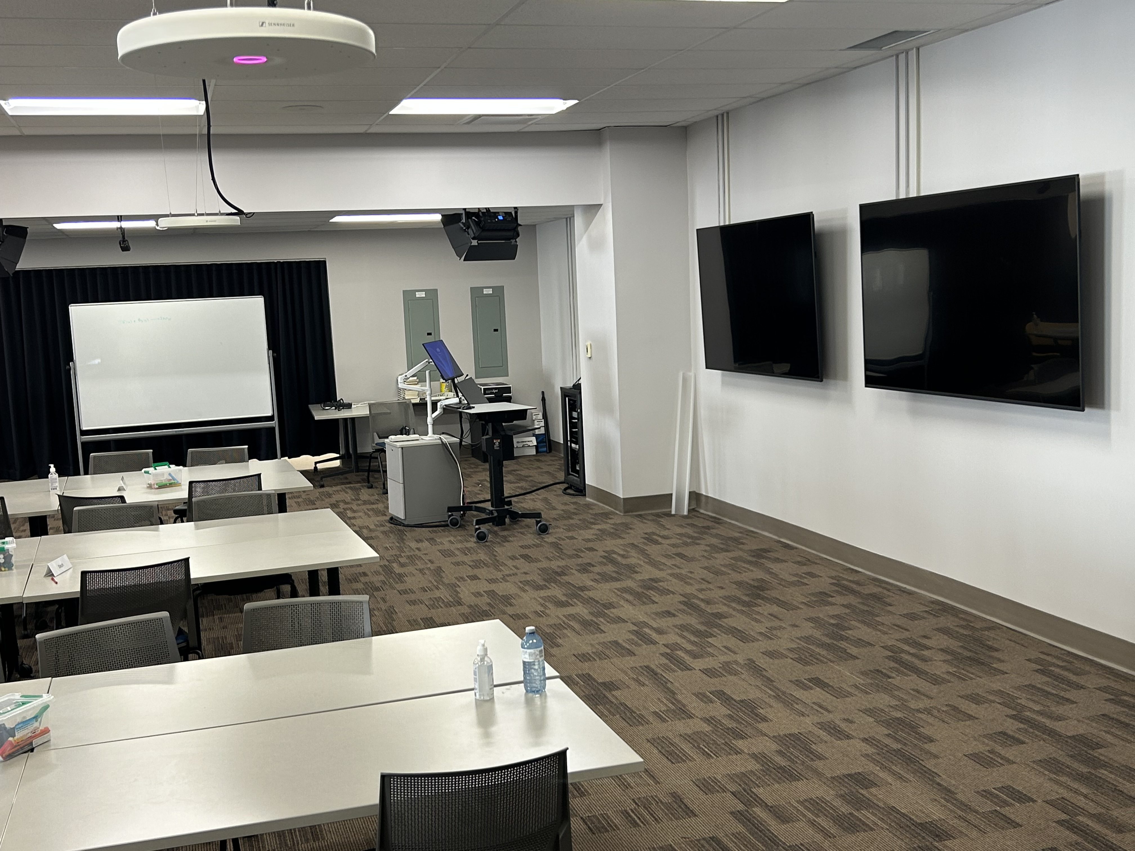
Schulich School of Medicine & Dentistry's Interdisciplinary Medical Sciences (IMS) classroom.

For the IT team responsible for mass deployment, the TC Bar M offered high functionality with minimal setup complexity, proving its worth as a "plug-and-play" solution. A key benefit was its straightforward operation and ability to function consistently without manual intervention. Creces noted, "The sound quality is simply fantastic, and the features are equally excellent. The user can install the TeamConnect Bar M and use it as is — or install it and customize it to their space. Deploying Sennheiser was a no-brainer for us and has been a complete and total win.”.

The deployment of the TC Bar M immediately benefited faculty by enhancing the professional quality of their lectures, as features like dynamic speaker tracking and automatic framing ensured the lecturer was always clearly visible and centered. This capability facilitates a natural presentation style, allowing instructors to connect with remote learners effectively. “This elevated level of performance has truly improved both communication sophistication and communication awareness, transforming the remote learning experience,” shared Creces.

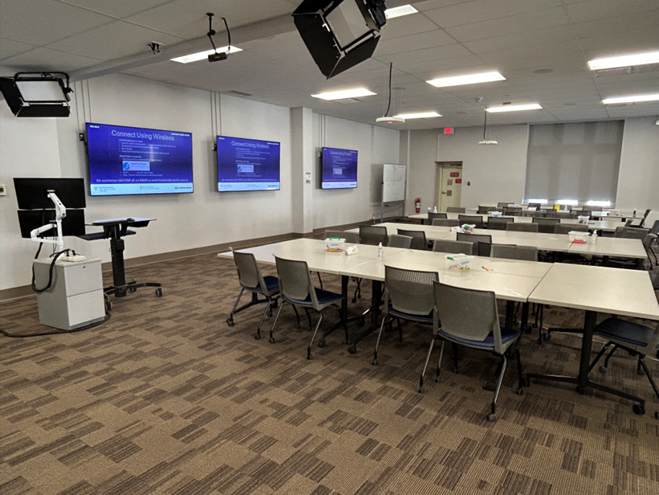
The IMS classroom utilizes advanced video technology for hybrid classes with high production values.
The TCC M microphones in IMS space are used for conferencing, recording, and reinforcement using TruVoicelift simultaneously.

The successful utilization of the Sennheiser TeamConnect solutions yielded rapid, strategic gains for Schulich, proving their long-term value as critical infrastructure upgrades. The most compelling and impactful metric was the complete termination of support inquiries related to the AV fleet, establishing a new benchmark for system reliability. This lack of issues validates the decision to prioritize quality and durability, with Creces reporting, "We haven't had any service calls for this product. Actually, we have never had one single ticket related to a Sennheiser microphone or TC bar." This zero-ticket result represents significant savings in labor costs and maximizes valuable hours of uninterrupted class time.

The Sennheiser solutions have effectively freed up the IT team’s time and resources by providing a dependable platform that simply works. Consequently, the TeamConnect solutions now provide a reliable foundation for the future, giving the IT department confidence that expanding the deployment to new buildings and renovated spaces will be straightforward and predictable. With 30 individual Sennheiser solutions now networked and actively monitored through Sennheiser Control Cockpit, the Schulich IT team can oversee performance, firmware updates, and room status at scale — reinforcing the simplicity and reliability that drove the original decision to standardize on the platform.

By definitively solving the problems of reliability and complexity, the Sennheiser TeamConnect solutions have empowered Schulich School of Medicine & Dentistry to shift its IT focus from reactive problem-solving to proactive support of its core academic mission. Based on the fleet’s exceptional, zero-downtime performance, the Schulich IT department offers an unqualified endorsement to other higher education institutions, with Creces stating, "I absolutely would recommend this setup. Sennheiser has built an incredible, reliable ecosystem with the TC Bars and microphones. We consider our experience — related to our Sennheiser products — a 100% success!”

For more information about Sennheiser’s TeamConnect solutions, visit www.sennheiser.com.

###

About the Sennheiser brand
We live and breathe audio. We are driven by the passion to create audio solutions that make a difference. Building the future of audio and bringing remarkable sound experiences to our customers – this is what the Sennheiser brand has represented for more than 75 years. While professional audio solutions such as microphones, meeting solutions, streaming technologies and monitoring systems are part of the business of Sennheiser electronic GmbH & Co. KG, the business with consumer devices such as headphones, soundbars and speech-enhanced hearables is operated by Sonova Holding AG under the license of Sennheiser.
www.sennheiser.com
www.sennheiser-hearing.com

Local Press Contact:
InGear
Peter Schuyler
peter@ingearpr.com
+1 917-496-8970

Global Press Contact
Jeff Horan
jeffrey.horan@sennheiser.com
+1 860-598-7539

