Experience the travel adventure of a lifetime

Backpack through Europe in the eneloop expedition 2100

Zellik, 2 February 2017 – Adventurous ramblers can sign up for the travel adventure of a lifetime. The eneloop expedition 2100 is looking for three two person teams that want to backpack through Europe for 120 days. These adventurers will receive rechargeable eneloop™ batteries as a means of exchange, pocket money, outdoor equipment and a drone in exchange for a Facebook page filled with adventures. During the expedition, each team will be set challenging tasks with which it can earn points. At the end of the expedition they can collect a €21,000 donation for an environmental organisation as well as great prizes for each team member. Those who dream of a (free!) hike through Europe and want to share their adventures with the (online) world, should quickly go to www.eneloopexpedition.com.

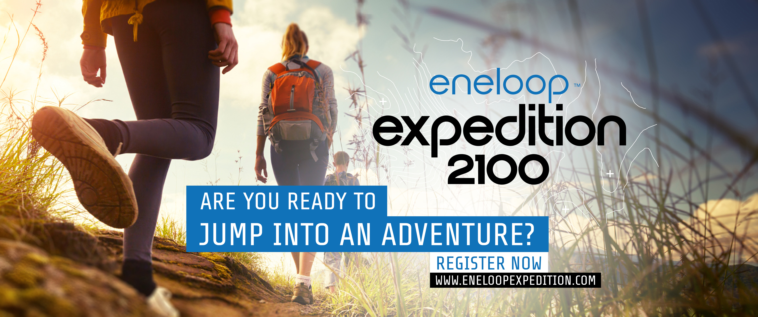

In the eneloop expedition 2100 three two person teams will compete in a 2100 km hike through Europe that lasts 120 days. Along the way they'll earn points by completing tasks. Each team will start their adventure on foot, with a low ecological footprint, in a different country (United Kingdom, Poland or Denmark) on 23 June 2017. Their goal is to reach the finish in Milan on 20 October 2017 with as many points as possible. They'll earn these points along the way by completing tasks.

Help from home and online fans
But the teams won't be alone because their home and online fans can follow everything online through a unique Facebook team page, via the general eneloop expedition 2100 website and the eneloop expedition 2100 Facebook page. Every visitor will see which tasks each team must complete, how many points they scored on previous tasks and how many kilometres they have already completed. Each team will give a daily peek behind the scenes via social media and they'll call on others to help them complete their tasks.

Support for an environmental organisation
Participants aren't only in it for the experience - each team chooses an environmentally-friendly organisation and collects money for it. At the finish, eneloop will donate €21,000 to the winning team's charity and €2100 to the charities of the other two teams. In addition to adventure and money for their charity, each team member wins his/her expedition equipment plus a host of great prizes from Panasonic.

Extra power thanks to eneloop
eneloop doesn't expect the teams to go into the expedition empty handed: in addition to weekly pocket money, each team receives a bunch of rechargeable eneloop batteries as a means of exchange. These batteries are pre-charged with solar energy and can be recharged up to 2100 times – hence the number of kilometres of the eneloop expedition 2100. Those who choose eneloop, choose a sustainable lifestyle. That's the idea behind the entire expedition. That's why eneloop loves giving a boost to environmentally-friendly organisations with the same vision for the future.

To participate is to win
Those interested must register with a team member before 17 April 2017. Anyone who is 18 years old, lives in Europe and has no obligations between 23 June and 20 October 2017 can participate. Read more details on www.eneloopexpedition.com or on the eneloop expedition 2100 Facebook page.

About Panasonic Energy Europe
Panasonic Energy Europe is headquartered in Zellik, near Brussels, Belgium. The company is part of the Panasonic Corporation, a leading global manufacturer of electronic and electrical goods. Panasonic’s vast and lengthy experience in the consumer electronics field has helped make Panasonic the largest battery manufacturer in Europe today. The European production facilities are located in Tessenderlo, Belgium, and Gniezno, Poland. Panasonic Energy Europe supplies ‘mobile’ energy solutions to more than 30 European countries. The company’s diverse product range includes rechargeable, chargers, zinc carbon, alkaline and specialty batteries (such as zinc air, photo lithium, lithium coin, micro alkaline, silver oxide).
For more information, visit: www.panasonic-batteries.com.

About Panasonic
The Panasonic Corporation is a leading company worldwide in the development and manufacture of electronic goods for a wide range of private, trade and industrial uses. Panasonic, based in Osaka, Japan, in financial year ended 31 March 2015 posted consolidated net sales of around 57.28 billion EUR. Panasonic is committed to creating a better life and a better world, continuously contributing to the evolution of society and to the happiness of people around the globe.
More information about the company and the Panasonic brand name at www.panasonic.net.

PRESS CONTACT

ARK Communication
Ann-Sophie Cardoen
Content & PR Consultant
T +32 3 780 96 96
ann-sophie@ark.be
www.ark.be

Panasonic Energy Europe NV
Vicky Raman
Brand Marketing Manager
T +32 2 467 84 35
vicky.raman@eu.panasonic.com
www.panasonic-batteries.com
www.panasonic-eneloop.com

