MSF SOMALIA - SOMALILAND | Comms Package_Health Crisis_ Measles patient stories
Drought-stricken families grappling with deadly effects of measles
Baidoa, Somalia
Abay Subow, a 35-year-old mother of six, arrived at the sprawling Nimole camp for the internally displaced people on the outskirt of Baidoa town in the Southwest state of Somalia in early 2020. Abay, along with her husband and six children, was forced to flee her agricultural home of Dinsor because of a combination of recurrent drought, conflict and lack of access to humanitarian assistance at her locality and conflict. Her hometown is located 120 kilometres southeast of Baidoa in Bay Region. After consecutive poor rains and failed harvest, and losing her flock of livestock to the drought, along with other family members and neighbours, Abay’s family made the decision to flee to Baidoa in search of food, shelter and water. Trekking along a tough and dangerous route, it took her six days to reach Baidoa, a city already struggling to host some half-million internally displaced people. Arriving in Nimole camp, she received little material support, though the conditions in the camp were harsh and squalid.
From a distance, a crowd of women, children and elderly people have gathered under a large bright green-leaved tree, which offers some respite from the midday heat at Barsar camp. The only source of water is a tap that runs for few hours. But it is dry, and a small group of teenage girls lined up to fill their jerry cans, hoping some water will show up. Auto rickshaws and small pickup trucks speed back and forth along dirt roads snaking through makeshift shelters pitched side-by-side, covered in identical rags and bits of the plastic sheet without proper spacing, which often leads to frequent fire outbreaks.
Abay holds her 3-year-old daughter, who is ill with measles and has only spent one night in MSF-supported Bay regional hospital (BRH) in Baidoa. A week ago, her daughter developed a fever, loss of appetite and a runny nose. According to Abay, this was not enough to convince her to take her daughter to the hospital, partly due to the bus fare that she cannot afford. A day later, a rash appeared followed by diarrhoea. As the condition of her child deteriorated, Abay wrapped her daughter on her back and began to walk to the hospital, which is far away from her home. At the hospital, her baby was diagnosed with measles.
“I have five other children to look after” says Abay. “My husband does menial jobs, so he is not around during the day. I do not seek treatment for my children for minor illnesses unless it gets worse. The hospital is far away from where I live. I can’t afford to come every time.”
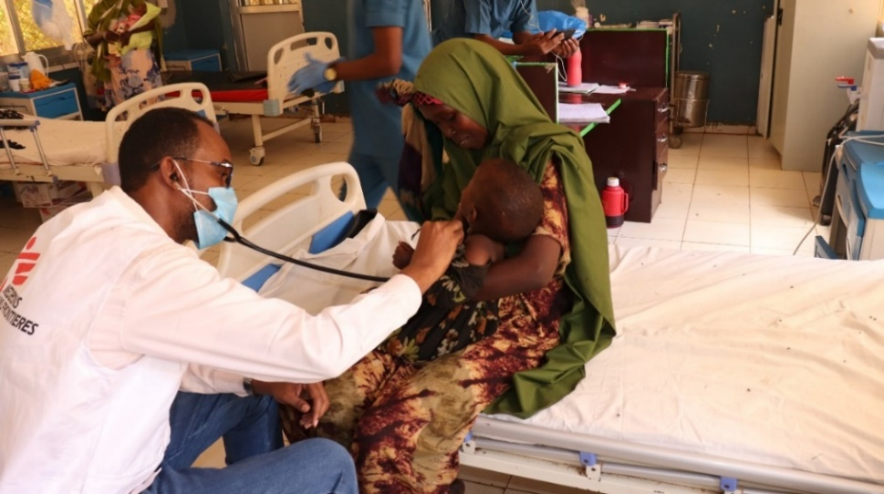
Photo: Abay (mother) holding her sick daughter in Bay hospital’s measles isolation ward. Her child has been unwell since catching measles a week ago. Add URN

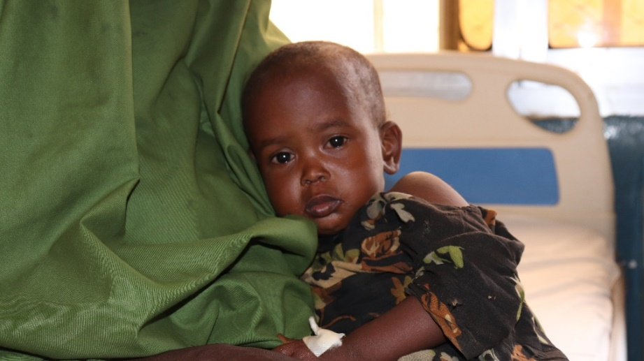
Photo: Sadiya Abdikadir, 3 years old, has been admitted to the MSF-supported Bay Regional Hospital’s measles isolation ward where she has been undergoing treatment. Add URN

Measles is highly prevalent in most parts of Somalia, affecting children of all ages all year round. According to World Health Organisation (WHO), in the first two months of this year over 3,500 suspected measles cases have been reported from 18 regions across the country. Given the low levels of vaccination coverage and high prevalence of both malnutrition and vitamin A deficiency, the overall risk for measles at the national level is assessed as very high. This risk is further aggravated by a complex humanitarian crisis caused by conflict and recurring droughts and resulting displacement.
Controlling measles is a huge challenge in Somalia, owing to low routine immunization coverage, displacement and the difficulties of reaching children who live in highly insecure areas or regions with poor roads and infrastructure. With drought and insecurity forcing people to move to urban areas to seek assistance, the risk of measles spreading in dense, urban centers is high.

“About a year ago, we had a handful of cases of measles brought to the facility on a daily basis”, says Asma, MSF’s medical activity manager in Baidoa, who works at the MSF-supported Bay hospital in Baidoa and has long been at the forefront of responding to the measles outbreak.
Most of the cases were coming from camps hosting people who have been displaced by the drought. They live in crowded areas so measles can spread very fast. Most children have severe complications like respiratory and eye infections and pneumonia and are admitted for supportive treatment to address this.”
Las Anod, Somaliland

It is common for children to develop rashes on their bodies most of the time owing to Somaliland’s hot weather; however, Maryan did not worry about her daughter’s condition until three days later when she noticed rashes on her daughter’s body and mouth sores.

“Occasionally I bath my daughter in the evening using warm water”, says Maryan Ahmed, a long-time drought-displaced mother who has now blended into the host community in Las Anod town, Sool region. On this day, I used a bit of cold water to bathe her. A few hours later, she had a high fever and had difficulties breathing.”

Since she knew the MSF-supported LAS-Anod General hospital, she rushed her daughter to the hospital where she was received. Her daughter, Bushra, was diagnosed with measles and was admitted to the measles isolation ward.

Bushra is now responding positively to treatment and her condition has improved.

“I feel now she’s up on her own”, says Maryan. “She took porridge in the morning and the fever is disappearing. She is asking me when we shall go home. We are happy.”

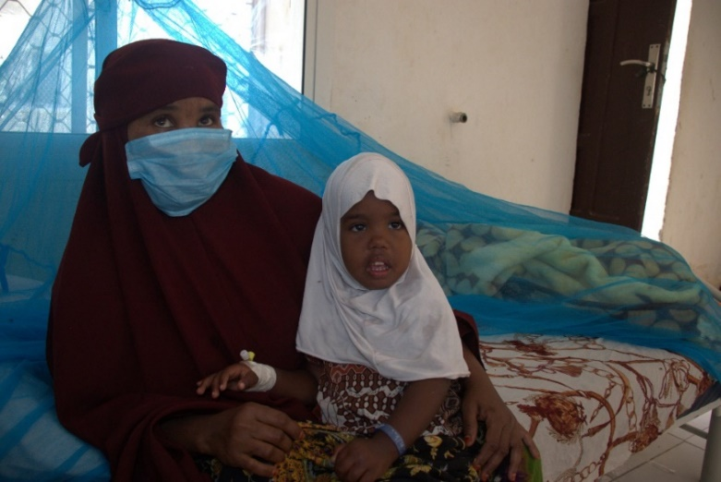
Photo: Bushra Mohamed, 3 years old, has been admitted to Las Anod hospital’s (LAGH) measles isolation ward where she has been undergoing treatment. Add URN

“Since February 2022, Las Anod General hospital has been receiving patients with measles mostly from Las Anod and neighbouring districts such as Taleh and Hudun” says Zafar Khan, MSF’s project coordinator in Sool. “We have so far treated 645 patients since the recent outbreak including children under five years with severe malnutrition and medical complications and a few pregnant women.”

MSF has been supporting hospitals in Somalia and Somaliland in establishing measles case management isolation ward as well providing medical supplies and offering human resource support and training for medical staff.

Even after a lot of community sensitisations on seeking timely treatment, local communities continue to delay seeking medical care until their condition worsens, fearing being identified as suspected to have a serious disease and then being isolated. Some families also do not afford the means to make it to health facilities. It is therefore very complicated to manage deadly outbreaks of this scale along with malnutrition and cholera outbreaks that are also happening at the same time.
Engaging communities and building trust is key to delivering successful medical activities. MSF builds on existing community structures for the delivery of its healthcare services and provides timely feedback to vulnerable communities.
***Ends***

