For immediate distribution

Sensory Utopia: Emerson Loughman Palmer Drops ‘Finding Sense’

After Chance Meeting at 30,000 Feet, Super Sonic Trio Launches Infectious New Single,
To Be Followed by LP and Los Angeles-Based Performances
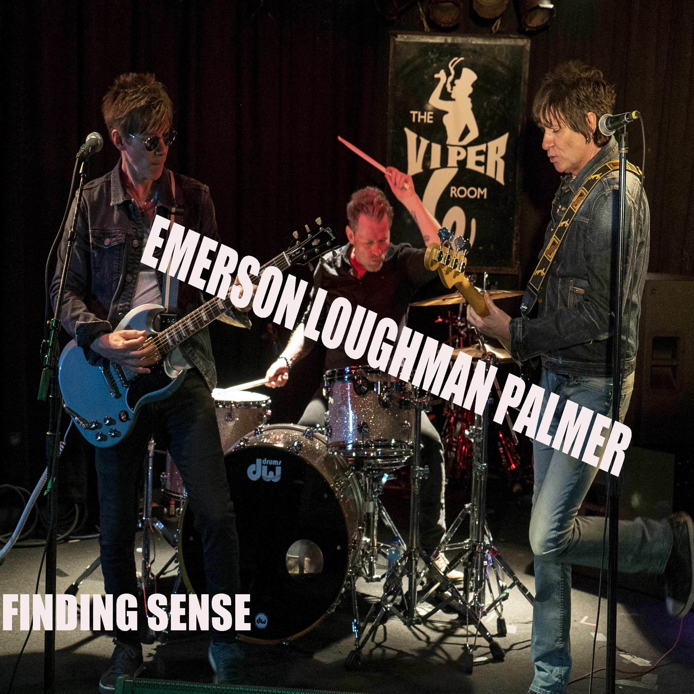
Hollywood, Calif., December 3, 2018 – The latest incarnation of Mark Loughman’s own brand of insurgent rock ‘n’ roll sees the Mancunian songsmith teaming up with Rod Stewart’s guitarist and drummer to create ‘Emerson Loughman Palmer’: a seething cauldron of some of the best studio talent Los Angeles has to offer. The trio, which features Emerson Swinford on lead guitar and David Palmer on drums, comes to life with a thought provoking, dystopian warning via the band’s first single: “Finding Sense” — out November 30th.
The new single will be followed by a six-track ep Be Empirical on both vinyl and CD mid-December, with both releases distributed by Fuga.com. This February, the band will perform Be Empirical in its entirety — including the new single “Finding Sense” — at Los Angeles’ legendary Viper Room, located on Sunset Strip.
The members of Emerson Loughman Palmer each carry impeccable rock ‘n’ roll credentials, having worked with mega superstar acts including Rod Stewart, ABC, Liz Phair, Queens of the Stone Age and many more. Most recently, Emerson Swinford and David Palmer have been an integral component of Rod Stewart’s touring band, which recently completed a two-year residency at the Colosseum at Caesar’s Palace in Las Vegas.
Watch the video here [runtime 3:36]: https://www.youtube.com/watch?v=p3tpqPu93GU
A Flight of Fancy
Back in 2016, Emerson, Loughman and Palmer met during a chance encounter on an airline flight, 30,000 feet in the air. They soon discovered a shared interest in classic rock ‘n’ roll and already knew many of the same people. The three remained in touch during the ensuing months, and once tours and recording schedules finally allowed, set aside time to rehearse and record. During the interim, Loughman penned a bevy of new songs, starting with “Finding Sense” — an almost balladesque number featuring Rickenbacker 12-strings and a damning underlying message about the status quo, complacency and corruption in our modern society.
“Finding Sense”, along with five other tracks, was recorded at Simon Phillips personal studio in Los Angeles to become part of the ep. Side A of Be Empirical was engineered by Simon Phillips (The Orb, Mike Oldfield) and side B by Matt Linesch (Van Halen, Don Henley) with Loughman assuming the producer’s chair.
To learn more about Emerson Loughman Palmer, please visit markloughman.com.
Media contact
Jeff Touzeau
Public Relations
Hummingbird Media
+1 (914) 602 2913
jeff@hummingbirdmedia.com

