For more information, please contact Marta de Paco
On +34 670 780 664 or email press@comunicahair.com

Important:
These images are only available for editorial content.
Credits must be included.
Notification of their publication is expected.

MANUEL MON & GONZALO ZARAUZA
COLOROPTIMIST Collection

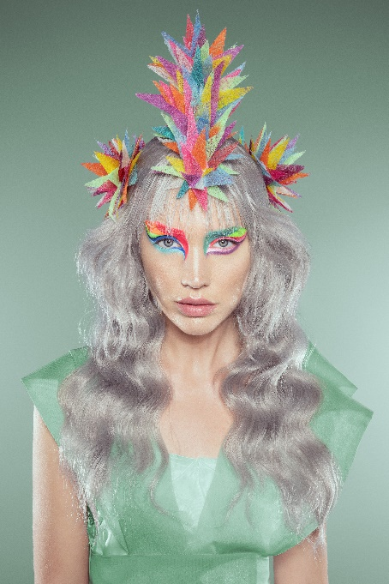
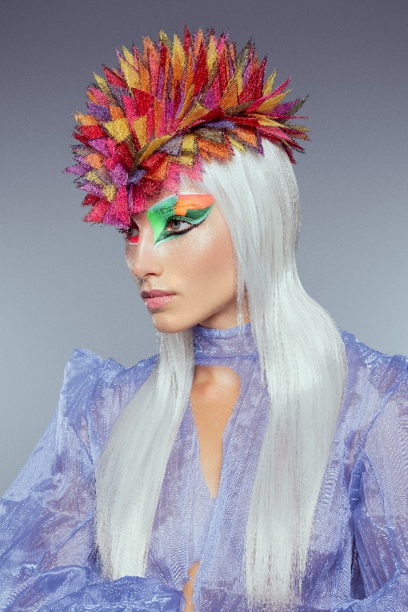
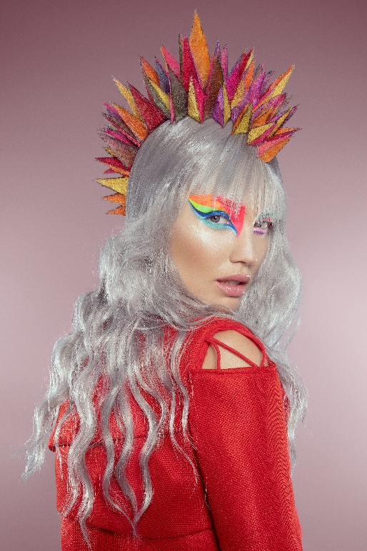

Hair: Manuel Mon and Gonzalo Zarauza – Vangard Hair
Hair Instagram: @manuelmonoficial | @gonzalo_zarauza
Photography: David Arnal @davidarnalteam
Retouche: Javier Villalabeitia @javiervillalabeitia
MUA: De Maria @de_maria
Styling: Visori @visorifashionart
Video: Germán de la Hoz @german_delahoz

MANUEL MON & GONZALO ZARAUZA
COLOROPTIMIST Collection

“We baptized our fifth collection with a strange word that, of course, is not academic at all. We love breaking the rules so… here’s ColorOPTIMIST!"

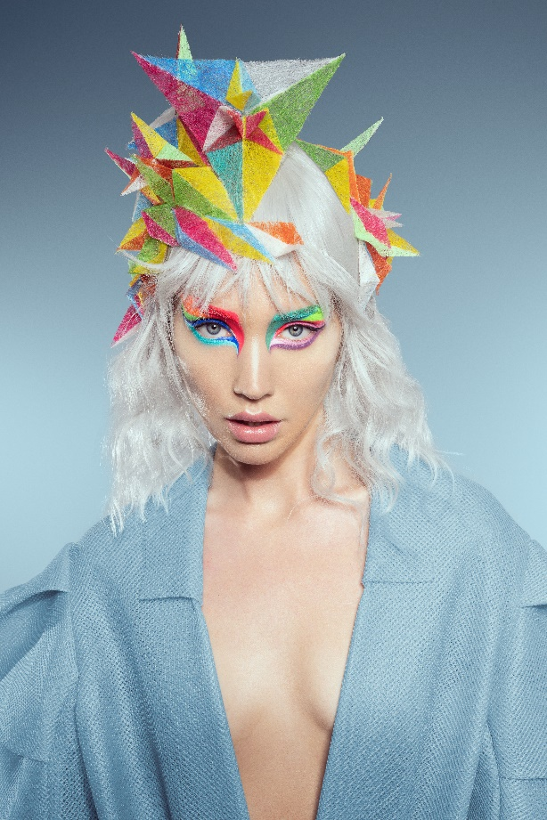
It seems we are starting to leave behind a gray period -a dark gray that seems almost black. It has been a very sad time for humanity. The whole world has been shaken as if a tsunami had reached the planet from top to bottom. A virus, one of the smallest known forms of life, has plunged us into total desolation and has exposed the miseries of human beings: selfishness, classism, aporophobia and, especially, inequality among our peers. Despite this, in 2020 there were also flashes of optimism, solidarity, understanding and respect between people, but was it a mirage?

Perhaps the pandemic has been a necessary turning point to look inward and start a catharsis that makes this a better world. The arrival of vaccines has provided a glimmer of hope. Hopefully, from 2021 onwards, that gray storm that invaded us will turn into a rainbow of vibrant colors, that move us and remind us of the joy of living, but of living in a more egalitarian and respectful society with humans and the planet. This is our inspiration from a conceptual point of view.

On an aesthetic level, we have been carried away by the exciting universe of an urban artist, who’s from Cantabria, and who is filling all continents with color. We refer to the great Okuda San Miguel. His work has inspired us so much that we are crazy about color and geometry. For that reason, at first, we wanted to call the collection "OKUDAhair", but we thought we had to respect the name of the artist and not appropriate it. Finally, we named it ColorOPTIMIST, which is nothing more than a tribute to our immense passion for color and hairdressing.

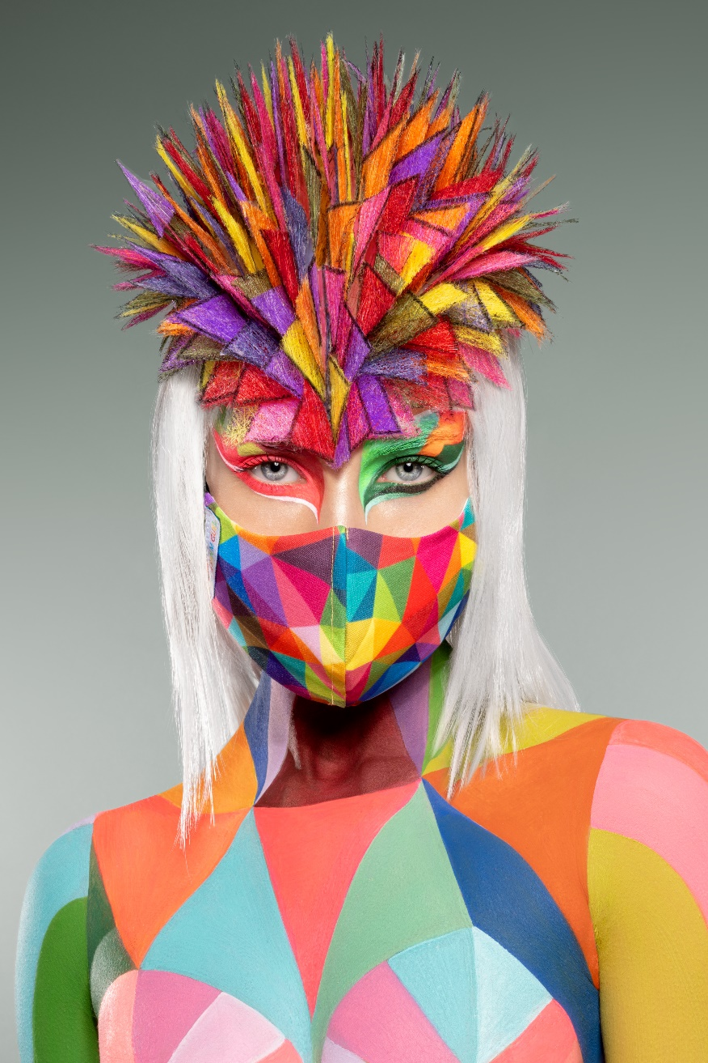
« BYE, GRAY. ¡WELCOME TO THE RAINBOW! »

