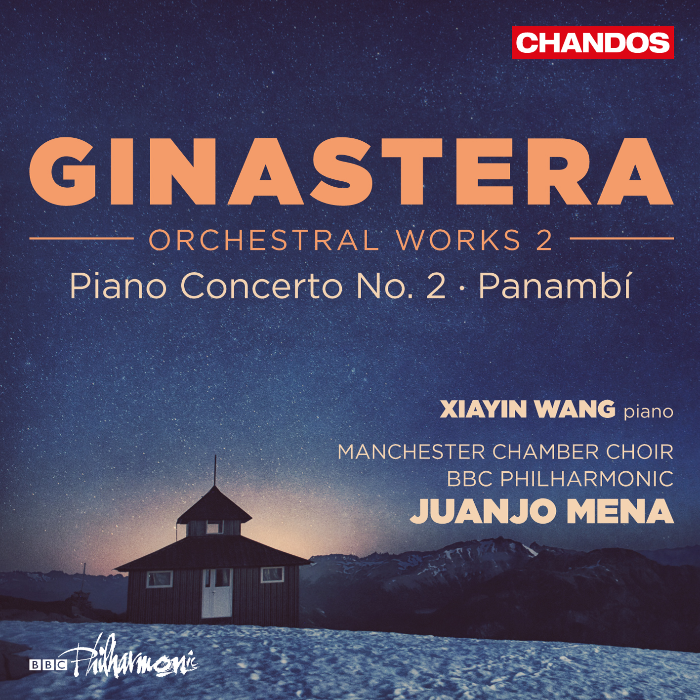

Xiayin Wang’s new recording of Ginastera’s Piano Concerto No. 2 released today on Chandos, celebrating the composer’s 100th anniversary

The album is part two of a three-volume series of Juanjo Mena’s exploration of Ginastera’s orchestral works with the BBC Philharmonic, and also features his exotic early ballet Panambí

Pianist Xiayin Wang’s recording of Ginastera’s virtuosic Piano Concerto No. 2 is available today on Chandos records. The album is part two of a three-volume series that celebrates the centennial anniversary of the birth of great Argentinian composer Alberto Ginastera, and also features the exotic early ballet Panambí.

Xiayin, hailed by The New York Times for her “estimable grasp of pianistic color” as well as her “go-for-broke bravado,” handily surmounts the staggering technical challenges of the work, which pays homage to both Beethoven and Chopin while retaining a musical language and character that was all Ginastera’s.

The album is a welcome contribution to Xiayin’s acclaimed discography, following her last recording of the concertos by Tchaikovsky and Khachaturian with the RSNO [CHAN 5167], which was selected as Editor’s Choice by Gramophone.

Amazon: https://www.amazon.com/Ginastera-Orchestral-Works-Vol-2/dp/B01LXZUHOE/
iTunes: https://itunes.apple.com/us/album/ginastera-orchestral-works/id1165596799

Album Details
Ginastera: Orchestral Works 2
Panambí, Op. 1 by Alberto Ginastera
Conductor: Juanjo Mena
Orchestra/Ensemble: BBC Philharmonic Orchestra, Manchester Chamber Choir
Period: 20th Century
Written: 1934-1936; Argentina
Concerto for Piano no 2, Op. 39 by Alberto Ginastera
Performer: Xiayin Wang (Piano)
Conductor: Juanjo Mena
Orchestra/Ensemble: BBC Philharmonic Orchestra
Period: 20th Century
Written: 1972; Argentina

Praise for Xiayin

“Now along comes Xiayin Wang, who may look fragrantly feminine but is a steely-fingered virtuoso of the old school”
-The Daily Mail

“An energetic young pianist with several fine recordings to her credit… she plays with a vitality and fluidity”
- The New York Times

“She can be at one moment sensual and the next rhythmically driving…with such assuredness, such delicacy, that one forgets the difficulties inherent in the performance, and is left breathless in musical awe”
- Musical America

About Xiayin Wang
Xiayin Wang completed studies at the Shanghai Conservatory and garnered an enviable record of first prize awards and special honors for her performances throughout China, most notably in the Fu Zhou National Piano Competition, Hang Zhou Instrumental Competition, Zhe Jiang Competition and the National Piano Competition in Beijing. She was heard with some of China’s leading orchestras, including the Beijing Opera House Symphony and the Zhe Jiang Symphony, and in many of the country’s most prestigious concert halls.

In addition to her performances in China, Ms. Wang has been heard in Europe with the Tenerife Symphony of Spain. Ms. Wang, who began piano studies at the age of five, subsequently came to New York in 1997 and, in 2000, was awarded the “Certificate of Achievement” by the Associated Music Teacher League of New York, winning an opportunity to perform at Carnegie Hall’s Weill Hall. She also pursued studies at the Manhattan School of Music and won the school’s Eisenberg Concerto Competition in 2002, as well as the Roy M. Rubinstein Award.

Xiayin Wang holds Bachelor’s, Master’s and Professional Studies degrees from the Manhattan School of Music.

For more information please visit www.xiayinwangpiano.com

