RME Announces Latest Program Approved for AVIXA CTS Renewal Units
The course, “Technology for Reliable Transport Over Unreliable Networks – IP Audio in Broadcast Applications,” will count towards 2 RUs

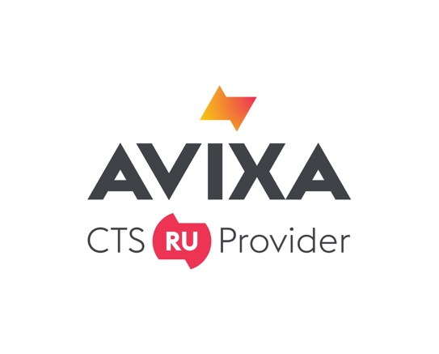
Fort Lauderdale, FL, October 22, 2019 – RME, premier German manufacturer of audio interfaces and official AVIXA CTS® Renewal Unit (RU) provider, has added a second course available for AVIXA CTS® RU credit, titled “Technology for Reliable Transport Over Unreliable Networks – IP Audio in Broadcast Applications,” granting more than 13,000 professionals holding AVIXA's Certified Technology Specialist™ credentials the ability to earn renewal units towards their certification by completing RME’s course for 2 Renewal Units (RUs). Derek Badala, who serves as Director of Sales for Synthax, RME’s distributor, will lead the education program and participant Q&A.
“We designed this course to provide Certified Technology Specialists with the opportunity to learn everything they need to know about today’s digital audio systems — including IP Audio in Broadcast Applications,” Badala said. “This course teaches how to navigate transporting audio reliably even when the networks available are unreliable.”
As an AVIXA Renewal Unit Provider, RME demonstrates its commitment to providing quality education and training for audiovisual professionals, including Certified Technology Specialist™ (CTS®) holders and the specialized designations CTS®-D (Design) and CTS®-I (Installation).
RME submitted this course for approval to the AVIXA independent Certification Renewal Committee to offer industry-specific learning opportunities to CTS holders and others for continuing their professional development. To obtain approval, RU programs must feature experienced instructors with clear evidence of qualifications in the session topic. Each class must contain at least one relevant learning objective or industry-related purpose, relate to a specific exam topic area and exam level, then conclude with an assessment tool to demonstrate participants that have grasped the objectives. These criteria are vigorously reviewed by AVIXA's Certification Renewal Committee.
“Continuing education is critical to the continued development of an industry that is moving as fast as professional AV,” said Amanda Beckner, CTS, Vice President of Learning, AVIXA. “We are delighted that RME is continuing to show its commitment to designing courseware that educates CTS holders on hot topics like audio over IP, and are confident that many of our 13,000-plus CTS holders worldwide will be interested in making the course part of their continuing education program.”
For more on RME, visit rme-usa.com

About Synthax, Incorporated
Synthax Inc. is the exclusive USA distributor for RME digital audio solutions, Digigram broadcast audio systems, Appsys digital audio tools, Ferrofish advanced audio applications, myMix personal monitoring systems and ALVA cableware. We supply a nationwide network of dealers with these products for professional audio, broadcast, music industry, commercial audio, theater, military and government applications. For additional information, visit the company online at http://www.synthax.com.
About the Certified Technology Specialist Credential
AVIXA’s Certified Technology Specialist, Certified Technology Specialist – Design and Certified Technology Specialist – Installation are the only audiovisual certifications accredited by the International Organization for Standardization's (ISO) United States representative, the American National Standards Institute (ANSI). Accepted by the U.S. Veterans Administration for reimbursement under the Montgomery G.I. Bill, AVIXA certification programs are designed to establish and maintain widespread credibility for the audiovisual industry and the professionals who perform the work. AVIXA's CTS, CTS-D, and CTS-I holders renew their credential every three years through continuing education. Each certification holder is required to attain 30 renewal units (RUs). To learn more about AVIXA and the Certified Technology Specialist (CTS) certifications, visit www.avixa.org/certification.

Media Contacts:
Katie Kailus
Public Relations
Hummingbird Media
+1 (630) 319-5226
katie@hummingbirdmedia.com

Jeff Touzeau
Public Relations
Hummingbird Media
+1 (914) 602 2913
jeff@hummingbirdmedia.com

