Sennheiser and Extron partner for seamless conferencing solutions

New Extron DMP Plus audio DSP processors work seamlessly with Sennheiser’s TeamConnect Ceiling 2 microphone array

Marlow/UK, April 30, 2020 – Sennheiser has partnered with Extron Electronics to create easy-to-deploy audio solutions for modern workspaces. With certified control drivers for Sennheiser’s TeamConnect Ceiling 2 microphone array added to the Extron DMP Plus series of audio DSPs, customers can create high-quality sound systems that are easy to control and work reliably.

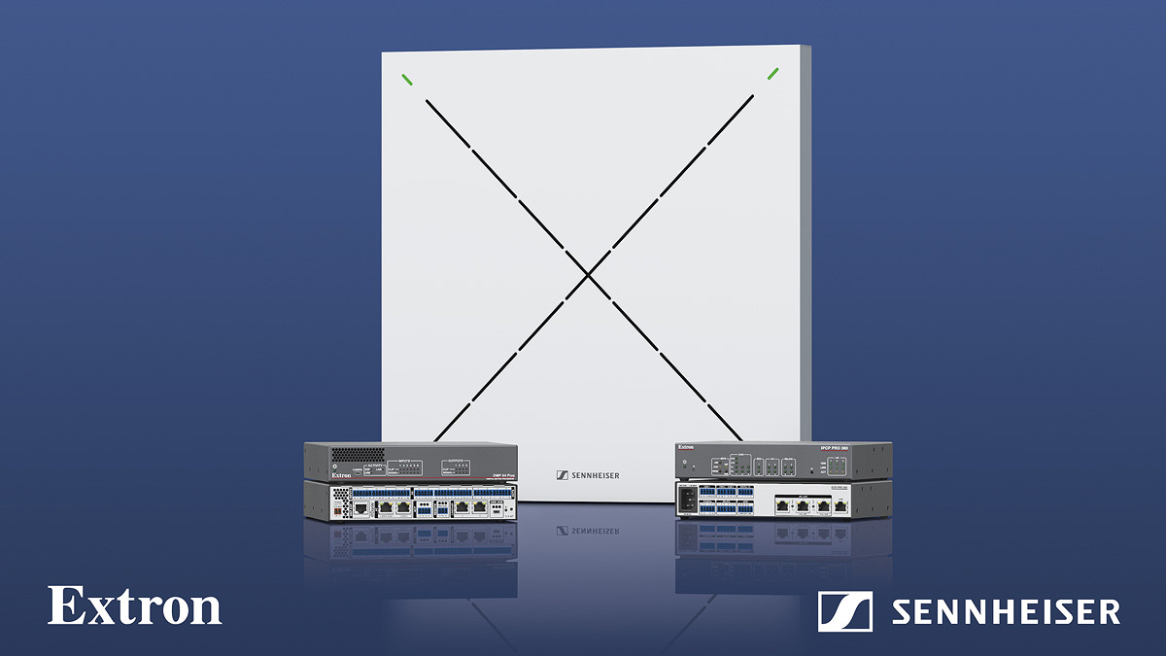
Partners Extron and Sennheiser provide a seamless conferencing experience for both on-site and remote participants

Extron is a leading global manufacturer of professional AV products with over 35 years of experience in the corporate, higher education, government, healthcare, and house of worship markets. The partnership with Sennheiser simplifies integration of TeamConnect Ceiling 2, Sennheiser’s automatic, adaptive beamforming microphone array, with Extron’s DMP Plus series audio DSP processors.

“It is exciting for Extron to combine our industry leading control and audio DSP solutions with Sennheiser’s 75 years of microphone experience,” says Casey Hall, Vice President of Worldwide Sales and Marketing at Extron. “By simplifying integration between products, our shared customers will benefit from improved workflows.”

“At Sennheiser, we always strive to give our customers a unique and, above all, easy-to-use product experience,” says Wienand Mensendiek, Head of Global Business Development & Commercialization at Sennheiser. “Working with an innovative company like Extron and combining TeamConnect Ceiling 2, a ceiling microphone that is unique in the market, with Extron’s DSPs makes exactly that possible.”

TeamConnect Ceiling 2 is an innovative ceiling-mounted conferencing microphone. It features adaptive beamforming technology that automatically focuses on a speaker’s voice – allowing speakers to move freely during their presentation. The solution blends in harmoniously with any conference room and offers a high-performance, discrete alternative for installation in medium to large conference spaces where table-mounted systems are not suitable or possible.

The new control system drivers from Extron that enable this seamless user experience have been developed and tested in partnership with Sennheiser. As part of the DMP Plus series audio DSPs, they support remote control of the microphone output level and mute state as well as LED sync with TeamConnect Ceiling 2, and distribute Sennheiser microphone audio to the entire conferencing system. The control drivers can be accessed via the Global Alliance section of the Sennheiser Business Communications website or directly from Extron.

To learn more, please visit https://en-de.sennheiser.com/global-alliances-extron or https://www.extron.com/article/sennheiser. The latter also includes three typical application scenarios complete with lists of required components and equipment – making it as easy as possible to set up an ideal conference solution.

About Sennheiser
Founded in 1945, Sennheiser is celebrating its 75th anniversary this year. Shaping the future of audio and creating unique sound experiences for customers – this aim unites Sennheiser employees and partners worldwide. The independent family company, which is managed in the third generation by Dr. Andreas Sennheiser and Daniel Sennheiser, is today one of the world’s leading manufacturers of headphones, loudspeakers, microphones and wireless transmission systems. In 2018, the Sennheiser Group generated turnover totaling €710.7 million. www.sennheiser.com

Local Press Contacts

Sarah James Maik Robbe
sarahj@gasolinemedia.com maik.robbe@sennheiser.com
+44 (0) 1483 223333 +44 (0) 7393 462484

