***EMBARGOED UNTIL 6.30pm AEST 3 SEPTEMBER 2018***
ABC and Kidney Health Australia announce recipient of inaugural Mark Colvin Scholarship
The ABC, in partnership with Kidney Health Australia, is proud to announce Alex Tighe as the recipient of the inaugural Mark Colvin journalism scholarship.
The 12-month paid cadetship commemorates the life and work of the esteemed ABC journalist, who died in 2017 due to complications related to kidney disease.
His Excellency Governor-General Sir Peter Cosgrove congratulated Alex during a ceremony at Admiralty House in Sydney on Monday 3 September, as part of Kidney Health Australia’s 50th anniversary celebrations.
ABC Managing Director Michelle Guthrie said: “The Mark Colvin Scholarship is a fitting tribute for such a giant of Australian journalism, ensuring that his commitment to accuracy, honesty and integrity will be passed on to future generations.
“Alex Tighe is a worthy recipient of this honour. Alex’s work in law and journalism demonstrates the qualities of critical analysis, creativity and curiosity that Mark held so dear. I am confident that Alex will continue Mark’s great legacy at the ABC.”
Alex said: “Mark Colvin was an incredible journalist and a great man, and it’s humbling to hold a scholarship in his name. His legacy is an embodiment of all that’s best about the ABC: intellectual rigour, empathy and perpetual curiosity. I hope to do my part towards continuing that tradition at the ABC.”
Alex, 23, has worked in community media as a writer, editor and radio producer. His journalism career started aged 13 when he hosted a program on community radio. His work includes a story on his mother’s kidney disease and the challenges of accessing medical treatment in regional NSW. He has held internships at ABC RN, triple j and Four Corners and worked as a paralegal and media adviser for a Sydney law firm.
As part of the cadetship, he will be mentored by leading ABC journalists in the editorial and technical skills required for reporting across media platforms.
Kidney Health Australia is the national organisation dedicated to saving and improving the lives of people living with kidney disease. Kidney Health Australia Chair Professor Carol Pollock said: “There are 1.7 million people living in Australia who are affected by kidney disease and 1.5 million are not aware of it. Fifty-three Australians die every day from kidney-related disease – that’s one person every 27 minutes; more than breast cancer, prostate cancer and road accidents combined.”

Mark Colvin
Mark was a prominent part of the ABC for more than four decades as a reporter, correspondent and presenter of ABC Radio’s PM. He was admired and respected by colleagues and audiences for his formidable intellect, sharp wit and integrity.
Mark joined the ABC as a cadet in 1974. His work at the ABC included 2JJ (now triple j), Nationwide, Four Corners, Foreign Correspondent, The 7.30 Report and Lateline.
Mark worked as an ABC foreign correspondent across Europe and Africa, covering such major stories as the American hostage crisis in Tehran and the Balkans War. In 1994, while on assignment in Rwanda and Zaire, Mark contracted an infection that led to a rare autoimmune disease, which nearly took his life. The illness ultimately resulted in kidney failure, which required dialysis and a kidney transplant.
In 1997, Mark returned to Sydney to present ABC Radio’s PM, interviewing Australia’s political leaders and leading coverage of major events such as the Arab Spring.
On 11 May 2017, Mark died from lung cancer related to the immunosuppressant medications he took to prevent rejection of his kidney transplant. Characteristically, he had the last word on Twitter, with the posthumous sign-off under his popular handle @Colvinius: “It’s all been bloody marvellous.”
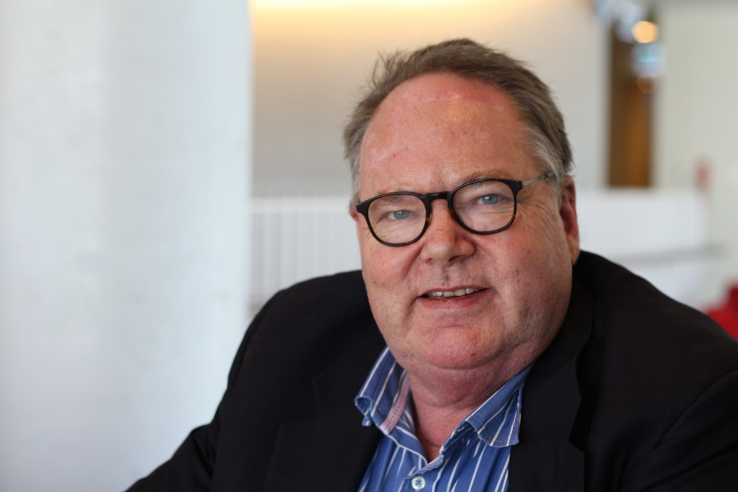___________________________________________________________________
For further information:
Peter Munro, ABC Communications, 02 8333 3082 or munro.peter@abc.net.au

