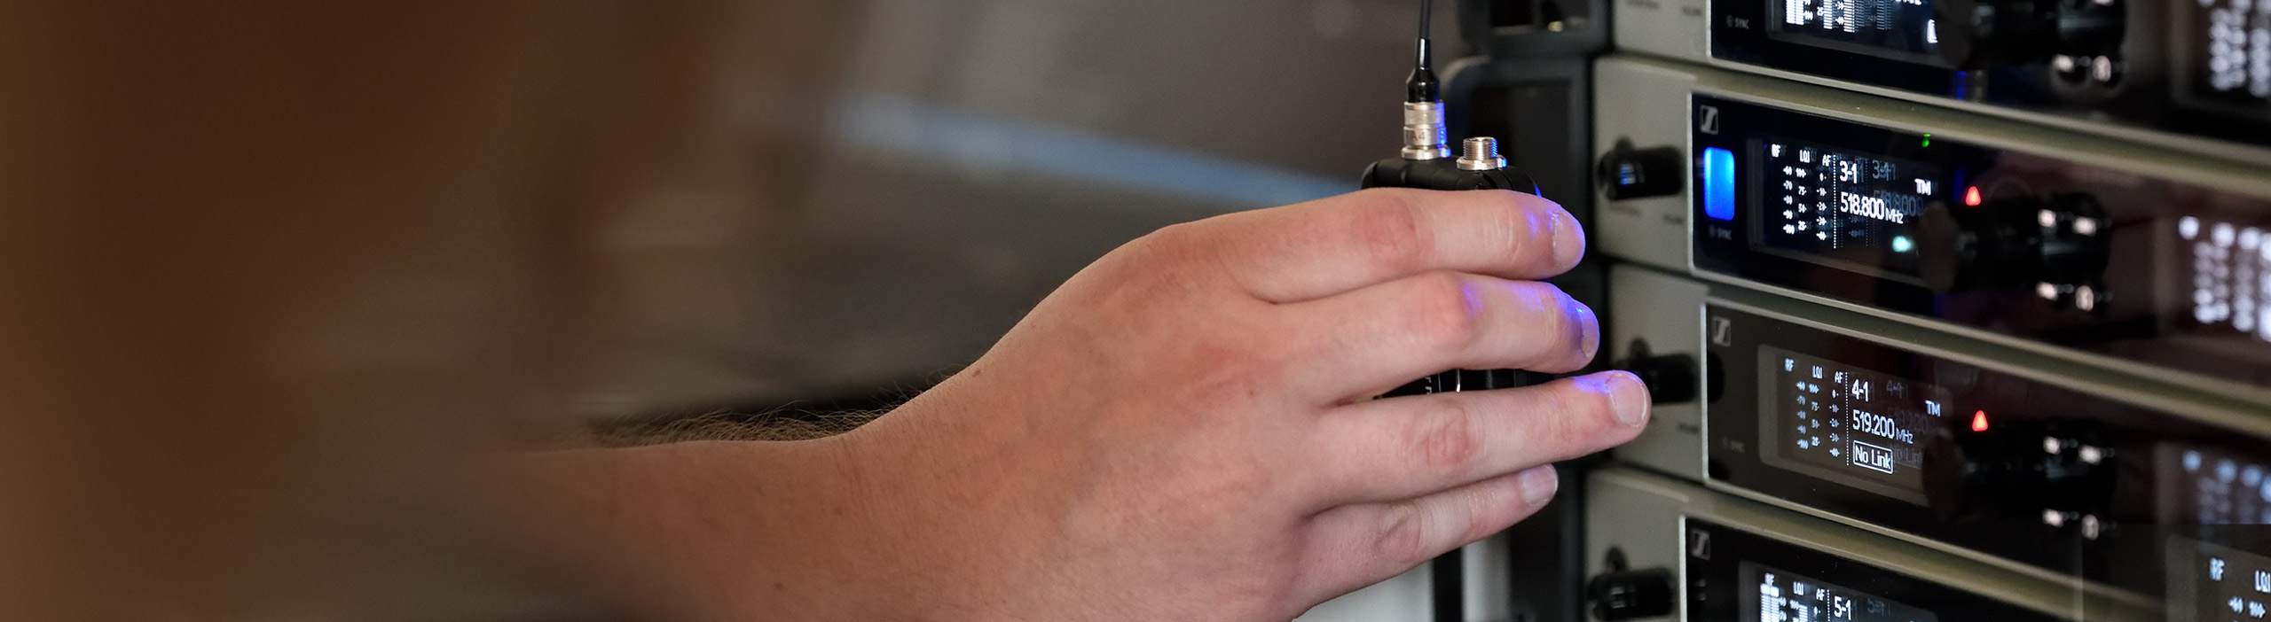

#DontStopTheEducation: Panel on Virtual Concert Production with Steel Panther’s Crew
Sennheiser to host a roundtable on August 11th with Steel Panther’s team on their approach to live music during the lockdown

Old Lyme, Connecticut, August 6, 2020 – The Sennheiser SoundAcademy will host a new roundtable session with American rock band Steel Panther’s team on August 11, 2020. The “Rockdown in the Lockdown” panel will discuss the band and crew’s approach to planning, production, promotion and delivering live music to fans during lockdown.

Panelists include Steel Panther’s drummer Stix Zadinia, the band’s marketing and business manager Jason Lekberg, digital strategy consultant J.T. Arbogast, and front of house engineer Nick Rucker. The roundtable will be hosted by Sennheiser’s Andy Egerton and Tim Moore, who will lead discussions focused on how the band has managed to continue performing and reaching fans during COVID-19, with a focus on their equipment, business and marketing strategies for livestreamed concerts.

Please register at https://zoom.us/webinar/register/WN_NoCWLE0QSpeXkAE2gJamGw.

Steel Panther – Rockdown in the Lockdown, Virtual Concert Production
Tuesday, August 11 at 17:00 Berlin time (15:00 UTC, 11:00 New York time, 8:00 AM Los Angeles time)

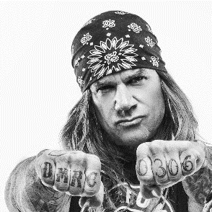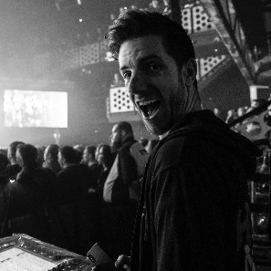

Stix Zadinia, J.T. Arbogast, Jason Lekberg and Nick Rucker (from left to right) will answer your questions on virtual concert planning, production and promotion

About the Panelists

Stix Zadinia

Stix is the drummer of Steel Panther. Best known for being the best at many insignificant things.

J.T. Arbogast

J.T. Arbogast is a Los Angeles based writer, director and performer. In addition to his own creative work, J.T. consults with filmmakers, bands, authors and brands on DIY producing, digital strategy and content, and grassroots distribution.

Jason Lekberg

Jason Lekberg is a music industry executive with both major and independent label experience as well as 20+ years of performance and creation. He specializes in product management as well as digital marketing and excels at first-to-market digital creativity. Jason currently runs Lekberg Enterprises; a Label-as-a-Service agency specializing in helping established artists take control of their careers as well as managing select artists and offering consultation for emerging music technology.

Nick Rucker

Nick Rucker is a Los Angeles-based sound engineer, producer and musician with over 20 years of experience in studio and live sound production. He has been Steel Panther’s front of house engineer since 2006.

About Sennheiser
Founded in 1945, Sennheiser is celebrating its 75th anniversary this year. Shaping the future of audio and creating unique sound experiences for customers – this aim unites Sennheiser employees and partners worldwide. The independent family company, which is managed in the third generation by Dr. Andreas Sennheiser and Daniel Sennheiser, is today one of the world’s leading manufacturers of headphones, loudspeakers, microphones and wireless transmission systems. In 2019, the Sennheiser Group generated turnover totaling €756.7 million. www.sennheiser.com

Local press contact Global press contact

Daniella Kohan Stephanie Schmidt
daniella.kohan@sennheiser.com Stephanie.schmidt@sennheiser.com
+1 (860) 222 – 4226 +49 (5130) 600 – 1275

